DAH SING BANK



FUNCTIONAL SPECIFICATIONS

OF

PERSONAL LOAN

Part 2

<LOS IMPLEMENTATON SERVICE>

Version 1.1123

NFeburaryovember 2021



The data presented herein shall not be disclosed outside Dah Sing Bank and shall not be duplicated, used or disclosed in whole or in part for any purpose without the expressed written consent of IBM China/Hong Kong Ltd. Dah Sing Bank shall have the right to duplicate and use the data for her own internal operations. This restriction does not limit Dah Sing Bank for information contained in the data if it is obtained from another source without restriction.

Table of Contents

1. Introduction 12
2. System Organization Structure 13
3. LOS System Flow 14
4. LOS Stage 15
5. LOS Management Module 16
5.1 Introduction 16
5.2 Summary 16
5.3 Login Manager 16
5.4 Task List Manager 16
5.5 Loan Modeling Manager 16
5.6 Application Manager 16
5.7 Document Manager 16
5.7.1 Description 16
5.7.2 Features 17
5.7.2.1 View Document Checklist 17
5.7.2.2 Add / Edit Document Checklist 17
5.7.2.3 FATCA Documents 17
5.7.2.4 FATCA Alert Message 18
5.7.3 Screen 19
5.7.4 Fields and Validations 20
5.8 Processing Manager 21
5.8.1 Description 21
5.8.2 Features 22
5.8.2.1 Assign CAO and Submit Application 22
5.8.2.2 Request Further Information 23
5.8.2.3 Download AML Report 24
5.8.2.4 View and Print AML Report 24
5.8.2.5 Enquiry AML Report 24
5.8.2.5.1. AML Result Extraction 25
5.8.2.5.2. Customer ID Matching Algorithm 25
5.8.2.5.3. Customer Name Matching Algorithm 26
5.8.2.5.4. Date of Birth Matching Algorithm 27
5.8.2.5.5. Potential Hit Checking Algorithm 29
5.8.2.5.6. AML Result Output 30
5.8.2.6 Manual AML Check 30
5.8.2.7 Download TU Report 30
5.8.2.8 View and Print TU Report 30
5.8.2.9 Manual Import TU Report 31
5.8.2.10 By-Pass TU Report 31
5.8.2.11 Re-send TU Request 31
5.8.2.12 Download Credit Score Information List 31
5.8.2.13 View and Print Credit Score Information List 32
5.8.2.14 Generate Credit Score Information List 32
5.8.2.15 TU Result Expiry 32
5.8.2.16 TU Status 32
5.8.2.17 TU Amendment 33
5.8.3 Screen 33
5.8.3.1 Main 33
5.8.3.2 Application History 34
5.8.3.3 TU 35
5.8.3.4 Account Conduct 36
5.8.3.5 Loan Information 36
5.8.3.6 Personal Data 36
5.8.3.7 Remarks History 37
5.8.3.8 Loan Summary 37
5.8.3.9 Occupation 37
5.8.4 Fields and Validations 37
5.8.4.1 Main 37
5.8.4.2 Application History 39
5.8.4.3 TU 39
5.8.4.4 Account Conduct 41
5.8.4.5 Loan Information 43
5.8.4.6 Personal Data 43
5.8.4.7 Remarks History 43
5.8.4.8 Loan Summary 44
5.8.4.9 Occupation 44
5.9 Underwriting Manager 44
5.9.1 Description 44
5.9.2 Features 44
5.9.2.1 View Credit Assessment Information 44
5.9.2.2 Edit Credit Assessment Information 45
5.9.2.3 Credit Assessment Checklist Template 45
5.9.2.4 Credit Assessment Checklist Field Mapping 48
5.9.2.4.1. Application Number 48
5.9.2.4.2. Customer Name 48
5.9.2.4.3. Customer ID 49
5.9.2.4.4. Date of Birth 49
5.9.2.4.5. Age 49
5.9.2.4.6. Residential Address 49
5.9.2.4.7. Residence Status 49
5.9.2.4.8. Mortgage Payment 49
5.9.2.4.9. Rental Expense 49
5.9.2.4.10. Name of Employer 49
5.9.2.4.11. Position 50
5.9.2.4.12. Year of Service(s) 50
5.9.2.4.13. AML Checking 50
5.9.2.4.14. Section 83/85 Checking 50
5.9.2.4.15. Last TU Checking Date 50
5.9.2.4.16. TU BKS 50
5.9.2.4.17. TU CMS 50
5.9.2.4.18. TU Public Record 50
5.9.2.4.19. Revolving Credit – Total Credit Limit 51
5.9.2.4.20. Revolving Credit – Total Used Limit 51
5.9.2.4.21. Revolving Credit – Utilization Rate 51
5.9.2.4.22. Revolving Credit – Current Pastdue Amount 51
5.9.2.4.23. Terms & Other Credit – Total Loan Amount 51
5.9.2.4.24. Terms & Other Credit – Total Loan O/S Amount 52
5.9.2.4.25. Terms & Other Credit – Total Installment Amount 52
5.9.2.4.26. Terms & Other Credit – Current Pastdue Amount 52
5.9.2.4.27. DSR Calculation – TU Report – 3% of Used Limit 53
5.9.2.4.28. DSR Calculation – TU Report – Total Installment Amount 53
5.9.2.4.29. DSR Calculation – TU Report – Excluded Last 3 Installment 53
5.9.2.4.30. DSR Calculation – Supporting Document – Mortgage Installment Amt 53
5.9.2.4.31. DSR Calculation – Supporting Document – Other Loan ( + ) 54
5.9.2.4.32. DSR Calculation – Newly Grant Dah Sing Group Facility 54
5.9.2.4.33. DSR Calculation – Newly Grant Dah Sing Group Facility – Other Exclusion ( - ) 57
5.9.2.4.34. DSR Calculation – Newly Grant Dah Sing Group Facility – Total Monthly Debts 57
5.9.2.4.35. DSR Calculation – Declared Income 57
5.9.2.4.36. DSR Calculation – Consolidated Income 58
5.9.2.4.37. DSR Calculation – Verified Income 58
5.9.2.4.38. DSR Calculation – Estimated Income 58
5.9.2.4.39. DSR Calculation – Total Monthly Income 58
5.9.2.4.40. DSR Calculation – DSR Cap 58
5.9.2.4.41. DSR Calculation – DSR 58
5.9.2.4.42. Total Exposure – Original Limit / Outstanding 58
5.9.2.4.43. Total Exposure – Adjustment ( + / - ) 64
5.9.2.4.44. Total Exposure – Newly Applied ( + ) and Total Product Final Limit / Outstanding 64
5.9.2.4.45. Total Exposure – Product Cap ($) 65
5.9.2.4.46. Total Exposure – Exposure Cap ($) 65
5.9.2.4.47. Total Exposure – Total Product ($) 65
5.9.2.4.48. Total Exposure – Total Exposure ($) 65
5.9.2.4.49. Total Exposure – Product Cap (X) 65
5.9.2.4.50. Total Exposure – Exposure Cap (X) 66
5.9.2.4.51. Total Exposure – Total Product (X) 66
5.9.2.4.52. Total Exposure – Total Exposure (X) 66
5.9.2.4.53. Asset Proof Approach – Discounted Net Worth 66
5.9.2.4.54. Total Exposure – Exposure Cap ($) (Asset Proof Approach) 66
5.9.2.4.55. Total Exposure – Exposure Cap (%) (Asset Proof Approach) 66
5.9.2.4.56. Total Exposure – Total Exposure ($) (Asset Proof Approach) 66
5.9.2.4.57. Total Exposure – Total Exposure (%) (Asset Proof Approach) 66
5.9.2.4.58. Customer Type 66
5.9.2.4.59. Property Owner 67
5.9.2.4.60. Earliest Account Open Date 67
5.9.2.4.61. Earliest Account Open Date (in Months) 68
5.9.2.4.62. Disposable Income 68
5.9.2.4.63. Product Name 69
5.9.2.4.64. Campaign Code / Description 69
5.9.2.4.65. Channel Source 69
5.9.2.4.66. Source Code / Description 69
5.9.2.4.67. Quick Application Indicator 69
5.9.2.4.68. Sub-Source Code / Description 69
5.9.2.4.69. Pre-approval Indicator / FTF Indicator 69
5.9.2.4.70. Pre-approval Amount 70
5.9.2.4.71. Requested Loan Amount 70
5.9.2.4.72. Requested Tenor 70
5.9.2.4.73. Requested Interest Rate 70
5.9.2.4.74. Default Interest Rate 70
5.9.2.4.75. Credit Decision – Pending 70
5.9.2.4.76. Credit Decision – Rejected 70
5.9.2.4.77. Credit Decision – Approved 70
5.9.2.4.78. Maximum Credit Limit 70
5.9.2.4.79. Maximum Tenor 71
5.9.2.4.80. Maximum Inst. Amount 71
5.9.2.4.81. Maximum Reference Limit 71
5.9.2.4.82. Credit Decision – Offer Other Loan 71
5.9.2.4.83. Credit Decision – Approval Code 71
5.9.2.4.84. Credit Decision – Approval Condition(s) 72
5.9.2.4.85. Credit Decision – Comments and Justification 72
5.9.2.4.86. Approved By 72
5.9.2.4.87. DSB Account (5710) – 3% of Used Limit 72
5.9.2.4.88. DSB Account (5710) – Total Installment Amount 72
5.9.2.5 View Rule Checking Result 72
5.9.2.6 Edit Rule Checking Result 73
5.9.2.7 Request for Pending Document 73
5.9.2.8 Reject Application 74
5.9.2.9 Approve Application 75
5.9.2.10 Offer Other Loan 78
5.9.2.11 Download Credit Assessment Checklist 80
5.9.2.12 Request Further Information 81
5.9.2.13 Request CPP Follow Up 81
5.9.2.14 (Obsolete) 82
5.9.2.15 Credit Assessment Checklist Template (CMI) 82
5.9.2.16 Credit Assessment Checklist Field Mapping (CMI) 83
5.9.2.16.1. Application Number 83
5.9.2.16.2. Customer Name 84
5.9.2.16.3. Customer ID 84
5.9.2.16.4. Date of Birth 84
5.9.2.16.5. Age 84
5.9.2.16.6. Residential Address 84
5.9.2.16.7. Position 84
5.9.2.16.8. Residence Status, Home Tel., Office Tel., Mobile No., Pager No., Marital Status 84
5.9.2.16.9. Name of Employer 85
5.9.2.16.10. Year of Service(s) 85
5.9.2.16.11. Declared Mortgage Installment 85
5.9.2.16.12. Verified Mortgage Installment 85
5.9.2.16.13. Declared Rental Expense 85
5.9.2.16.14. Verified Rental Expense 85
5.9.2.16.15. Declared Monthly Income 85
5.9.2.16.16. Verified Monthly Income 86
5.9.2.16.17. AML Checking 86
5.9.2.16.18. Section 83/85 Checking 86
5.9.2.16.19. Product Name 86
5.9.2.16.20. Channel Source 86
5.9.2.16.21. Campaign Code / Description 86
5.9.2.16.22. Source Code / Description 86
5.9.2.16.23. Sub-Source Code / Description 86
5.9.2.16.24. Sales Code, Total Tax Payable, Tax Bill Settle Amount 86
5.9.2.16.25. Requested Loan Amount 87
5.9.2.16.26. Proposed Loan Amount 87
5.9.2.16.27. Requested Tenor 87
5.9.2.16.28. Proposed Tenor 87
5.9.2.16.29. Default Monthly Flat Rate 87
5.9.2.16.30. Requested Monthly Flat Rate, Approved Monthly Flat Rate 87
5.9.2.16.31. Default Credit Life (p.a.) 87
5.9.2.16.32. Requested Credit Life (p.a.), Approved Credit Life (p.a.) 88
5.9.2.16.33. Default APR 88
5.9.2.16.34. Requested APR, Approved APR 88
5.9.2.16.35. Default Instalment 88
5.9.2.16.36. Requested Instalment, Approved Instalment 89
5.9.2.16.37. Default Premium 89
5.9.2.16.38. Requested Premium, Approved Premium 89
5.9.2.16.39. Discretionary Pricing Approved by 89
5.9.2.16.40. TU Credit Information 89
5.9.2.16.41. (Obsolete) 90
5.9.2.16.42. (Obsolete) 90
5.9.2.16.43. (Obsolete) 90
5.9.2.16.44. (Obsolete) 90
5.9.2.16.45. (Obsolete) 90
5.9.2.16.46. (Obsolete) 90
5.9.2.16.47. (Obsolete) 90
5.9.2.16.48. (Obsolete) 90
5.9.2.16.49. (Obsolete) 90
5.9.2.16.50. (Obsolete) 90
5.9.2.16.51. (Obsolete) 91
5.9.2.16.52. Debt Consolidation Plan 91
5.9.2.16.53. Debt Consolidation Plan - Record 91
5.9.2.16.54. Debt Consolidation Plan - Source 91
5.9.2.16.55. Debt Consolidation Plan - Bank / Finance Name 91
5.9.2.16.56. Debt Consolidation Plan - Type 91
5.9.2.16.57. Debt Consolidation Plan - Account No. 91
5.9.2.16.58. Debt Consolidation Plan - Currency 91
5.9.2.16.59. Debt Consolidation Plan - Loan Amount / Credit Limit 91
5.9.2.16.60. Debt Consolidation Plan - Outstanding 92
5.9.2.16.61. Debt Consolidation Plan - Last 3 Instalment 92
5.9.2.16.62. Debt Consolidation Plan - Monthly Payment 92
5.9.2.16.63. Debt Consolidation Plan - Verified O/S 92
5.9.2.16.64. Debt Consolidation Plan - Verified Monthly Payment 92
5.9.2.16.65. Debt Consolidation Plan - Actions 92
5.9.2.16.66. Debt Consolidation Plan - Settle Amount 92
5.9.2.16.67. Debt Consolidation Plan – Reduce Limit Amount 92
5.9.2.16.68. Debt Consolidation Plan - Remarks 92
5.9.2.16.69. Debt Consolidation Plan - Verified O/S - Total 92
5.9.2.16.70. Debt Consolidation Plan - Verified O/S - Accounts Consolidated 93
5.9.2.16.71. Debt Consolidation Plan - Verified O/S - Accounts Not Consolidated 93
5.9.2.16.72. Debt Consolidation Plan - Verified Monthly Payment - Total 93
5.9.2.16.73. Debt Consolidation Plan - Verified Monthly Payment - Accounts Consolidated 93
5.9.2.16.74. Debt Consolidation Plan - Verified Monthly Payment - Accounts Not Consolidated 93
5.9.2.16.75. Debt Consolidation Plan – Total Consol. Amount ($) 93
5.9.2.16.76. Debt Consolidation Plan – Cash-out ($) 93
5.9.2.16.77. Debt Consolidation Plan – Total Loan Amount($) 93
5.9.2.16.78. Debt Consolidation Plan – Total Consol. Amount (Income Multiple) 93
5.9.2.16.79. Debt Consolidation Plan – Cash-out (Income Multiple) 94
5.9.2.16.80. Debt Consolidation Plan – Total Loan Amount (Income Multiple) 94
5.9.2.16.81. DSR Calculation, Total Exposure 94
5.9.2.16.82. (Obsolete) 94
5.9.2.16.83. (Obsolete) 94
5.9.2.16.84. (Obsolete) 94
5.9.2.16.85. (Obsolete) 94
5.9.2.16.86. (Obsolete) 94
5.9.2.16.87. (Obsolete) 94
5.9.2.16.88. (Obsolete) 95
5.9.2.16.89. (Obsolete) 95
5.9.2.16.90. (Obsolete) 95
5.9.2.16.91. (Obsolete) 95
5.9.2.16.92. (Obsolete) 95
5.9.2.16.93. (Obsolete) 95
5.9.2.16.94. (Obsolete) 95
5.9.2.16.95. (Obsolete) 95
5.9.2.16.96. (Obsolete) 95
5.9.2.16.97. (Obsolete) 95
5.9.2.16.98. (Obsolete) 95
5.9.2.16.99. Applicant Type 96
5.9.2.16.100. Property Owner 96
5.9.2.16.101. Disposable Income 96
5.9.2.16.102. Repayment Schedule 96
5.9.2.16.103. CMI Special Program 96
5.9.2.16.104. CMV, CMV Ref. No. 96
5.9.2.16.105. CMV Quota By, Current Property O/S 96
5.9.2.16.106. Preferred Industry 97
5.9.2.16.107. Obsolete 97
5.9.2.16.108. Obsolete 97
5.9.2.16.109. Credit Decision – Pending 97
5.9.2.16.110. Credit Decision – Rejected 97
5.9.2.16.111. Credit Decision – Approval Conditions 97
5.9.2.16.112. Credit Decision – Comments / Justification by PFC 97
5.9.2.16.113. Credit Decision – Approved 97
5.9.2.16.114. Credit Decision – Approval Code 97
5.9.2.16.115. Credit Decision – Comments / Justification by RCD 98
5.9.2.16.116. Approved By 98
5.9.2.17 Confirm Approval Decision 98
5.9.2.18 (Obsolete) 98
5.9.2.19 (Obsolete) 98
5.9.2.20 Update Pending Document Condition 98
5.9.2.21 (Obsolete) 98
5.9.2.22 Refresh Credit Assessment Checklist 98
5.9.2.23 Submit Approval Decision 99
5.9.2.24 Return Credit Assessment Checklist 99
5.9.2.25 Max. Tenor 100
5.9.2.26 Max. Installment Amount 100
5.9.2.27 Max. Credit Limit 101
5.9.2.28 Keep Approval Decision Information for Reference during application reapproval process 102
5.9.2.29 Override Approved Tenor Logic 103
5.9.2.30 Mortgage Loan Application Warning 103
5.9.2.31 Start ECCD Process 104
5.9.2.32 Debt Consolidation Plan and Settlement Instruction 106
5.9.2.33 DSR Calculation Logic for MP / VP Application 107
5.9.2.34 Approver override On-us Mortgage Indicator 107
5.9.2.35 TU Proxy Income Date Validataion in Underwritting Manager 108
5.9.2.36 Calculation Logic on Currency Mismatch Indicator 109
5.9.2.37 Handling of Online Straight Through Application on Currency Mismatch Indicator 109
5.9.3 Screen 109
5.9.3.1 Main 109
5.9.3.2 Credit Assessment 110
5.9.3.2.1. Normal PL 110
5.9.3.2.2. CMI 117
5.9.3.3 Rule Checking 123
5.9.3.4 Pending Document 125
5.9.3.5 (Obsolete) 125
5.9.4 Fields and Validations 125
5.9.4.1 Main 125
5.9.4.2 Credit Assessment 126
5.9.4.2.1. Normal PL 126
5.9.4.2.2. CMI 150
5.9.4.2.3. Control logic of RCD On-us Mortgage Indicator 168
5.9.4.3 Rule Checking 169
5.9.4.4 Pending Document 171
5.9.4.5 (Obsolete) 172

Introduction
Please refer to part 1 of this document.

System Organization Structure
Please refer to part 1 of this document.

LOS System Flow
Please refer to part 1 of this document.

LOS Stage
Please refer to part 1 of this document.

LOS Management Module

Introduction
Please refer to part 1 of this document.

Summary
Please refer to part 1 of this document.

Login Manager
Please refer to part 1 of this document.

Task List Manager
Please refer to part 1 of this document.

Loan Modeling Manager
Please refer to part 1 of this document.

Application Manager
Please refer to part 1 of this document.

Document Manager

Description
This module provides features to manipulate document, which associated with a specific loan application. Default document checklist is configured in campaign and user can add additional document to the specific loan application.
Here are functions provided by Document Manager
- View Document Checklist
- Add / Edit Document Checklist

Features

View Document Checklist
In Document Manager, system shows document checklist in read mode. In Default Documents section, it lists documents configured in selected campaign.

Add / Edit Document Checklist
User can click “Edit” button to update document information. If “Unwilling to Provide” checkbox is selected, remark is required to enter. In addition, user can add new document to Other Documents section and input note.
After update, user can click “Save” button to save the change to system and the checklist will change back to read mode. Alternatively, user can click “Cancel Save” button to discard the change. System will show the data image before update in read mode.

FATCA Documents
FATCA Documents are required if
- Any of the following criteria is met
    - Nationality = US
    - Born in US = Yes
    - Home Address same as Permanent Address = N - US
- And selected product nature is Revolving
Then, the following documents will be shown in FATCA Documents section in Document Manager. Only the required document will be shown.
Nationality | Born in US | Home Address same as Permanent Address | US Person | Required Documents
US | - | - | - | - Self Declaration Form (if application is created by DCD)
Non-US | Yes | - | Yes | - Self Declaration Form (if application is created by DCD)
Non-US | Yes | - | No | - Self Declaration Form (if application is created by DCD)  - A non-US ID Copy (i.e. HKID or Non US Passport copy)  - A copy of the Certificate of Loss of Nationality of the US
Non-US | No | N - US | Yes | - Self Declaration Form (if application is created by DCD)
Non-US | No | N - US | No | - Self Declaration Form (if application is created by DCD)  - A non-US ID Copy (i.e. HKID or Non US Passport copy)

FATCA Alert Message
FATCA Alert Message is prompted if all the following criteria are met:
- FATCA Indicia is hit (section 5.4.2.13)
- Application Stage is not
    - Pending Disbursement
    - Pending Close
    - Closed - Disbursed
    - Closed - Cancelled
    - Closed - Rejected
    - Closed - Transferred

FATCA Alert Message is defined as follows:
FATCA Indicia | Condition | FATCA Alert Message
Nationality = US | Branch created application | Please provide TIN (Tax Identification No.) before drawdown.
Nationality = US | DCD created application | Extra Document is required for FATCA before drawdown. Please refer to Document Manager.
US Person = Y and Born in US = Y | Branch created application | Please provide TIN (Tax Identification No.) before drawdown.
US Person = Y and Born in US = Y | DCD created application | Extra Document is required for FATCA before drawdown. Please refer to Document Manager.
US Person = N and Born in US = Y | Branch created application | Extra Document is required for FATCA before drawdown. Please refer to Document Manager.
US Person = N and Born in US = Y | DCD created application | Extra Document is required for FATCA before drawdown. Please refer to Document Manager.
US Person = Y and Home Address same as Permanent Address Indicator = N - US | Branch created application | Please provide TIN (Tax Identification No.) before drawdown.
 | DCD created application | Extra Document is required for FATCA before drawdown. Please refer to Document Manager.
US Person = N and Home Address same as Permanent Address Indicator = N - US | Branch created application | Extra Document is required for FATCA before drawdown. Please refer to Document Manager.
 | DCD created application | Extra Document is required for FATCA before drawdown. Please refer to Document Manager.

Screen
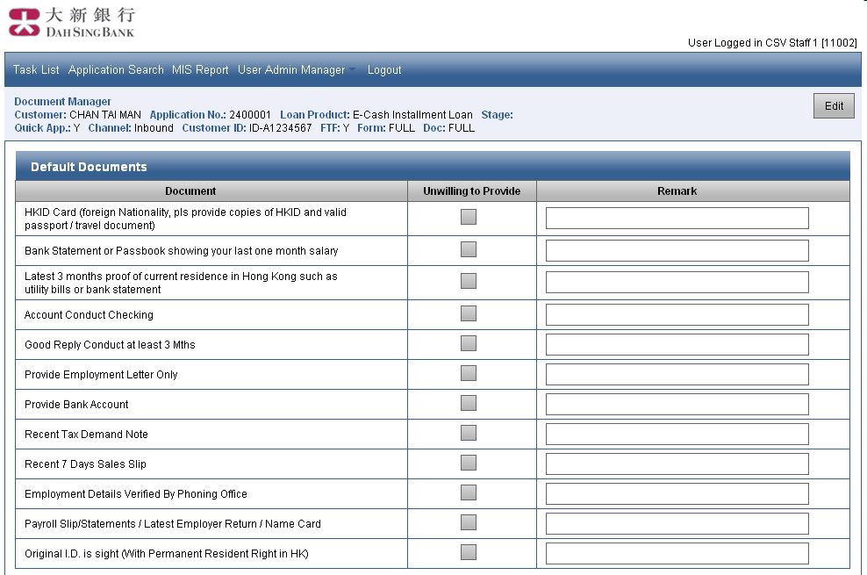
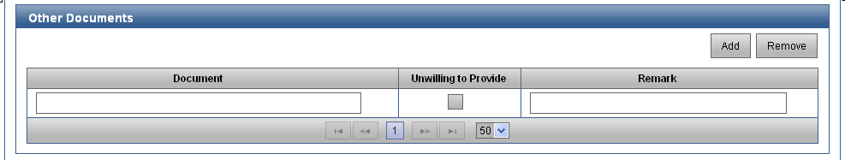
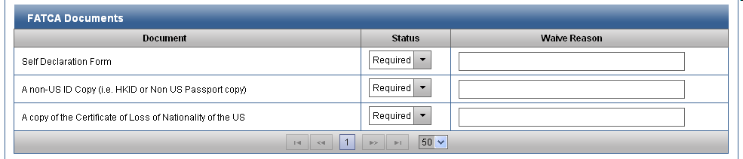
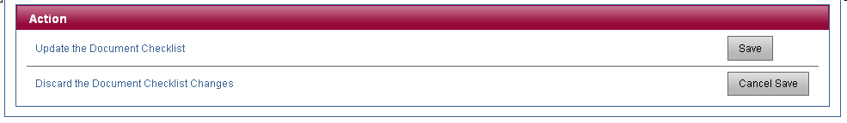

Fields and Validations
Section: Title
Screen Label | Type | Data Type | Mandatory | Validation | Possible Value | Source | Remarks
Edit | Button | N/A | N/A | N/A | N/A | N/A | Change Document Checklist to edit mode.

Section: Default Documents
Screen Label | Type | Data Type | Mandatory | Validation | Possible Value | Source | Remarks
For each document configured in campaign, it has the following fields:
Document | Text | String | Mandatory | N/A | N/A | From LOS
Unwilling to Provide | Checkbox | Boolean | Optional | N/A | Selected, Unselected | User Input
Remark | Text Box | String (100) | Optional | N/A | N/A | User Input | It is mandatory if Unwilling to Provided is selected.

Section: Other Documents
Screen Label | Type | Data Type | Mandatory | Validation | Possible Value | Source | Remarks
Add | Button | N/A | N/A | N/A | N/A | N/A | Add a new entry to this section.
Remove | Button | N/A | N/A | N/A | N/A | N/A | Remove selected entry in this section.
For each entry, it has the following fields:
Document | Text Box | String (100) | Mandatory | N/A | N/A | User Input
Unwilling to Provide | Checkbox | Boolean | Optional | N/A | Selected, Unselected | User Input
Remark | Text Box | String (100) | Optional | N/A | N/A | User Input | It is mandatory if Unwilling to Provide is selected.

Section: FATCA Documents
Screen Label | Type | Data Type | Mandatory | Validation | Possible Value | Source | Remarks
This section is shown if FATCA Documents are required according to section 5.7.2.3.
Multiple rows are shown. For each row, it has the following fields:
Document | Text | String | Mandatory | N/A | N/A | From LOS
Status | Drop down list | String | Mandatory | N/A | Required, Received, Waived | User Input | Default: Required
Waive Reason | Text Box | String (100) | Optional | N/A | N/A | User Input | It is mandatory if Status is Waived.

Section: Action
Screen Label | Type | Data Type | Mandatory | Validation | Possible Value | Source | Remarks
This section is shown if checklist is in edit mode.
Save | Button | N/A | N/A | N/A | N/A | N/A | Update the Document Checklist.
Cancel Save | Button | N/A | N/A | N/A | N/A | N/A | Discard the Document Checklist Changes. Document Checklist will be changed to read mode.

Processing Manager

Description
This module provides features to
- Assign CAO and Submit Application
- Request Further Information
- Download AML Report
- View and Print AML Report
- Enquiry AML Report
- Manual AML Check
- Download TU Report
- View and Print TU Report
- Manual Import TU Report
- By-Pass TU Report
- Re-send TU Request

Features

Assign CAO and Submit Application
This function allows user to assign application to CAO, optionally, and submit application.
Error message will be displayed if any of following criteria is met when user clicks the Submit button:
- AML Check for the customer is “Not Completed”, i.e. not completed and not manual.
If validation passes, submission screen will be shown as below and user can select approver and click “Submit” button to continue the operation.
Customer Checking Result
Name | TU Credit Check | AML Check
CHAN TAI MAN | Completed | Completed
 By-Pass TU Credit Check validation
Approver Assignment
Approver | (dropdown list)

Action
Submit Application | (Submit)
Cancel Application Submission | (Cancel)

Section: Customer Checking Result
Screen Label | Type | Data Type | Mandatory | Validation | Possible Value | Source | Remarks
Name | Text | String | Mandatory | Display Only | N/A | From LOS
TU Credit Check | Text | String | Mandatory | Display Only | Completed, Manual, Scan Alert, TU Error, Expired | From LOS
AML Check | Text | String | Mandatory | Display Only | Completed, Manual, Not Completed | From LOS
(Nil) | Checkbox | Boolean | Optional | N/A | By-Pass TU Credit Check validation | User Input | Default: It is selected if “By-Pass TU Report” has been clicked before. Otherwise, it is not selected.

Section: Approver Assignment
Screen Label | Type | Data Type | Mandatory | Validation | Possible Value | Source | Remarks
Approver | Drop down list | String | Optional | N/A | Name and ID of active users with PL_CAO role | User Input | Default: Previously assigned approver, if any  It is shown as “User Name [User ID]”.

Section: Action
Screen Label | Type | Data Type | Mandatory | Validation | Possible Value | Source | Remarks
Submit | Button | N/A | N/A | N/A | N/A | N/A | Submit Application
Cancel | Button | N/A | N/A | N/A | N/A | N/A | Cancel Application Submission

Error message will be displayed if all of following criteria are met when user clicks Submit button:
- TU Credit Check is TU Error, Scan Alert, Expired
- By-Pass TU Credit Check validation is not selected
If validation passes, application will be submitted to RCD Proposal Preparation stage and assigned approver will be shown as Last Handling Staff of the application if Approver is selected. If no approver is selected, Last Handling Staff will be blank until an approver picks up the application then the Last Handling Staff will be equal to that approver.

Request Further Information
This function allows user to route back application to frontline / PL_PFC for further information. Both remark and attachment are optional.
Processing Manager
Request Further Information
Remark | : (Text area)
Attachment | : (Remove) (Upload)
Action
Request Further Information |  |  | (Route Back)
Cancel Route Back |  |  | (Cancel)

Section: Request Further Information
Screen Label | Type | Data Type | Mandatory | Validation | Possible Value | Source | Remarks
Remark | Text Area | String (1000) | Optional | N/A | N/A | User Input
Attachment | Text | String | Optional | N/A | N/A | From LOS | Attached file name.
Remove | Button | N/A | N/A | N/A | N/A | N/A | When this button is clicked, system will remove uploaded attachment.  This button is shown if attachment is uploaded. Otherwise, it is hidden.
Upload | Button | N/A | N/A | N/A | N/A | N/A | When this button is clicked, system will allow user to add file for attachment.

Section: Action
Screen Label | Type | Data Type | Mandatory | Validation | Possible Value | Source | Remarks
Route Back | Button | N/A | N/A | N/A | N/A | N/A | Request Further Information.
Cancel | Button | N/A | N/A | N/A | N/A | N/A | Cancel Route Back and Go back to Processing Manager’s Main page.

After the routing, the application will go to
- Processing Returned stage if selected product’s Flow is Normal PL (Exclude MP / VP Application).
- CMI Proposal Preparation stage if selected product’s Flow is CMI.
- CMI Proposal Preparation stage if selected product is MP / VP.
User can view the remark and download attachment through Remark Manager.

Download AML Report
This function allows user to download AML Report. Browser will prompt download dialog for user to select download path. Error message “No AML report is available” will be shown if no AML enquiry has been triggered.

View and Print AML Report
This function allows user to view and print AML Report. System will pop-up a new window to show the report. Then, user can print the report through the browser.

Enquiry AML Report
This function allows the user to trigger online AML enquiry through LOS manually. Details on online AML enquiry interface please refer to Technical Specification. When operation is successful, AML’s status will be shown as “Completed”.

AML Result Extraction
LOS will first divide the value of AMLRecord into 3 parts as follows:
Part | Extraction Logic
Header | Data segment before and including the string “<!-- SUMMARY-END -->”
Detail Segments | There are multiple segments in this part. Each segment is between the string “<!-- CASE-BEGIN -->” and “<!-- CASE-END -->”. This part will be empty if no case detail is available.
Trailer | Data segment after and including the string “<!-- FOOTER-BEGIN -->”

Header will contain the following information from original HTML:
- DSB AML System Warning: Potential Hits Found, No. of Hits = <count> and No. of not match = <count>
- Case reference is HQ_DSB - <YYYMMDD> - <Reference Number> -- XXXXXDSBAMLSRV05
- User Query <Customer Name> <ID / PP#>

LOS will then extract detail fields from segments in the Case Details part extracted and the logic is as follows:
Field | Extraction Logic
Case ID | Use "<!-- ID-REF-BEGIN -->" & "<!-- ID-REF-END -->"
Customer ID | Apply regular expression pattern " hki[cd].*?:(.*?);" to the segment between “<!-- ADDINFO-BEGIN -->” and “<!-- ADDINFO-END -->” with case insensitive flag. The value is the result of the first matching group of the first match. Otherwise, the value is blank.
Customer Name | Data segment between the string “<!-- NAME-BEGIN -->” and “<!-- NAME-END -->”  Replace "-" or "/" characters with space " ".
Date of Birth | Data segment between the string “<!-- DOB-BEGIN -->” and “<!-- DOB-END -->”
Note: Multiple records for each field may be available.

Customer ID Matching Algorithm
If no Customer ID field is available, Customer ID is marked as NO DATA.
All brackets (“(”, “)”) will be removed from Customer ID fields first.
If one of the Customer ID field is exactly matched the ID Number of the inputted obligor, Customer ID is marked as MATCH. Otherwise, it is marked as DIFFERS.

1. If both are HKID
- if customer id match return hit
- if customer id not match return not hit
2. If both are non-HKID
- if customer id match return hit
- if customer id not match, check customer name and DOB
3. If either one is non-HKID
- check customer name and DOB
4. Customer ID TYPE in LOS always exists, but Customer ID TYPE in AML may not exist:
- If AML customer id and type no data, use logic 3
- If LOS ID TYPE = ID, AML= ID TYPE no data, use logic 1
- If LOS ID TYPE = non-HKID, AML= ID TYPE no data, use logic 3

Customer Name Matching Algorithm
All hyphens (“-”) and slashes (“/”) in Customer Name fields will be converted to spaces (“ ”) first.
For each Customer Name field, the following matching logic will be applied:
If commas(“,”) is found in Customer Name field then
The Customer Name field is divided into 2 parts by the 1st comma found from the beginning.
The part before comma is defined as Surname part and the other part is defined as Other Name part.
All Surname part, Other Name part, Surname of the inputted obligor and Other Name of the inputted obligor is separated into words using spaces(“ ”) as separator.
If at least one word from Surname part matches a word from Surname of the inputted Obligor
and at least one word from Other Name part matches a word from Other Name of the inputted obligor
then
Customer Name is marked as MATCH.
Else
Customer Name field, Surname of the inputted obligor and Other Name of the inputted obligor is separated into words using spaces(“ ”) as separator.
Words from Surname and Other Name of the inputted obligor are matched against words from Customer Name field.
If total number of unique word matches is more than or equaled to 2 then
Customer Name is marked as MATCH.

If none of the Customer Name fields return MATCH, Customer Name will be marked as DIFFERS.

In addition, PARTIAL MATCH will be applied in Customer Name Matching
- System will classify the case as POTENTIAL HIT case if either the AML record is in ONE word or the LOS record is in ONE word, and given that either AML to LOS match count or LOS to AML match count >=1
- Surname will be separated from other name by a comma in the AML record
- Rule 1. If AML retrieved with surname (the value before the comma “,” of the name in AML system), total sum of surname match must at least match once, and other name must also at least match once. Surname & Other name checking should be done separately & check both ways (LOS to AML and AML to LOS)
- Rule 2. If AML retrieved without surname (no comma “,” found in the name of AML system), Sum of LOS to AML & AML to LOS match count >= 2 as match, but same word match can only count once, and used once for match cases

Date of Birth Matching Algorithm
If no Date of Birth field is available, Date of Birth is marked as NO DATA.
All hyphens (“-”), spaces (“ ”) and commas (“,”) in Date of Birth fields will be converted to slashes (“/”) first. Any repeating slashes will then be converted to single slashes.

Component values (V1, V2, V3) will be extracted from the processed Date of Birth field according to the positions of slashes and length of the process value. All components values will be converted to integer values, but Short Month Name will be matched case-insensitively when specified and corresponding numeric month value (1 – 12) will be stored instead. Any conversion error will be handled as “Others”.
Length | Pattern | Extraction
4 | AAAA | V1 = AAAA, V2 = 0, V3 = 0
6 | AAAA/B | V1 = AAAA, V2 = B, V3 = 0
6 | A/BBBB | V1 = BBBB, V2 = A, V3 = 0
7 | AAAA/BB | V1 = AAAA, V2 = BB, V3 = 0
6 | AA/BBBB | V1 = BBBB, V2 = AA, V3 = 0
8 | AAAA/B/C | V1 = AAAA, V2 = B, V3 = C
8 | A/B/CCCC | V1= CCCC, V2 = B, V3 = A
8 | AAA/BBBB | V1 = BBBB, V2 = AAA (Short Month Name), V3 = 0
8 | AAAA/BBB | V1 = AAAA, V2 = BBBB (Short Month Name), V3 = 0
8 | AABBCCDD | If AABB is between 1900 and 2099,  V1 = AABB,  If CC > 12,  V2 = DD, V3 = CC  Else,  V2 = CC, C3 = DD  Else,  V1 = CCDD,  If AA > 12,  V2 = BB, V3 = AA  Else,  V2 = AA, C3 = BB
9 | AAAA/B/CC | V1 = AAAA, V2 = B, C3= CC
9 | AA/B/CCCC | V1 = CCCC, V2 = B, V3 = AA
9 | A/BB/CCCC | V1 = CCCC, V2 = A, V3 = BB
10 | AAAA/BB/CC | V1 = AAAA,  If BB > 12,  V2 = CC, V3 = BB  Else,  V2 = BB, V3 = CC
10 | AA/BB/CCCC | V1 = CCCC,  If AA > 12,  V2 = BB, V3 = AA  Else,  V2 = AA, V3 = BB
10 | A/BBB/CCCC | V1 = CCCC, V2 = BBB (Short Month Name), V3 = A
10 | AAA/B/CCCC | V1 = CCCC, V2 = AAA (Short Month Name), V3 = B
10 | AAAA/BBB/C | V1 = AAAA, V2 = BBB (Short Month Name), V3 = C
11 | AA/BBB/CCCC | V1 = CCCC, V2 = BBB (Short Month Name), V3 =AA
11 | AAA/BB/CCCC | V1 = CCCC, V2 = AAA (Short Month Name), V3 = BB
11 | AAAA/BBB/CC | V1 = AAAA, V2 = BBB (Short Month Name), V3 = CC
Others | * | V1 = 9999, V2 = 9999, V3 = 9999

Component values (V1, V2, V3) will be validated after extraction. LOS will treat Date of Birth as MATCH if any validation error is encountered. The validation logic is as follows:
Component | Validation
V1 | V1 >= 1900 and <= 2099
V2 | V2 <= 12
V3 | V3 <= 31

If the validation is passed, component values (V1, V2, V3) will be matched against the Date of Birth of the inputted obligor with the following logic:
If V1 > 0 and V2 > 0 and V3 > 0 then
If V3 > 12 and V1 = YYYY and V2 = MM and V3 = DD then
Date of Birth is marked as MATCH
If V1 = YYYY then
If V2 = MM and V3 = DD then
Date of Birth is marked as MATCH
Else if V2 = DD and V3 = MM then
Date of Birth is marked as MATCH
Else if V1 > 0 and V2 > 0 and V3 = 0 then
If V1 = YYYY and V2 = MM then
Date of Birth is marked as MATCH
Else if V1 > 0 and V2 = 0 and V3 = 0 then
If V1 = YYYY then
Date of Birth is marked as MATCH
Otherwise,
Date of Birth is marked as DIFFERS

Potential Hit Checking Algorithm
Each AML Detail segment is evaluated using the following table from Rule 1.
Rule | Customer ID Matching Result | Customer Name Matching Result | Date of Birth Matching Result | Result
1 | MATCH | * | * | Add segment to List of Potential Hit.
2 | * | MATCH | MATCH | Add segment to List of Potential Hit.
3 | NO DATA | MATCH | NO DATA | Add segment to List of Potential Hit.
4 | DIFFERS | MATCH | DIFFERS / NO DATA | Add segment to List of Potential Hit.
5 | * | * | * | Add segment to List of DIFFERS and insert Not Match Reason Line to the beginning of segment.
Note: Result marked with “*” means the result is omitted for that rule.

Definition of Differs Reason Line
<Case ID>: DIFFERS. Reason: Customer Name <Customer Name Matching Result>; Customer ID <Customer ID Matching Result>; DOB <DOB Matching Result>

AML Result Output
The final report will be constructed with Header part, all Potential Hit segments, DIFFERS segments and Trailer part as follows:
<Header>
<segment 1 in List of Potential Hit segments>
<segment 2 in List of Potential Hit segments >
…
<segment n in List of Potential Hit segments >
<segment 1 in List of DIFFERS segments>
<segment 2 in List of DIFFERS segments >
…
<segment n in List of DIFFERS segments >
<Trailer>

(“Differs Reason Line” will be shown before the items.)

Manual AML Check
When AML enquiry is performed manually, user can use this function to mark the AML enquiry completed manually. AML’s status will be shown as “Manual”.

Download TU Report
This function allows user to download TU Report. Browser will prompt download dialog for user to select download path.

View and Print TU Report
This function allows user to view and print TU Report. System will pop-up a new window to show the report. Then, user can print the report through the browser.

Manual Import TU Report
This function allow user to import a TU Report to LOS manually. When user clicks the “Import TU Report” button, LOS will display a file upload field for user to select the file to be imported. Error will be displayed if no file is selected during submission.
After submission, LOS will process the imported file using DSB library. Detail on the processing of the imported file please refers to TU Report File Deblocking in Technical Specification.
If the file is processed successfully and the customer ID of the result matches the customer ID in the current application, the result will be assigned to the application and the file will be saved in LOS as text report of the TU result. The status of TU Check will be changed to “Manual”.
Otherwise, error message will be displayed.

By-Pass TU Report
System allows user to by-pass TU report checking when submit application to CAO. When By-Pass TU Report button is clicked, system will select By-Pass TU Credit Check validation check box in submission screen as default.

Re-send TU Request
System allows user to re-send TU Request if any of the following criteria is met:
- Last TU Result returns safe scan.
- Last TU Result returns error.
- TU Report is expired. Please refer to section 5.8.2.15 for details.
- Difference is found between current values in fields of the customer and snapshot of field values for the last TU Request. If TU report is from DM List, fields in DM List will be used as snapshot values.
- Application stage is not in Pending Close, Closed - Disbursed, Closed - Rejected, Closed - Transferred and Closed - Cancelled.
System will format TUEF request message to TU and process the response message. Please refer to Technical Spec for details of field mapping.

Download Credit Score Information List
This function allows user to download Credit Score Information List. Browser will prompt download dialog for user to select download path.

View and Print Credit Score Information List
This function allows user to view and print Credit Score Information List. System will pop-up a new window to show the report. Then, user can print the report through the browser.

Generate Credit Score Information List
This function allows user to generate Credit Score Information List manually. Data will be collected from different systems. Please refer to LOS ML Functional Specification Section 5.11.3 for details.

TU Result Expiry
TU result data will be expired if current date – TU enquiry date is greater than a configurable number of days, which is maintained by ITD. If current date is same as TU enquiry date, the number of day difference is 0. There are 2 parameters, one for TU Report from DM List and the other one is for other case.
TU Report | Valid Days
TU Report from DM List | 90
TU Report from Others | 60

When the TU result expired, the TU screen will show the TU result is expired. However, the actual data in the LOS will not be deleted. The TU result housekeeping will refer to Housekeeping section in Technical Specification.

TU Status
Status of TU Request will be changed according to the following conditions:
 | Original TU Status | Conditions | New TU Status
1. | (Any) | - TU Report is imported from DM List. | Completed
2. | (Any) | - TU Report is copied from other application of which TU Status is Completed. | Completed
3. | (Any) | - TU Report is copied from other application of which TU Status is Manual | Manual
4. | (Any) | - TU Check is submitted  - And error report is returned | TU Error
5. | (Any) | - TU Check is submitted  - And TU Report’s Summary Segment’s Safe Scan Alert (Tag 01) > 0 | Scan Alert
6. | (Any) | - TU Check is submitted  - And TU Report’s Summary Segment’s Safe Scan Alert (Tag 01) = 0 | Completed
7. | (Any) | - User uploads TU report manually  - And operation is successful | Manual
8. | Completed | - Expiration Check batch job executes  - And TU report is expired | Expired
9. | Manual | - Expiration Check batch job executes  - And TU report is expired | Expired

TU Amendment
This function allows user to record TU Amendment if any of the following criteria is met:
- There is difference found for Phone Number, DOB, Customer Name previous sent to TU Enquiry;
- There is difference found for Home Address and Amendment Reason is Wrong Input.

Current system time will be recorded as Amendment Date and current user will be recorded as Amendment Staff.

Confirm Route Back to Front Line and Resend TU
For EM NIL NPP Application Only:

- Upon trigger, System shall:
  - Resend TU Enquiry Check; and
  - Perform the below check upon acquiring the TU Report; and
    - TU Address Proof & Proxy Income Check
    - Policy Rule Check
    - NPP Eligibility Check
  - Update the latest check result of individual policy rule i.e. Pass or Fail to the Rule Checking Tab.
  - Update the Overall Rule Check & Policy Rule Check results.
  - Route back the application to Application Creation Stage for both branch & DCD created application.

Confirm Route Back to Front Line and Skip TU Sending
For EM NIL NPP Application Only:

- Upon trigger, System shall:
  - Skip TU Enquiry Check Sending and Treat the TU Report is Complete; and
  - Updated the TU status change to “Complete”; and
  - Perform the below check upon acquiring the TU Report:
    - TU Address Proof & Proxy Income Check
    - Policy Rule Check
    - NPP Eligibility Check
  - Update the latest check result of individual policy rule i.e. Pass or Fail to the Rule Checking Tab.
  - Update the Overall Rule Check Result.
  - Update the Policy Rule Check Result.
  - Route back the application to Application Creation Stage for both branch & DCD created application.

Confirm Route Back to Front Line and Confirmed TU Submit Fail
For EM NIL NPP Application Only:

- Upon trigger, System shall:
  - Skip TU Enquiry Check Sending; and
  - Update the Overall Rule Check Result to ‘’Fail’; and
  - Update the Policy Rule Check Result to “Fail”; and
  - Route back the application to Application Creation Stage for both branch & DCD created application.

Confirm Route Back to Front Line to Perform Information Amendment
For EM NIL NPP Application Only:

- Upon trigger, System shall:
  - Skip TU Enquiry Check Sending; and
  - User is mandatory to enter the Remarks field; and
  - The application is routed back to Application Creation Stage where the application creator shall perform the required information and resubmit the application. It will auto trigger to TU enquiry automatically.

Screen

Main
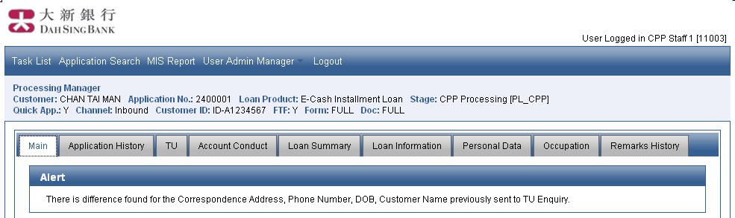
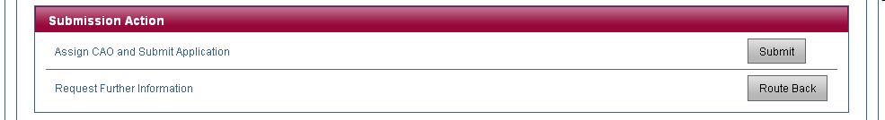
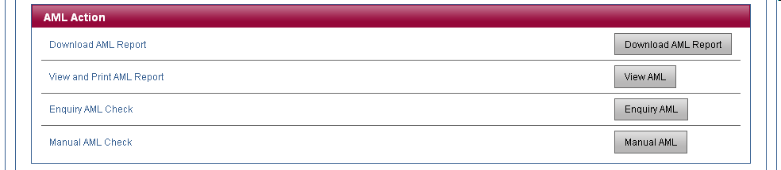
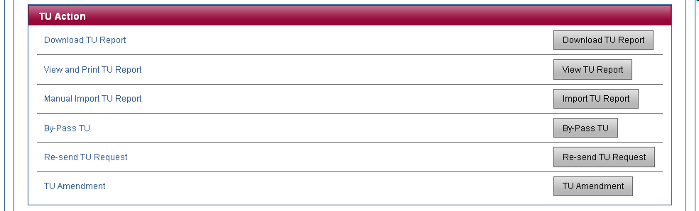
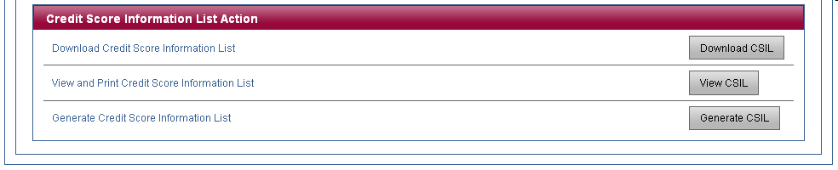

Application History
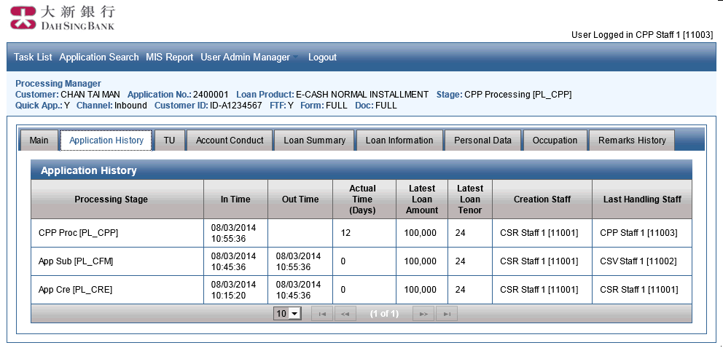

TU
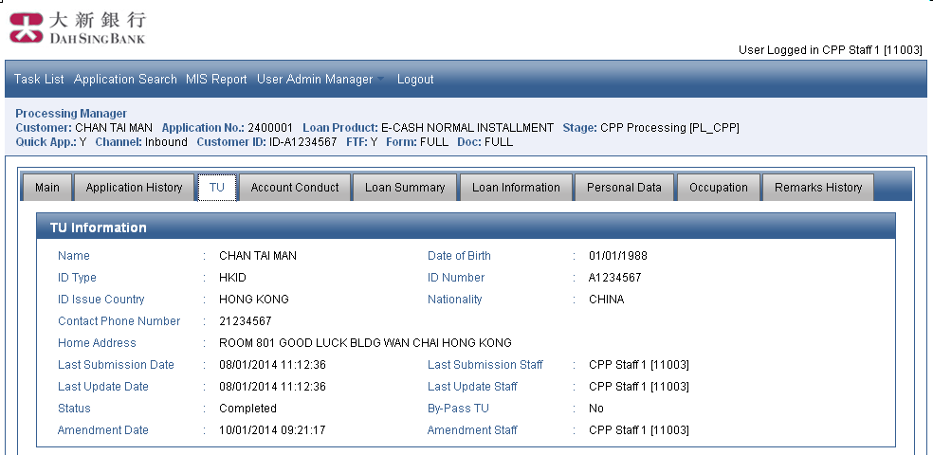
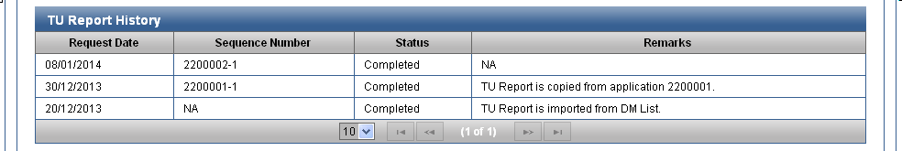
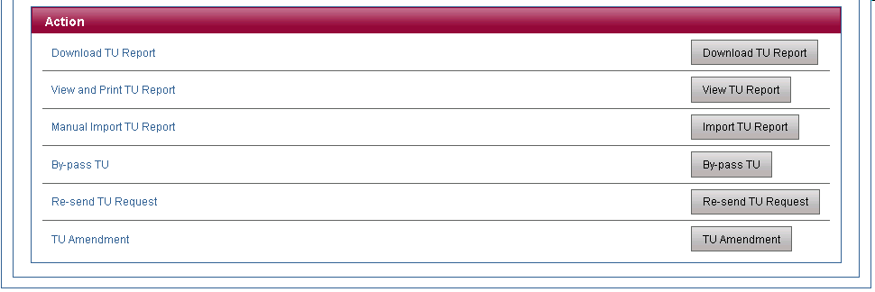

Account Conduct
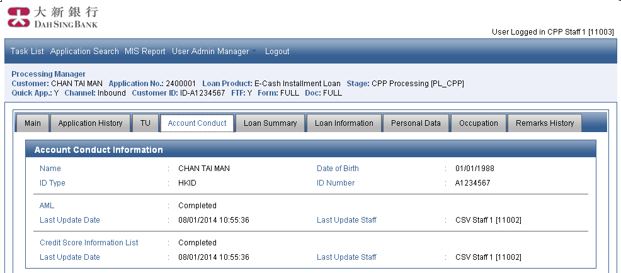
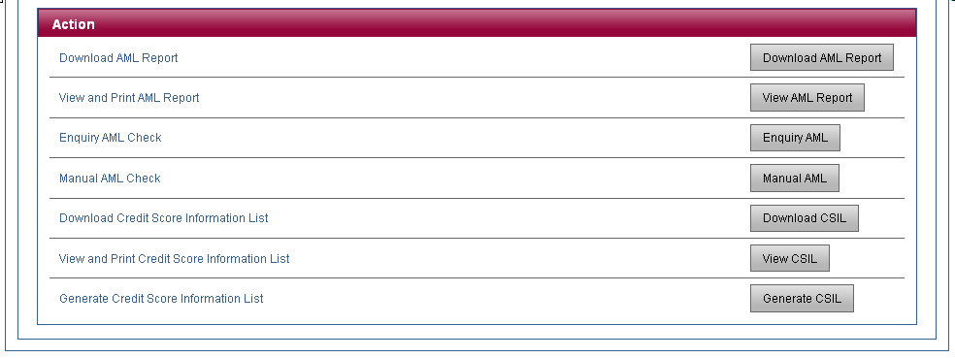

Loan Information
Data are shown in read mode. Please refer to Application Manager’s Loan Information page for details.

Personal Data
Data are shown in read mode. Please refer to Application Manager’s Personal Data page for details.

Remarks History
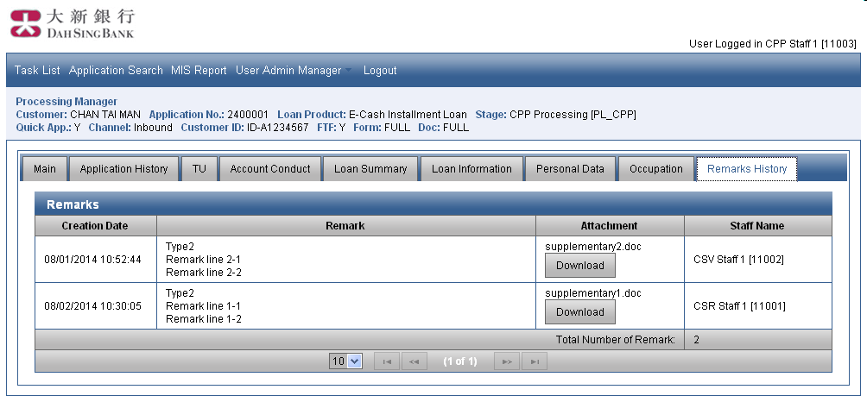

Loan Summary
Data are shown in read mode. Please refer to Application Manager’s Loan Summary page for details.

Occupation
Data are shown in read mode. Please refer to Application Manager’s Occupation page for details.

Fields and Validations

Main
Section: Alert
Screen Label | Type | Data Type | Mandatory | Validation | Possible Value | Source | Remarks
This section is shown if there is difference found for Home Address, Phone Number, DOB, Customer Name previous sent to TU Enquiry.
Phone Number, DOB, Customer Name will be included in the message only if difference is found and Home Address with the amendment reason is Wrong Input.
(Nil) | Text | String | Mandatory | Display Only | N/A | From LOS

Section: Submission Action
Screen Label | Type | Data Type | Mandatory | Validation | Possible Value | Source | Remarks
Submit | Button | N/A | N/A | N/A | N/A | N/A | Assign CAO and Submit Application
Route Back | Button | N/A | N/A | N/A | N/A | N/A | Request Further Information

Section: AML Action
Screen Label | Type | Data Type | Mandatory | Validation | Possible Value | Source | Remarks
Download AML Report | Button | N/A | N/A | N/A | N/A | N/A | Download AML Report
View AML | Button | N/A | N/A | N/A | N/A | N/A | View and Print AML Report
Enquiry AML | Button | N/A | N/A | N/A | N/A | N/A | Enquiry AML Check
Manual AML Check | Button | N/A | N/A | N/A | N/A | N/A | Manual AML Check  Mark AML Enquiry performed manually.

Section: TU Action
Screen Label | Type | Data Type | Mandatory | Validation | Possible Value | Source | Remarks
Download TU Report | Button | N/A | N/A | N/A | N/A | N/A | Download TU Report
View TU Report | Button | N/A | N/A | N/A | N/A | N/A | View and Print TU Report
Import TU Report | Button | N/A | N/A | N/A | N/A | N/A | Manual Import TU Report
By-Pass TU | Button | N/A | N/A | N/A | N/A | N/A | By-Pass TU
Re-send TU Request | Button | N/A | N/A | N/A | N/A | N/A | Re-send TU Request
TU Amendment | Button | N/A | N/A | N/A | N/A | N/A | TU Amendment

Section: Credit Score Information List Action
Screen Label | Type | Data Type | Mandatory | Validation | Possible Value | Source | Remarks
Download CSIL | Button | N/A | N/A | N/A | N/A | N/A | Download Credit Score Information List
View CSIL | Button | N/A | N/A | N/A | N/A | N/A | View and Print Credit Score Information List
Generate CSIL | Button | N/A | N/A | N/A | N/A | N/A | Generate Credit Score Information List

Application History
Section: Application History
Screen Label | Type | Data Type | Mandatory | Validation | Possible Value | Source | Remarks
Multiple rows are shown in this section. The records will be shown in reverse chronological order on In time.
Processing Stage | Text | String | Mandatory | Display Only | N/A | From LOS | It is shown as “Stage Short Name [Owner Role]”.
In Time | Text | Date | Mandatory | Display Only | N/A | From LOS | It is entry date of the processing stage. Date is in dd/MM/yyyy HH:mm:ss.
Out Time | Text | Date | Optional | Display Only | N/A | From LOS | It is completion date of the processing stage. It is blank if the stage is not completed yet. Date is in dd/MM/yyyy HH:mm:ss.
Actual Time (Days) | Text | Number | Mandatory | Display Only | N/A | From LOS | It is day difference between In Time and Out Time. If they are the same day, actual time is 0. It is day difference between In Time and current system date if the stage is not completed yet.
Latest Loan Amount | Text | Number (9) | Mandatory | Display Only | N/A | From LOS | The sequence to lookup the Latest Loan Amount is: Accepted Loan Amount, Approved Loan Amount, Requested Loan Amount.
Latest Loan Tenor | Text | Number (4) | Mandatory | Display Only | N/A | From LOS | The sequence to lookup the Latest Loan Tenor is: Accepted Loan Tenor, Approved Loan Tenor, Requested Loan Tenor.
Creation Staff | Text | String | Mandatory | Display Only | N/A | From LOS | It is name of creation staff. It is shown as “User Name [User ID]”.
Last Handling Staff | Text | String | Mandatory | Display Only | N/A | From LOS | It is name of last handling staff. It is shown as “User Name [User ID]”.  If there is acting, “ (Acting for: User Name [User ID]” will be appended.

TU
Section: TU Information
Screen Label | Type | Data Type | Mandatory | Validation | Possible Value | Source | Remarks
Name | Text | String | Mandatory | Display Only | N/A | From LOS | It is Surname + Space + Other Name.
Date of Birth | Text | Date | Mandatory | Display Only | N/A | From LOS | It is in dd/MM/yyyy
ID Type | Text | String | Mandatory | Display Only | HKID, Passport, China ID | From LOS
ID Number | Text | String | Mandatory | Display Only | N/A | From LOS
ID Issue Country | Text | String | Mandatory | Display Only | Country Code Table | From LOS
Nationality | Text | String | Mandatory | Display Only | Country Code Table | From LOS
Contact Phone Number | Text | Number | Mandatory | Display Only | N/A | From LOS | It is Home Tel in Personal Data page.
Home Address | Text | String | Mandatory | Display Only | N/A | From LOS
Last Submission Date | Text | Date | Optional | Display Only | N/A | From LOS | It is in dd/MM/yyyy hh:MM:ss. It is updated if request is submitted to TU.
Last Submission Staff | Text | Date | Optional | Display Only | N/A | From LOS | It is shown as “User Name [User ID]”. It is updated if request is submitted to TU.
Last Update Date | Text | Date | Optional | Display Only | N/A | From LOS | It is in dd/MM/yyyy hh:MM:ss.
Last Update Staff | Text | Date | Optional | Display Only | N/A | From LOS | It is shown as “User Name [User ID]”.
Status | Text | String | Optional | Display Only | Completed, Manual, Scan Alert, TU Error, Expired | From LOS
By-Pass TU | Text | String | Mandatory | Display Only | Yes, No | From LOS
The following fields are shown if TU Amendment is recorded.
Amendment Date | Text | Date | Optional | Display Only | N/A | From LOS | It is in dd/MM/yyyy hh:MM:ss.
Amendment Staff | Text | Date | Optional | Display Only | N/A | From LOS | It is shown as “User Name [User ID]”.

Section: TU Report History
Screen Label | Type | Data Type | Mandatory | Validation | Possible Value | Source | Remarks
There are multiple records. Each row represents either the following scenarios:
- Import TU Report from DM List
- Copy TU Report from other application
- Request Report from TU
When a row is clicked, the corresponding TU report will be downloaded. By default, records are sorted by Request Date in descending order. Each record has the following fields:
Request Date | Text | Date | Mandatory | Display Only | N/A | From LOS | It is in dd/MM/yyyy
Sequence Number | Text | String | Mandatory | Display Only | N/A | From LOS | It is user reference in TUEF request.
Status | Text | String | Mandatory | Display Only | Completed, Manual, Scan Alert, TU Error, Expired | From LOS
Remarks | Text | String | Mandatory | Display Only | N/A | From LOS | If TU Report is from DM List, it is shown as “TU Report is imported from DM List.”  If TU Report is copied from other application, it is shown as “TU Report is copied from application <Source Application Number>.”  Otherwise, it is “NA”.

Section: Action
Screen Label | Type | Data Type | Mandatory | Validation | Possible Value | Source | Remarks
Download TU Report | Button | N/A | N/A | N/A | N/A | N/A | Download TU Report
View TU Report | Button | N/A | N/A | N/A | N/A | N/A | View and Print TU Report
Import TU Report | Button | N/A | N/A | N/A | N/A | N/A | Manual Import TU Report
By-Pass TU | Button | N/A | N/A | N/A | N/A | N/A | By-Pass TU
Re-send TU Request | Button | N/A | N/A | N/A | N/A | N/A | Re-send TU Request
TU Amendment | Button | N/A | N/A | N/A | N/A | N/A | TU Amendment

Account Conduct
Section: Account Conduct Information
Screen Label | Type | Data Type | Mandatory | Validation | Possible Value | Source | Remarks
Name | Text | String | Mandatory | Display Only | N/A | From LOS | It is Surname + Space + Other Name.
Date of Birth | Text | Date | Mandatory | Display Only | N/A | From LOS | It is in dd/MM/yyyy
ID Type | Text | String | Mandatory | Display Only | HKID, Passport, China ID | From LOS
ID Number | Text | String | Mandatory | Display Only | N/A | From LOS
AML | Text | String | Mandatory | Display Only | Completed, Missing, Manual | From LOS | If performed manual AML check, it is “Manual”.  If AML Check Result is present, it is “Completed”.  Otherwise it is “Missing”.
Last Update Date | Text | Date | Optional | Display Only | N/A | From LOS | Last Updated Date for AML Check Result.  Empty if AML is Missing.  It is in dd/MM/yyyy hh:MM:ss
Last Update Staff | Text | String | Optional | Display Only | N/A | From LOS | Last Update Staff of AML Check Result.  Empty if AML is Missing.  It is shown as “User Name [User ID]”.
Credit Score Information List | Text | String | Mandatory | Display Only | Completed, Missing | From LOS | “Completed” if Credit Score Information List is present.  Otherwise, “Missing”.
Last Update Date | Text | Date | Optional | Display Only | N/A | From LOS | Last Updated Date for Credit Score Information List.  Empty if Credit Score Information List is Missing.  It is in dd/MM/yyyy hh:MM:ss
Last Update Staff | Text | String | Optional | Display Only | N/A | From LOS | Last Update Staff of Credit Information List.  Empty if Credit Score Information List is Missing.  It is shown as “User Name [User ID]”.

Section: Action
Screen Label | Type | Data Type | Mandatory | Validation | Possible Value | Source | Remarks
Download AML Report | Button | N/A | N/A | N/A | N/A | N/A | Download AML Report
View AML Report | Button | N/A | N/A | N/A | N/A | N/A | View and Print AML Report
Enquiry AML | Button | N/A | N/A | N/A | N/A | N/A | Enquiry AML Check
Manual AML | Button | N/A | N/A | N/A | N/A | N/A | Manual AML Check  Mark AML Enquiry performed manually.
Download CSIL | Button | N/A | N/A | N/A | N/A | N/A | Download Credit Score Information List
View CSIL | Button | N/A | N/A | N/A | N/A | N/A | View and Print Credit Score Information List
Generate CSIL | Button | N/A | N/A | N/A | N/A | N/A | Generate Credit Score Information List

Loan Information
Data are shown in read mode. Please refer to Application Manager’s Loan Information page for details.

Personal Data
Data are shown in read mode. Please refer to Application Manager’s Personal Data page for details.

Remarks History
Section: Remarks
Screen Label | Type | Data Type | Mandatory | Validation | Possible Value | Source | Remarks
Multiple rows are shown. Maximum 50 rows will be shown on one page. By default, records are sorted by Creation Date in descending order. Each row has the following fields:
Creation Date | Text | Date | Mandatory | Display Only | N/A | From LOS | Date is in dd/MM/yyyy HH:mm:ss.
Remark | Text | String | Mandatory | Display Only | N/A | From LOS
Attachment | Text | String | Optional | Display Only | N/A | From LOS | Filename of attachment
Attachment | Button | N/A | N/A | N/A | N/A | N/A | Click to download the attachment.  It is shown if attachment is available. Otherwise, it is hidden.
Staff Name | Text | String | Mandatory | Display Only | N/A | From LOS | It is shown as “User Name [User ID]”.  If there is acting, “ (Acting for: User Name [User ID]” will be appended.
Total Number of Remark | Text | Number | Mandatory | Display Only | N/A | From LOS | Number of remark available. It is 0 if no remark is available.

Loan Summary
Data are shown in read mode. Please refer to Application Manager’s Loan Summary page for details.

Occupation
Data are shown in read mode. Please refer to Application Manager’s Occupation page for details.

Underwriting Manager

Description
This module provides features to approve or reject the loan. User can consolidate credit information of customer, calculate indices for approval decision and generate credit proposal.
To access features provided by Underwriting Manager, user can pick up application from Task List. Menu will be changed to include Underwriting Manager. If Underwriting Manager is not the default module, user can click it from menu. Main page will be shown with action buttons.
Mortgage Loan Application Warning will be shown if Underwriting Manager is the default module when user pick up application from Task List or user select Underwriting Manager from menu.

Features

View Credit Assessment Information
This function allows user to view Credit Assessment information. User can select Underwriting Manager from menu and click Credit Assessment page. Before showing the page, system will refresh the data if all the following criteria are met:
- Application is picked up from Task List.
- Application stage is RCD Proposal Preparation stage.
Also, Action section will show the following buttons for making approval decision.
Underwriting Manager |  |  |  |  |  | (Edit)
Main | Credit Assessment | Rule Checking | Pending Document
Customer Information
TU Credit Information
DSR Calculation
Total Exposure
Other Information
Loan Information
Action
Request for Pending Document |  |  |  |  | (Pending)
Approve Application |  |  |  |  | (Approve)
Offer Other Loan |  |  |  |  | (Offer Other Loan)
Reject Application |  |  |  |  | (Reject)

Edit Credit Assessment Information
This function allows user to edit Credit Assessment information. In Underwriting Manager’s Credit Assessment page, user can click Edit button in upper right corner. The following sections will change to edit mode:
- Customer Information
- TU Credit Information
- DSR Calculation
- Asset Proof Approach (if DSR Calculation is No)
- Total Exposure
- Other Information
After editing, user can click Save button. System will
- Refresh the page according to newly inputted data
- Store the data in database
- Show page in read mode
Alternatively, user can discard the change by clicking “Cancel Save” button. Original data will be restored and page will be shown in read mode.

Credit Assessment Checklist Template
For Normal PL
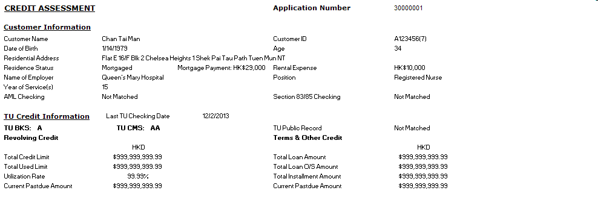
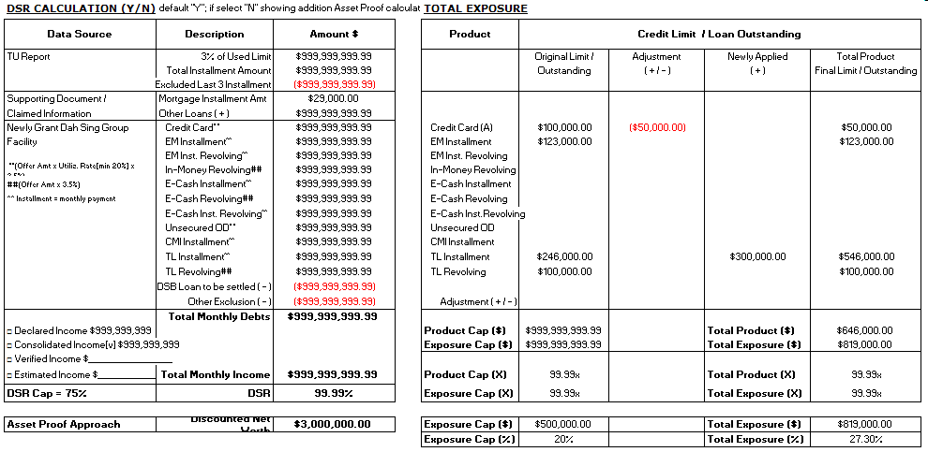
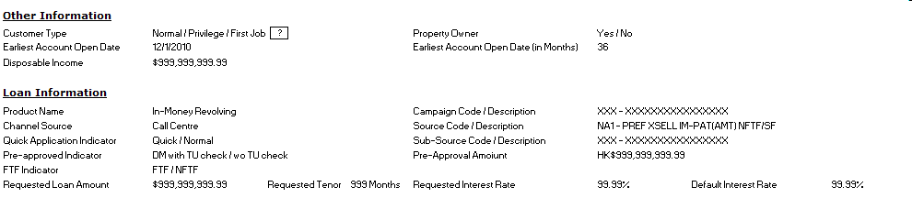
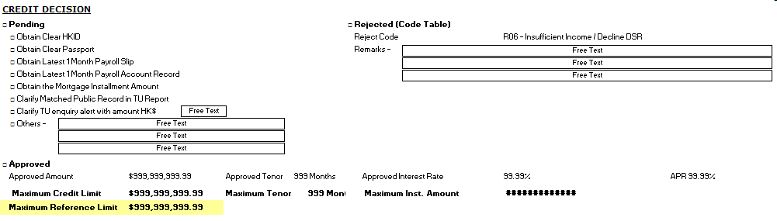
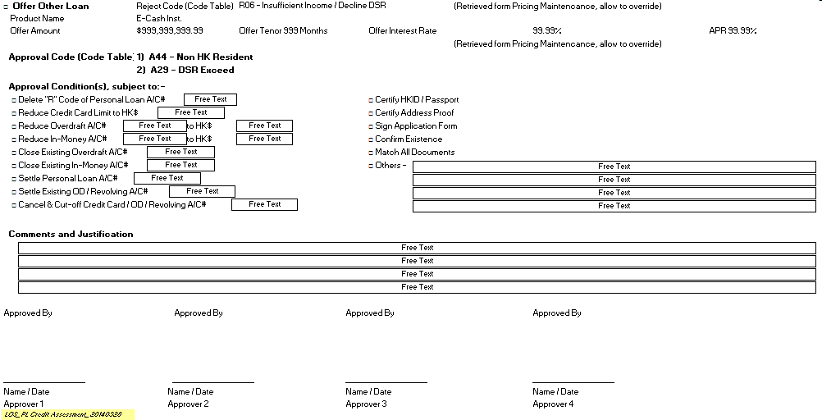

Remark:
  - Pending, Rejected, Approved and Offer Other Loan in Credit Decision Section will be shown in Credit Assessment Checklist according to the latest credit decision.
- Approval Code, Approval Condition(s), Comments and Justification, Approvers will be shown in Credit Assessment Checklist if the latest credit decision is Approved or Offer Other Loan.

For MP / VP Application
The basic template is the same as Normal PL Template with below changes:
    - Add Debt Consolidation Plan and Settlement Information

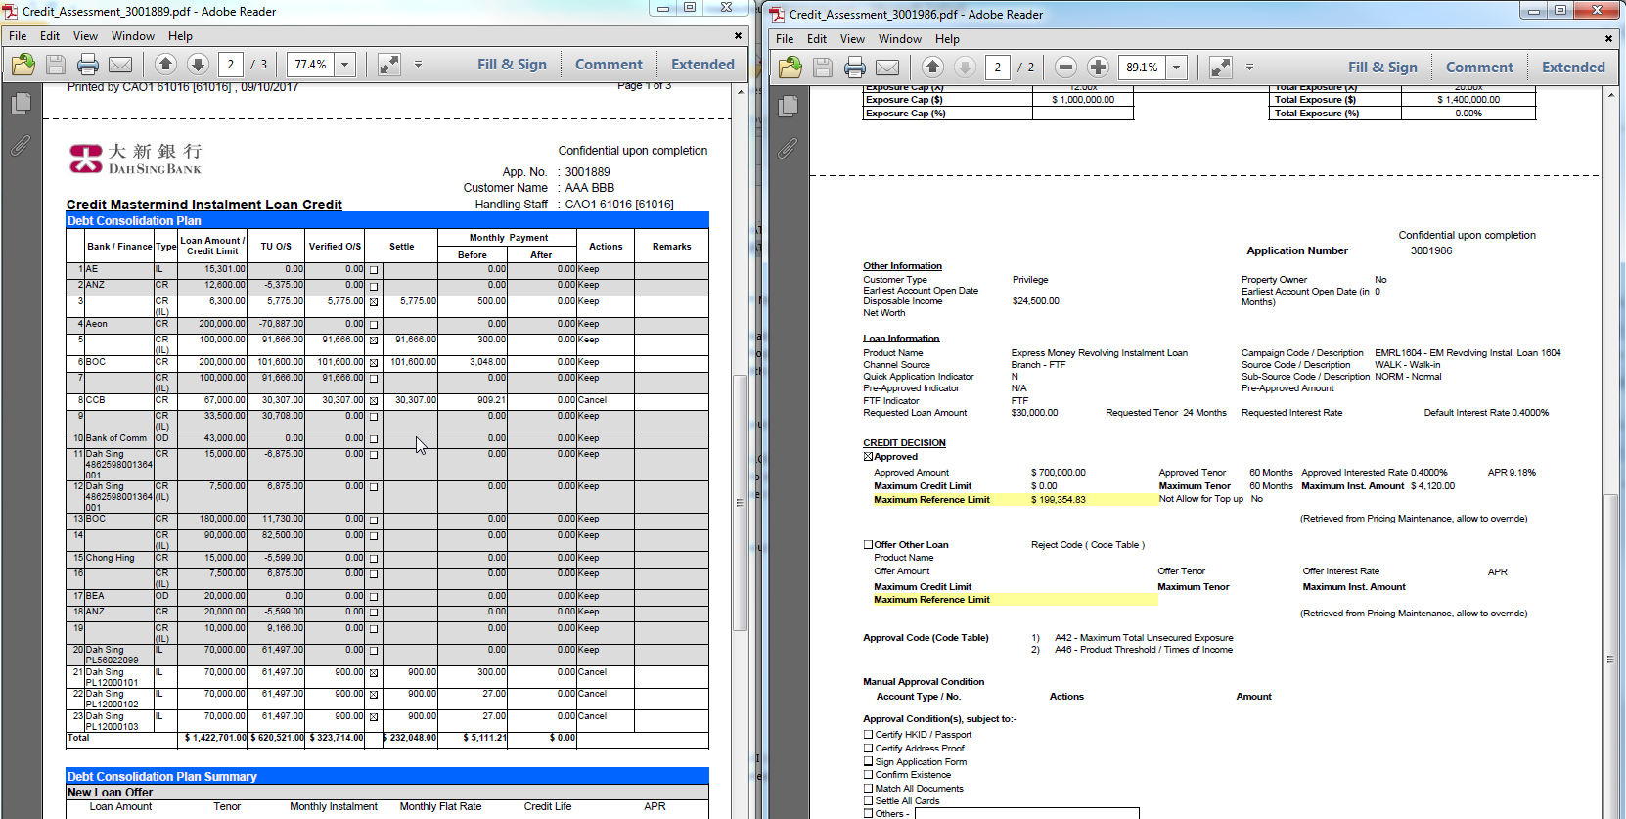

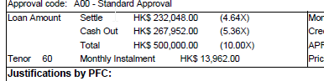
    - Remove the “Reject” Section

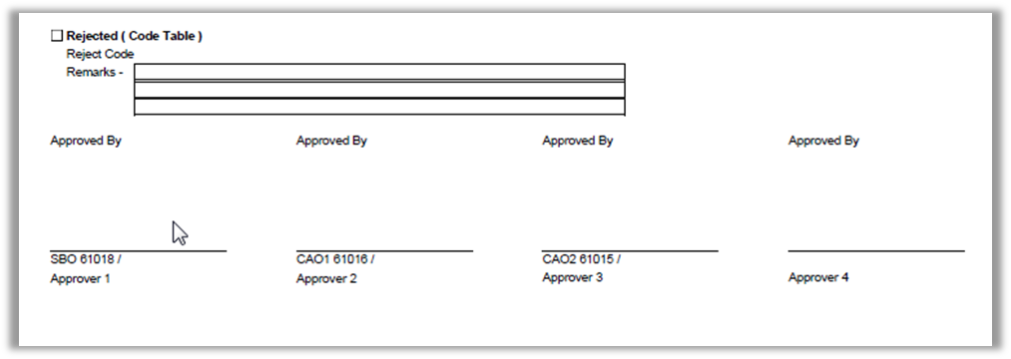

Credit Assessment Checklist Field Mapping

Application Number
It is unique number generated by the system for the application.

Customer Name
It is Surname + Space + Other Name inputted in Application Form’s Personal Data page.

Customer ID
Customer ID is formatted base on ID Type as follows:
ID Type | Customer ID
HKID | It is ID Number with check digit enclosed by bracket. E.g. A123456(7)
Passport | It is ID Number.
China ID | It is ID Number.

Date of Birth
It is Date of Birth inputted in Application Form’s Personal Data page.

Age
It is Adjusted Age if value is inputted by CAO. Otherwise, it is system calculated age. System Calculated Age = Year of Credit Assessment Data Refresh Date – Year of Date of Birth.

Residential Address
It is Home Address inputted in Application Form’s Personal Data page.

Residence Status
It is Residence inputted in Application Form’s Personal Data page.

Mortgage Payment
It is Adjusted Mortgage Payment if value is inputted by CAO. Otherwise, it is Mortgage Payment inputted in Application Form’s Personal Data page.

Rental Expense
It is Adjusted Rent Expense if value is inputted by CAO. Otherwise, it is Rent inputted in Application Form's Personal Data page.

Name of Employer
It is Employer Name inputted in Application Form’s Occupation page.

Position
It is Occupation inputted in Application Form’s Personal Data page.

Year of Service(s)
It is (Y * 12 + M) / 12. Result is round down to integer.
Y is year part of “Years of Service” inputted in Application Form’s Personal Data page.
M is month part of “Years of Service” inputted in Application Form’s Personal Data page.

AML Checking
It is AML Checking inputted in Underwriting Manager.

Section 83/85 Checking
It is Section 83/85 Checking inputted in Underwriting Manager.

Last TU Checking Date
It is TU Submission Date if the latest TU Report is retrieved from TU directly.
It is “98 HOST_RESULT_DATE” from TU Deblocking result if the latest TU report is uploaded manually.
It is the TU report date from DM List if the latest TU report is imported from DM List.
It is the Last TU Checking Date of source application if the latest TU report is copied from other application.

TU BKS
It is TUEF result’s Score Segment (SC)’s Grade (03) if Score Type (01) = BK01 or BK02.
For TU Deblocking result, it is 04 BKS_STRING’s BKS Grade.

TU CMS
It is TUEF result’s Score Segment (SC)’s Grade (03) if Score Type (01) = CM01 or CM02.
For TU Deblocking result, it is 03 CMS_STRING’s CMS Grade.

TU Public Record
It is TU Public Record inputted in Underwriting Manager.

Revolving Credit – Total Credit Limit
It is TUEF result’s Credit Exposure Segment (EX)’s Sum of Total Credit Limit (03) if I/C (14) = I and Currency Code (05) = HKD / CNY / USD. Total Credit Limit (03) is converted to HKD before addition.
For TU Deblocking result, it is 05 EXPOSURE_HKD_STRING’s Revolving Credits Total Credit Limit + 06 EXPOSURE_USD_STRING’s Revolving Credits Total Credit Limit * USD Exchange Rate + 07 EXPOSURE_RMB_STRING’s Revolving Credits Total Credit Limit * CNY Exchange Rate.

Revolving Credit – Total Used Limit
It is TUEF result’s Credit Exposure Segment (EX)’s Sum of Total Used Credit Limit (06) if I/C (14) = 1 and Currency Code (05) = HKD / CNY / USD. Total Used Credit Limit (06) is converted to HKD before addition.
For TU Deblocking result, it is 05 EXPOSURE_HKD_STRING’s Revolving Credits Used Credit Limit + 06 EXPOSURE_USD_STRING’s Revolving Credits Used Credit Limit * USD Exchange Rate + 07 EXPOSURE_RMB_STRING’s Revolving Credits Used Credit Limit * CNY Exchange Rate.

Revolving Credit – Utilization Rate
It is Revolving Credit’s Total Used Limit / Revolving Credit’s Total Credit Limit * 100%. Result is rounded to 2 decimal places.

Revolving Credit – Current Pastdue Amount
It is TUEF result’s Credit Exposure Segment (EX)’s Sum of Total Past Due Amount (08) if I/C (14) = I and Currency Code (05) = HKD / CNY / USD. Total Past Due Amount (08) is converted to HKD before addition.
For TU Deblocking result, it is 05 EXPOSURE_HKD_STRING’s Revolving Credits Past Due Amount + 06 EXPOSURE_USD_STRING’s Revolving Credits Past Due Amount * USD Exchange Rate + 07 EXPOSURE_RMB_STRING’s Revolving Credits Past Due Amount * CNY Exchange Rate.

Terms & Other Credit – Total Loan Amount
It is TUEF result’s Credit Exposure Segment (EX)’s Sum of Total Loan Amount (11) if I/C (14) = I and Currency Code (05) = HKD / CNY / USD. Total Loan Amount (11) is converted to HKD before addition.
For TU Deblocking result, it is 05 EXPOSURE_HKD_STRING’s Terms & Other Credits Loan Amount + 06 EXPOSURE_USD_STRING’s Terms & Other Credits Loan Amount * USD Exchange Rate + 07 EXPOSURE_RMB_STRING’s Terms & Other Credits Loan Amount * CNY Exchange Rate.

Terms & Other Credit – Total Loan O/S Amount
It is TUEF result’s Credit Exposure Segment (EX)’s Sum of Total Outstanding Balance (12) if I/C (14) = I and Currency Code (05) = HKD / CNY / USD. Total Outstanding Balance (12) is converted to HKD before addition.
For TU Deblocking result, it is 05 EXPOSURE_HKD_STRING’s Terms & Other Credits O/S Balance + 06 EXPOSURE_USD_STRING’s Terms & Other Credits O/S Balance * USD Exchange Rate + 07 EXPOSURE_RMB_STRING’s Terms & Other Credits O/S Balance * CNY Exchange Rate.

Terms & Other Credit – Total Installment Amount
A = TUEF result’s Credit Exposure Segment (EX)’s Sum of Total Installment Amount (02) if I/C (14) = I and Currency Code (05) = HKD / CNY / USD. Total Installment Amount (02) is converted to HKD before addition.
B = TUEF result’s Account Segment (AC)’s Sum of Installment Amount (15) if
- I/C (41) = I
- and Currency Code (07) = HKD / CNY / USD
- and Account Type (05) begin with 1 (except 1400 and 1600), 2 (except 28XX), 3 & 6
- and Account Status (04) not equal W & C & BW
- and Outstanding Balance (16) / Installment Amount (15) <= [Remaining month for installment reduction]
Terms & Other Credit’s Total Installment Amount = A – B. Minimum value is 0.
Remaining month for installment reduction is a system parameter maintained by IT and the default value is 3.

For TU Deblocking result,
A = 05 EXPOSURE_HKD_STRING’s Terms & Other Credits Ins Amount + 06 EXPOSURE_USD_STRING’s Terms & Other Credits Ins Amount * USD Exchange Rate + 07 EXPOSURE_RMB_STRING’s Terms & Other Credits Ins Amount * CNY Exchange Rate
B = 14 LAST3_HKD_STRING + 15 LAST3_USD_STRING * USD Exchange Rate + 16 LAST3_RMB_STRING * CNY Exchange Rate
Terms & Other Credit’s Total Installment Amount = A – B. Minimum value is 0.

Terms & Other Credit – Current Pastdue Amount
It is TUEF result’s Credit Exposure Segment (EX)’s Sum of Total Past Due Amount (13) if I/C (14) = I and Currency Code (05) = HKD / CNY / USD. Total Past Due Amount (13) is converted to HKD before addition.
For TU Deblocking result, it is 05 EXPOSURE_HKD_STRING’s Terms & Other Credits Past Due Amount + 06 EXPOSURE_USD_STRING’s Terms & Other Credits Past Due Amount * USD Exchange Rate + 07 EXPOSURE_RMB_STRING’s Terms & Other Credits Past Due Amount * CNY Exchange Rate.

DSR Calculation – TU Report – 3% of Used Limit
It is Revolving Credit’s Total Used Limit * 3%. Result is rounded to 2 decimal places. 3% is system parameter.

DSR Calculation – TU Report – Total Installment Amount
It is TUEF result’s Credit Exposure Segment (EX)’s Sum of Total Installment Amount (02) if I/C (14) = I and Currency Code (05) = HKD / CNY / USD. Total Installment Amount (02) is converted to HKD before addition.
For TU Deblocking result, it is 05 EXPOSURE_HKD_STRING’s Terms & Other Credits Ins Amount + 06 EXPOSURE_USD_STRING’s Terms & Other Credits Ins Amount * USD Exchange Rate + 07 EXPOSURE_RMB_STRING’s Terms & Other Credits Ins Amount * CNY Exchange Rate.

DSR Calculation – TU Report – Excluded Last 3 Installment
B = TUEF result’s Account Segment (AC)’s Sum of Installment Amount (15) if
- I/C (41) = I
- and Currency Code (07) = HKD / CNY / USD
- and Account Type (05) begin with 1 (except 1400 and 1600), 2 (except 28XX), 3 & 6
- and Account Status (04) not equal W & C & BW
- and Outstanding Balance (16) / Installment Amount (15) <= [Remaining month for installment reduction]
Remaining month for installment reduction is a system parameter maintained by IT and the default value is 3.
For TU Deblocking result,
B = 14 LAST3_HKD_STRING + 15 LAST3_USD_STRING * USD Exchange Rate + 16 LAST3_RMB_STRING * CNY Exchange Rate
Excluded Last 3 Installment is B if Total Installment Amount > B. Otherwise, it is 0.

DSR Calculation – Supporting Document – Mortgage Installment Amt
Please refer to section 5.9.2.4.8 Mortgage Payment.

DSR Calculation – Supporting Document – Other Loan ( + )
It is “Other Loan ( + )” inputted in Underwriting Manager.

DSR Calculation – Newly Grant Dah Sing Group Facility
Revolving Credit Utilization Rate = Revolving Credit’s Total Used Limit / Revolving Credit’s Total Credit Limit * 100%, capped at 100%. If Revolving Credit’s Total Credit Limit = 0, system will treat Revolving Credit Utilization Rate as 0%.

Credit Card
It is “Newly Applied (+)” of Credit Card in Total Exposure * Utilization Rate * [3.5%].
Utilization Rate is higher of
- [20%]
- Revolving Credit Utilization Rate
[3.5%] and [20%] are system parameter.

Final Loan Amount is defined as requested amount (for not yet approved), approved amount (for approved), accepted amount (for accepted), and disbursed amount (for disbursed).

EXPRESS MONEY NORMAL INSTALLMENT
Please refer to Personal Installment Loan with Selecting Product = EM Installment.

EXPRESS MONEY REVOLVING INSTALLMENT
It is sum of Maximum Installment Amount in LOS if
- Application’s Product is EM Revolving Installment
- Application’s Customer ID is same as current customer
- Application is not in Closed - Cancelled, Closed - Rejected, Closed - Transferred stage,
- Application Nature is Normal or Top Up (Revolving IL Top Up done via Section 6 – Revolving IL Top Up Loan is excluded),
- Application is disbursed on Current System Date during data refresh or application is not in Closed - Disbursed and Pending Close stage.
- For Accepted Application, LOS will consider the Accepted Monthly Instalment instead of Max. Credit Approved Monthly Instalment
- LOS will apply the consideration logic TU report date in order to make decision that the application has been contributed to TU or not in order to extract the value from LOS for DSR Calculation. The logic is going to align with builded logic in Card Loan and Revolving IL Top up

IN-MONEY REVOLVING
It is sum of Final Loan Amount in LOS * Utilization Rate * [3.5%] if
- Application’s Product is In-Money Revolving
- Application’s Customer ID is same as current customer
- Application is not in Closed - Cancelled, Closed - Rejected, Closed - Transferred stage,
- Application Nature is Normal (Top up is not applicable to revolving loan),
- Application is disbursed on Current System Date during data refresh or application is not in Closed - Disbursed and Pending Close stage.
Utilization Rate is higher of
- [100%]
- Revolving Credit Utilization Rate
[3.5%] and [100%] are system parameter.

E-CASH NORMAL INSTALLMENT
Please refer to Personal Installment Loan with Selecting Product = E-Cash Installment.

E-CASH REVOLVING INSTALLMENT
It is sum of Maximum Installment Amount in LOS if
- Application’s Product is E-Cash Revolving Installment
- Application’s Customer ID is same as current customer
- Application is not in Closed - Cancelled, Closed - Rejected, Closed - Transferred stage,
- Application Nature is Normal or Top Up (Revolving IL Top Up done via Section 6 – Revolving IL Top Up Loan is excluded),
- Application is disbursed on Current System Date during data refresh or application is not in Closed - Disbursed and Pending Close stage.
- For Accepted Application, LOS will consider the Accepted Monthly Instalment instead of Max. Credit Approved Monthly Instalment
- LOS will apply the consideration logic TU report date in order to make decision that the application has been contributed to TU or not in order to extract the value from LOS for DSR Calculation. The logic is going to align with builded logic in Card Loan and Revolving IL Top up

E-CASH REVOLVING
It is sum of Final Loan Amount in LOS * Utilization Rate * [3.5%] if
- Application’s Product is E-Cash Revolving
- Application’s Customer ID is same as current customer
- Application is not in Closed - Cancelled, Closed - Rejected, Closed - Transferred stage,
- Application Nature is Normal (Top up is not applicable to revolving loan),
- Application is disbursed on Current System Date during data refresh or application is not in Closed - Disbursed and Pending Close stage.
Utilization Rate is higher of
- [100%]
- Revolving Credit Utilization Rate
[3.5%] and [100%] are system parameter.

FLEXIMONEY
It is sum of Final Loan Amount in LOS * Utilization Rate * [3.5%] if
- Application’s Product Nature is OD
- Application’s Customer ID is same as current customer
- Application is not in Closed - Cancelled, Closed - Rejected, Closed - Transferred stage,
- Application Nature is Normal (Top up is not applicable to overdraft),
- Application is disbursed on Current System Date during data refresh or application is not in Closed - Disbursed and Pending Close stage.
Utilization Rate is higher of
- [20%]
- Revolving Credit Utilization Rate
[3.5%] and [20%] are system parameter.

CREDIT MASTERMIND
Please refer to Personal Installment Loan with Selecting Product = Credit Mastermind.

TAX LOAN
Please refer to Personal Installment Loan with Selecting Product = TL Installment.

Personal Installment Loan
It is sum of Installment Amount based on Final Loan Amount and higher of Offer, Requested and Default Interest Rate in LOS if
- Application’s Product is the selecting product
- Application’s Customer ID is same as current customer
- Application is not in Closed - Cancelled, Closed - Rejected, Closed - Transferred stage,
- Application Nature is Normal or Top Up (Revolving IL Top Up done via Section 6 – Revolving IL Top Up Loan is excluded),
- Application is disbursed on Current System Date during data refresh or application is not in Closed - Disbursed and Pending Close stage.

DSB Loan to be settled ( - )
System will call IBS Service Customer Portfolio for Loan Creation (0352006) to get customer portfolio from HOST. If AcctDetails with AcctType equal to PL and PLAccNo equal to Settlement Account from DM List if any. It is installment amount in the matching AcctDetails.

DSR Calculation – Newly Grant Dah Sing Group Facility – Other Exclusion ( - )
It is “Other Exclusion ( - )” inputted in Underwriting Manager.

DSR Calculation – Newly Grant Dah Sing Group Facility – Total Monthly Debts
It is
“TU Report – 3% of Used Limit”
+ “TU Report – Total Installment Amount”
- “TU Report – Excluded Last 3 Installment”
- “(DSB Account (5710) -> 3% of Used Limit)”
+ (DSB Account (5710) -> Total Instalment Amount)
+ “Supporting Document – Mortgage Installment Amt”
+ “Supporting Document – Other Loans”
+ Sum of Amount in Newly Grant Dah Sing Group Facility (except DSB Loan to be settled and Other Exclusion)
- “DSB Loan to be settled”
- “Other Exclusion”

DSR Calculation – Declared Income
It is Basic Mth Income + Housing Allowance + Other Income inputted in Application Form’s Occupation page.
It is selected if Declared Income is selected in Underwriting Manager.

DSR Calculation – Consolidated Income
It is Income Type and Consolidated Income from DM List.
It is selected if Consolidated Income is selected in Underwriting Manager.

DSR Calculation – Verified Income
It is Verified Income inputted in Underwriting Manager.
It is selected if Verified Income is selected in Underwriting Manager.

DSR Calculation – Estimated Income
It is Estimated Income inputted in Underwriting Manager.
It is selected if Estimated Income is selected in Underwriting Manager.

DSR Calculation – Total Monthly Income
It is selected income, either one of Declared Income, Consolidated Income, Verified Income, Estimated Income, Tu Proxy Income or Verified Income in CRM must be selected.

“NOT” Display Condition for “TU Proxy Income” for Selection:
If Income Proof Indicator = “WAIVE” and CRM Verified Income Date + [47] > = Application Creation Date

DSR Calculation – DSR Cap
It is DSR Cap determined in Policy Rule 11 DSR Exceed.

DSR Calculation – DSR
It is Total Monthly Debts / Total Monthly Income * 100%. Result is rounded to 2 decimal places.

Total Exposure – Original Limit / Outstanding
Credit Card [A / V ]
It is higher of
- Credit Line of Valid Principal Credit Card on Customer Level
- Virtual Credit Limit

Credit Line of Valid Principal Credit Card on Customer Level is
For each record with EMBOSSER-NAME-4 equaled to Customer ID in CardHolder Offline authorization Download File
If CUST-NMBER starts with 0
AND 14th digit of CARD_NMBR is 0
AND CM-STATUS is 0, 1 or 2
AND (EXPIRY-DATE-YY > current system year OR (EXPIRY-DATE-YY = current system year AND EXPIRY-DATE-MM >= current system month))
AND ((ORG = 001 AND TYPE is not in list (589,594,390,391,206,207,208,209,276,277,278))
OR (ORG = 003 AND TYPE = 801 or 901)
OR (ORG = 005)
OR (ORG = 006 AND TYPE = 101 or 301)
OR (ORG = 501 AND TYPE is not in list (517,520,990,991,992)))
AND ((BLOCK-CODE is in list (“ “, B,C,D,G,H,J,M,R,P,W,V))
OR (BLOCK-CODE = L
AND ((ALT-BLOCK-CODE <> E AND current system date – DET-BLOCK-CODE <= 30 days)
OR (ALT-CLOCK-CODE = E AND current system date – DET-ALT-BLOCK-CODE <= 60days)))
OR (BLOCK-CODE = N
AND (ALT-BLOCK-CODE <> E
OR ALT-BLOCK-CODE = E AND current system date – DET-ALT-BLOCK-CODE <= 60days)))
OR (BLOCK-CODE = S
AND (ALT-BLOCK-CODE <> E AND current system date – DET-BLOCK-CODE <= 30 days)
OR (ALT-CLOCK-CODE = E AND current system date – DET-ALT-BLOCK-CODE <= 60days)))
OR (BLOCK-CODE = E AND current system date – DET-BLOCK-CODE <= 60days)
OR (BLOCK-CODE = U
AND (ALT-BLOCK-CODE <> E
OR ALT-BLOCK-CODE = E AND current system date – DET-ALT-BLOCK-CODE <= 60days))))
Then
Add CRLIMIT to this item

* CUST-NMBER is used for duplication check.
* It is Principal Card if 14th digit of CARD_NMBR is 0.

Virtual Credit Limit is:
Highest value of Original Credit Line and New Credit Line among records in Virtual Credit Limit File where
- Customer ID in the file = Current Customer ID with ID Type prefix.
- And Expiate Date in the file < Current System Date during data refresh.

“Credit Card (V)” is displayed if record met all the following criteria is found in Virtual Credit Limit File
- Customer ID in the file = Current Customer ID with ID Type prefix.
- Expiate Date in the file < Current System Date during data refresh.

Otherwise, “Credit Card (A)” is displayed.

EXPRESS MONEY NORMAL INSTALLMENT
Please refer to Personal Loan with Selecting Product = EXPRESS MONEY NORMAL INSTALLMENT.

EXPRESS MONEY REVOLVING INSTALLMENT
Please refer to Personal Loan with Selecting Product = EXPRESS MONEY REVOLVING INSTALLMENT.

IN-MONEY REVOLVING
It is Credit Line of “Valid Cash Card & You Buy Cash – Cash Card” of In-Money Revolving.
Credit Line of “Valid Cash Card & You Buy Cash – Cash Card” is
For each record with EMBOSSER-NAME-4 equaled to Customer ID in CardHolder Offline authorization Download File
If CUST-NMBER starts with 7
AND CM-STATUS is 0, 1 or 2
AND BLOCK-CODE is not in list (A,E,F,K,O,Q)
AND (EXPIRY-DATE-YY > current system year OR (EXPIRY-DATE-YY = current system year AND EXPIRY-DATE-MM >= current system month))
AND (ORG = 101 AND TYPE is 020, 021, 022, 030, 031, 032, 023, 024, 033, 034, 036, 060, 061, 070, 071, 072, 080, 039 OR
ORG = 101 AND TYPE is 018, 028)
Then
Add CRLIMIT to this item

* CUST-NMBER is used for duplication check.

E-CASH NORMAL INSTALLMENT
Please refer to Personal Loan with Selecting Product = E-CASH NORMAL INSTALLMENT.

E-CASH REVOLVING INSTALLMENT
Please refer to Personal Loan with Selecting Product = E-CASH REVOLVING INSTALLMENT.

E-CASH REVOLVING
It is Credit Line of “Valid Cash Card & You Buy Cash – Cash Card” of E-Cash Revolving.
Credit Line of “Valid Cash Card & You Buy Cash – Cash Card” is
For each record with EMBOSSER-NAME-4 equaled to Customer ID in CardHolder Offline authorization Download File
If CUST-NMBER starts with 7
AND CM-STATUS is 0, 1 or 2
AND BLOCK-CODE is not in list (A,E,F,K,O,Q)
AND (EXPIRY-DATE-YY > current system year OR (EXPIRY-DATE-YY = current system year AND EXPIRY-DATE-MM >= current system month))
AND (ORG = 001 AND TYPE is 099 OR
ORG = 101 AND TYPE is 099, 040, 050, 090, 091, 041)
Then
Add CRLIMIT to this item

* CUST-NMBER is used for duplication check.

FLEXIMONEY
Please refer to Unsecured Overdraft with Selecting Product = FLEXIMONEY.

CREDIT MASTERMIND
Please refer to Personal Loan with Selecting Product = CREDIT MASTERMIND.

TAX LOAN
Please refer to Personal Loan with Selecting Product = TAX LOAN

TAX REVOLVING LOAN
Please refer to Unsecured Overdraft with Selecting Product = TAX LOAN.

Personal Loan
It is exposure of Existing P-loan Product excluding loan type 06/26/36.

Existing P-loan Product excluding loan type 06/26/36 is (after Core Banking phase 2, should exclude various Product Codes, and details below TBC)
For each AcctDetails tag with AcctType = “PL” in Customer Portfolio Enquiry result,
Refer to PersonalLoanAcctInfor tag under AcctDetails,
If PLLoanType is not in the list (06,26,36)
Then
If PLAcctStatus = “<space>”
AND HoldCode <> “R”
AND RevolvingLimit = 0 or empty
Then
Add OutstandingBal to exposure of Product according to lookup table
Else if PLAcctStatus = “<space>”, “FP” or “ES”
AND RevolvingLimit > 0
Then
If OutstandingBal > 0
AND (Current System Date > RevolvingLimitExpiryDate OR Current System Date - DeactivationDate > 6 month)
Then
Add OutstandingBal to exposure of Product according to lookup table
Else If (Current System Date <= RevolvingLimitExpiryDate AND Current System Date - DeactivationDate <= 6 month)
Then
Add RevolvingLimit to exposure of Product according to lookup table
Else If PLAcctStatus = “<space>”
AND HoldCode = “R”

Then
Add PrincipalLoanAmt to exposure of Product according to lookup table

Product corresponding to the AcctDetails record is lookup according to the following table starting from first row:
PLLoanType | SourceCode | HoldCode | Product
= 05 | - | - | TAX LOAN
= 16 | - | Not Include “R” | E-CASH NORMAL INSTALLMENT
= 16 | - | - | E-CASH REVOLVING INSTALLMENT
= 30 | - | - | CREDIT MASTERMIND
- | Start with “CM” | - | CREDIT MASTERMIND
- | = “PFD” | - | CREDIT MASTERMIND
- | - | Not Include “R” | EXPRESS MONEY NORMAL INSTALLMENT
- | - | - | EXPRESS MONEY REVOLVING INSTALLMENT
Note: Criteria with “-” is omitted.

Unsecured Overdraft
It is Sum of OD Limit of Existing OD Product with account type = 359 & 360 (FMOD, RTL & ECOD).
OD Limit of Existing OD Product with account type = 359 & 360 (FMOD, RTL & ECOD) is (after Core Banking phase 2, should revise to check Product Code instead of account type, details TBC)
For each AcctDetails tag with AcctType = “CA” in Customer Portfolio Enquiry result,
Refer to CurrentAcctInfo tag under AcctDetails,
If (3rd to 5th digit of AcctNum is 359 or 360) and ODLimit > 0
and NOT match RTL Source Code
Then
Add ODLimit to this exposure of Product according to lookup table

*ODLimit = 0 if OD facility is expired.

Product corresponding to the AcctDetails record is lookup according to the following table starting from first row:
(after Core Banking phase 2, should revise to check Product Code instead of Account Number, details TBC)
Account Number | Matched Revolving Tax Loan Source Code | Product
Does not match the following:  8835990537  8835990647  8835991026  9035990599  9035990995  9035991012  9135935817  9135935834  9135935848  9135935865  9135935896  9435935634  9435990668  9435990705  9435990767 | Yes | TAX LOAN
- | No | FLEXIMONEY
Note: Criteria with “-” is omitted.

Revolving Tax Loan Source Code is matched if SourceCode of AcctDetails record matched one of the following:
Order | Source Code
1 | T99/ T00 OR 1st digit in 'A'
2 | EIN/ EPA/ EPC/ EIC OR 1st digit in 'T'
3 | EWR/ EMR/ EPR/ EIR/ ENR/ EMC/ EPC/ EIC/ ENC/ ECR/ ECC/ EDR/ EDC/ ERR/ ERC/ TWR/ TMR/ TSR/ TWC/ TMC/ TSC/ MPR/ MPC/ MIR/ MIC/ TPC/ TPR/ THC/ THR
4 | EJR/ EJC/ EKR/ EKC/ EWR/ EWC/ EPR/ EPC/ EIR/ EIC/ EHR/ EHC/ TIR/ TIC/ TJR/ TJC/ TKR/ TKC
5 | ELR/ ELC/ ESR/ ESC/ EBR/ EBC
6 | PTO
7 | PT6/ PP6/ TU6/ TO6/ TW6/ TZ6/ AIF/ APP/ EIN/ EPA/ TCD/ T0A/ T0B/ T0C/ T0D/ T0E/ T0F/ EMR/ ENR/ ENC/ ECR/ ECC/ EDR/ EDC/ ERR/ ERC/ TMR/ TSR/ TMC/ TSC/ MPR/ MPC/ MIR/ MIC/ THC/ THR/ EBR/ EBC/ ELR/ ELC/ ESR/ ESC
8 | MX1/ MX2

Total Exposure – Adjustment ( + / - )
It is value inputted in Underwriting Manager.

Total Exposure – Newly Applied ( + ) and Total Product Final Limit / Outstanding
Final Loan Amount is defined as requested amount (for not yet approved), approved amount (for approved), accepted amount (for accepted), and disbursed amount (for disbursed).

Newly Applied ( + )
It shows the applied amount in application. Once Approved Amount is updated and saved, it is Approved Amount.
IN-MONEY REVOLVING / E-CASH REVOLVING / E-CASH INSTALLMENT / EM INSTALLMENT / CMI / TAX LOAN / FLEXIMONEY
Newly Applied is sum of Final Loan Amount of a product in LOS if
- Application’s Product is of same product
- Application’s Customer ID is same as current customer
- Application is not in Closed - Cancelled, Closed - Rejected, Closed - Transferred stage,
- Application Nature is Normal or Top Up (Revolving IL Top Up done via Section 6 – Revolving IL Top Up Loan is excluded),
- Application is disbursed on Current System Date during data refresh or Application is not in Closed - Disbursed and Pending Close stage.

E-CASH REVOLVING INSTALLMENT / EM REVOLVING INSTALLMENT
Newly Applied is sum of Maximum Credit Limit of a product in LOS if
- Application’s Product is of same product
- Application’s Customer ID is same as current customer
- Application is not in Closed - Cancelled, Closed - Rejected, Closed - Transferred stage,
- Application Nature is Normal or Top Up (Revolving IL Top Up done via Section 6 – Revolving IL Top Up Loan is excluded),
- Application is disbursed on Current System Date during data refresh or Application is not in Closed - Disbursed and Pending Close stage.

Total Product Final Limit / Outstanding
It is “Original Limit / Outstanding” + “Adjustment” + “Newly Applied”. Adjustment can be negative value.

Total Exposure – Product Cap ($)
It is Product Threshold determined by Policy Rule 13 “Product Threshold / Times of Income”.

Total Exposure – Exposure Cap ($)
It is Exposure Cap determined by Policy Rule 16 Maximum Total Unsecured Exposure.

Total Exposure – Total Product ($)
It is sum of Total Product Final Limit / Outstanding with product group same as applied product.

Total Exposure – Total Exposure ($)
It is sum of “Total Exposure – Total Product Final Limit / Outstanding”.

Total Exposure – Product Cap (X)
It is Times of Income determined by Policy Rule 13 Product Threshold / Times of Income.

Total Exposure – Exposure Cap (X)
It is Times of Income determined by Policy Rule 16 Maximum Total Unsecured Exposure.

Total Exposure – Total Product (X)
It is Total Product ($) / Total Monthly Income. Result is rounded to 2 decimal places.

Total Exposure – Total Exposure (X)
It is Total Exposure ($) / Total Monthly Income. Result is rounded to 2 decimal places.

Asset Proof Approach – Discounted Net Worth
It is value inputted in Underwriting Manager.

Total Exposure – Exposure Cap ($) (Asset Proof Approach)
It is Exposure Cap determined by Policy Rule 16 Maximum Total Unsecured Exposure.

Total Exposure – Exposure Cap (%) (Asset Proof Approach)
It is Maximum Percentage of Discounted Net Worth determined by Policy Rule 16 Maximum Total Unsecured Exposure.

Total Exposure – Total Exposure ($) (Asset Proof Approach)
It is sum of “Total Exposure – Total Product Final Limit / Outstanding”.

Total Exposure – Total Exposure (%) (Asset Proof Approach)
It is Total Exposure ($) / Discounted Net Worth * 100%. Result is rounded to 2 decimal places.

Customer Type
It is overridden Customer Type if it is inputted in Underwriting Manager. Otherwise, it is system determined Customer Type.
System determines Customer Type as Privilege, First Job or Normal base on criteria configured in Policy Manager. Please refer to Policy Manager for details.

Property Owner
It is overridden Property Owner if it is inputted in Underwriting Manager. Otherwise, it is system determined Property Owner.
System determines Property Owner as follows:
It is Yes if Residence in Personal Data of Application Form is “Own Flat / Flat with mortgage”.
Otherwise, it is No.

Earliest Account Open Date
System will determine the earliest account open date among the following types of active loan / card accounts of customer:

Personal Loan Account
Retrieve PersonalLoanAcctInfo’s AcctCreationDate from IBS Service 0352006 Customer Portfolio for Loan Creation if
(after Core Banking phase 2, the criteria should be revised to check Product Code instead of Loan Type, details TBC)
- PLLoanType is
PLLoanType | Description
05 | Tax Loan
07 | Express Money
10 | Dream Car Money
11 | Dream Home Money
12 | Healthy Money
13 | Wedding Money
14 | Study Money
15 | Special EM to CC
16 | E-cash Installment Loan
20 | Express Money Inst. Free Loan
30 | Credit Master Mind (CMI)
35 | Merchant Instal. Loan
36 | Mission Hill (China Loan)
- PLAcctStatus is space.

Fleximoney OD Account
Retrieve CurrentAcctInfo’s OpenDate from IBS Service 0352006 Customer Portfolio for Loan Creation if
- AcctNum 3rd to 5th digits are 359 (after Core Banking phase 2, to be revised to check Product Code, details TBC)
- And ODLimit > 0

Credit Card Account
Retrieve DTE_OPENED from CardLink Cardholder interface file if
- EMBOSSER-NAME-4 = Customer ID Number with Type Prefix
- And CUST-NMBR’s first digit is 0
- And CUST-ORG is "001", "003", "005", ''006" or "501"
And CM-STATUS is 1

Cash Card Account
Retrieve DTE_OPENED from CardLink Cardholder interface file if
- EMBOSSER-NAME-4 = Customer ID Number with Type Prefix
- And CUST-NMBR’s first digit is 7
And CM-STATUS is 1

Earliest Account Open Date (in Months)
System will determine the Earliest Account Open Date (in Months) as follows:
MY = (Year of Current System Date - Year of Earliest Account Open Date - 1) * 12
MM = 12 - Month of Earliest Account Open Date + Month of Current System Date
MD = If (Date of Earliest Account Open Date > Day of Current System Date) then -1 else 0
Earliest Account Open Date = MY + MM + MD

Disposable Income
It is Total Monthly Income – Rental Expense – Total Monthly Debts.
Total Monthly Income is defined in section 5.9.2.4.39.
Rental Expense is defined in section 5.9.2.4.9.
Total Monthly Debts is defined in section 5.9.2.4.34.

Product Name
It is Loan Product of the application.

Campaign Code / Description
It is Campaign Code and Description of the application.

Channel Source
It is Channel of the application.

Source Code / Description
It is Source Code and Description inputted in Application Form’s Loan Information page.

Quick Application Indicator
It is Quick Application inputted in Application Form’s Loan Information page. It is "Quick" if Quick Application is Yes. Otherwise, it is "Normal".

Sub-Source Code / Description
It is Sub-Source Code and Description inputted in Application Form’s Loan Information page.

Pre-approval Indicator / FTF Indicator
Pre-approval Indicator is determined as follows:
Application Associated with DM List | DM List with TU Check | Pre-approval Indicator
Yes | Yes | DM with TU check
Yes | No | DM wo TU check
No | - | N/A

FTF Indicator is determined as follows:
FTF | FTF Indicator
Yes | FTF
No | NFTF

Pre-approval Amount
It is Pre-approval Amount from DM List.

Requested Loan Amount
It is Loan Amt Request inputted in Application Form’s Loan Information page.

Requested Tenor
It is Repayment Period (mth) inputted in Application Form’s Loan Information page.

Requested Interest Rate
It is Interest Rate Request (%) inputted in Application Form’s Loan Information page.

Default Interest Rate
It is Default Interest Rate (%) lookup from the selected campaign. Declared Income is used for calculation if Credit Assessment is not saved. otherwise, Total Monthly Income is used.

Credit Decision – Pending
It is Credit Decision inputted in Underwriting Manager when Pending Document.

Credit Decision – Rejected
It is Credit Decision inputted in Underwriting Manager when reject.

Credit Decision – Approved
It is Credit Decision inputted in Underwriting Manager when approve.

Maximum Credit Limit
System will calculate Maximum Credit Limit if selected Product's With Credit Limit is Yes.
As pre-load data, only EXPRESS MONEY REVOLVING INSTALLMENT's Credit Limit is set to Yes.
Calculation please refer to section 5.9.2.27.

Maximum Tenor
System will calculate Maximum Tenor if selected Product's With Credit Limit is Yes.
As pre-load data, only EXPRESS MONEY REVOLVING INSTALLMENT's Credit Limit is set to Yes.
Calculation please refer to section 5.9.2.25.

Maximum Inst. Amount
System will calculate Maximum Inst. Amount if selected Product's Product Nature is “Normal Installment” or “Revolving Installment”.
Calculation please refer to section 5.9.2.26.

Maximum Reference Limit
System will calculate Maximum Reference Limit as follows:
Value = Maximum Inst. Amount / ( (1 + Approved Credit Life (p.a.) * Maximum Tenor / 1200 ) * (Approved Monthly Flat Rate / 100 + 1 / Maximum Tenor) )

Credit Decision – Offer Other Loan
It is Credit Decision inputted in Underwriting Manager when offer other loan. It includes
- Reject Code
- Product Name
- Offer Amount
- Offer Tenor
- Offer Interest Rate
- APR

Credit Decision – Approval Code
It will show in the following priorities:
- If there is any rule with “Nature = Not Allowed” failed, it will show “1) Not Allowed”.
- If there is any rule with “Nature = Referral or Exception” failed, it is shown as “Sequence Number) Approval Code - Rule Name”. E.g. “1) A44 - Non HK Resident”. Multiple entries will be showed.
- If all rules with “Nature = Referral or Exception” pass, it is shown as “1) A00 - Standard Approval”.

Credit Decision – Approval Condition(s)
It is condition(s) inputted in Underwriting Manager when approve or offer other loan.

Credit Decision – Comments and Justification
It is comments and justification inputted in Underwriting Manager when making approval decision.

Approved By
They are approver selected in Underwriting Manager. If approver name is inputted, it will override the default user name from CIPA.

DSB Account (5710) – 3% of Used Limit

It is TUEF result’s Account Segment (AC)’s Sum of (Outstanding Balance (16) * 3%) and apply currency convertion (Currency Code (05) = HKD / CNY / USD)

Condition:
    - Account Type = 5710
    - Account belong to DSB Bank
    - Account is not last 3 instalment

DSB Account (5710) – Total Installment Amount
Sum of (Monthly Installemnt Amount from PL System)

Condition:
- Account Type = 5710
- Account belong to DSB Bank
- Account is not last 3 instalment

View Rule Checking Result
This function allows user to view Rule Checking Result. User can select Underwriting Manager from menu and click Rule Checking page. Before showing the page, system will refresh the rule checking result if all the following criteria are met:
- Application is picked up from Task List.
- Application stage is RCD Proposal Preparation or CMI Proposal Preparation stage.
Warning message will be shown if the application returns matched result when checking against Online Fraud Check result files. Details on Online Fraud Check result files please refer to Technical Specification.

Edit Rule Checking Result
This function allows user to update manual rule checking result and override system rule checking result. In addition, user can input remark for the checking result.

Request for Pending Document
When “Request for Pending Document” button is clicked,
Underwriting Manager |  |  |  |  |  | (Edit)
Main | Credit Assessment | Rule Checking | Pending Document
Customer Information
TU Credit Information
DSR Calculation
Total Exposure
Other Information
Loan Information
Action
Request for Pending Document |  |  |  |  | (Pending)
Approve Application |  |  |  |  | (Approve)
Offer Other Loan |  |  |  |  | (Offer Other Loan)
Reject Application |  |  |  |  | (Reject)

Screen will change to
Underwriting Manager
Main | Credit Assessment | Rule Checking | Pending Document
Customer Information
TU Credit Information
DSR Calculation
Total Exposure
Other Information
Loan Information
Credit Decision
Decision: Pending

Action
Confirm Request for Pending Document |  |  |  |  | (Confirm Pending)
Cancel Request for Pending Document |  |  |  |  | (Cancel)
Credit Decision section with Decision = Pending will be shown in edit mode. After selecting pending document, user can click “Confirm Pending” button.
Error will be prompted and operation will be stopped if any of the following criteria is met:
- User has NOT checked any pending documents;
- The pending document ‘Clarify TU Enquiry Alert with Amount HK$’ is checked and HK$ is not entered;
- ‘Others’ is checked and nil remark text is entered.
If the validation on “Confirm Pending” passes, the application will:
- The application is routed to PL_FOL at Pending Document stage subject to current stage = RCD Proposal Preparation or CMI Proposal Preparation stage;
- The application is routed to PL_PFC at CMI Proposal Preparation stage subject to Product’s Flow = CMI and current stage = RCD Proposal Sign Off stage;
- Email notification is sent to creation staff (for branch case) or to DCD (for call centre case) subject to the Quick Application Indicator = Y
Frontline can view the selected items in Application Manager’s Pending Document page.
Alternatively, user can click Cancel button to discard the change and the page will be switched back to read mode.

Reject Application
When Reject Application button is clicked, screen will change to
Underwriting Manager
Main | Credit Assessment | Rule Checking | Pending Document
Customer Information
TU Credit Information
DSR Calculation
Total Exposure
Other Information
Loan Information
Credit Decision
Decision: Rejected

Action
Confirm Reject Application |  |  |  |  | (Confirm Reject)
Cancel Reject Application |  |  |  |  | (Cancel)
Credit Decision section with Decision = Rejected will be shown in edit mode. After inputting reject reason, user can click “Confirm Reject” button.
System will check:
- Reject Code is inputted
Otherwise, action will be cancelled and error message will be displayed.
Application will be submitted to Closed - Rejected stage. Reject Letter Data File will be sent to print centre in pre-defined period. Please refer to Reject Letter Data File Generation batch job for details. System will terminate any outstanding pricing deviation approval task. If it is Quick PL application, system will send email notification to creation staff if it is created by retail branch or configured email account for call centre cases.
Alternatively, user can click Cancel button to discard the change and the page will be switched back to read mode.

Approve Application
When “Approve Application” button is clicked, system will prompt errors if any of the following criteria is met:
- Credit Assessment data is incomplete.
- Rule Checking result is not saved.
- There is policy failed with Not Allowed.
- No TU Report is associated to the application.
- TU Status is “TU Error”.
- TU Report is expired.
And system will prompt warning message if any of the following criteria is met:
- Customer’s Self-Employed indicator is “Yes” at Occupation tab of Application Manager

For Normal PL, if all validations pass, screen will change to
Underwriting Manager
Main | Credit Assessment | Rule Checking | Pending Document
Customer Information
TU Credit Information
DSR Calculation
Asset Proof Approach
Total Exposure
Total Exposure (Asset Proof Approach)
Other Information
Loan Information
Credit Decision
Decision: Approved

Credit Decision (Others)
Approvers
Action
Save and Submit Approval Decision |  |  |  |  | (Submit)
Save Approval Decision |  |  |  |  | (Save)
Cancel Approval Decision |  |  |  |  | (Cancel)
Credit Decision section with Decision = Approved, Credit Decision (Others) section and Approvers section will be shown in edit mode.
System will retrieve approved interest rate from campaign’s pricing matrix based on approved amount and approved tenor and approved interest rate will be higher of requested pricing or pricing derived from approved amount & tenor.

For CMI, if all validations pass, screen will change to
Underwriting Manager
Main | Credit Assessment | Rule Checking | Pending Document
Customer Information
Loan Information
TU Credit Information
Debt Consolidation Plan
DSR Calculation
Total Exposure
Other Information
Approval Conditions
Comments / Justification by PFC
Credit Decision
Decision: Approved

Approvers
Action
Save and Submit Approval Decision |  |  |  |  | (Submit)
Save Approval Decision |  |  |  |  | (Save)
Cancel Approval Decision |  |  |  |  | (Cancel)
Credit Decision section with Decision = Approved, Credit Decision (Others) section and Approvers section will be shown in edit mode.
System will retrieve approved interest rate from campaign’s pricing matrix based on approved amount and approved tenor and approved interest rate will be higher of requested pricing or pricing derived from approved amount & tenor.

After inputting the decision, if Submit or Save button is clicked, system will refresh credit assessment page and re-run rule checking. Error will be prompted if any of the following criteria is met
- There is policy failed with Not Allowed.
- Selected approver combination is in lower authority than the Minimum Approval Authority. System will sort selected approver roles in descending order of approval authority and sort Minimum Approval Authority roles in descending order of approval authority. Then, compare the approval authority of selected approver role and Minimum Approval authority role one by one. If any selected approver role is in lower authority than corresponding role in Minimum Approval Authority, this criteria is met. E.g.
Minimum Approval Authority: | C3 | C4
Selected Approver Combination: | C2 | C5
This criteria is met as second approver role in Selected Approver Combination is in lower authority than second role in Minimum Approval Authority.
- Total no. of approver selected for endorsement party > 3
- Total no. of approver selected for approval party must be > 3
- Total no. of approver selected for endorsement party and approval party > 4
- APR is greater than APR Cap of campaign
- APR is less than APR Bottomline of campaign
- Monthly Flat Rate is greater than Monthly Flat Rate Cap of campaign
- Monthly Flat Rate is less than Monthly Flat Rate Bottomline of campaign
If APR Cap, APR Bottomline, Monthly Flat Rate Cap and/or Monthly Rate Bottomline is not available, the corresponding checking will be skipped.
Number of selected approvers can be more than number of approvers in the Minimum Approval Authority.
If all validations pass, system will save the change. Credit Assessment Checklist will be ready for download.
For submit, application will be submitted to RCD Proposal Signoff stage for Normal PL or CPP Processing stage for CMI. In result screen, user can download credit assessment checklist.
Result
Approval Decision is submitted successfully.

Action
Download Credit Assessment Checklist | (Download)

Alternatively, user can click Cancel button to discard the change and the page will be switched back to read mode.

For PDM21060 (“100% PLGS Guarantee” = Y), LWS is going to check any Application (All Application including PL / CL/ CLI / NPP Card / ML (Including Borrow ID/ Mortgagor ID or Guarantor ID) except SME and Term Loan) which is in progress by customer ID.
If yes, the following error message is required to prompt.
A warning message: ‘Customer has PL/ OD/Cash Card/Mortgage/Credit Card application in progress’

Offer Other Loan
When “Offer Other Loan” button is clicked, system will prompt errors if any of the following criteria is met:
- Credit Assessment data is incomplete.
- Rule Checking result is not saved.
- No TU Report is associated to the application.
- TU Status is “TU Error”.
- TU Report is expired.
And system will prompt warning message if any of the following criteria is met:
- Customer’s Self-Employed indicator is “Yes” at Occupation tab of Application Manager

If all validations pass, a new credit assessment screen will be shown in edit mode
Underwriting Manager
Main | Credit Assessment | Rule Checking | Pending Document
Customer Information
TU Credit Information
DSR Calculation
Total Exposure
Other Information
Loan Information
Credit Decision
Decision: Offer Other Loan

Credit Decision (Others)
Approvers
Action
Save and Submit Offer Other Loan Decision |  |  |  |  | (Submit)
Save Offer Other Loan Decision |  |  |  |  | (Save)
Cancel Offer Other Loan Decision |  |  |  |  | (Cancel)
System will calculate DSR and Exposure base on offer product.
System will retrieve offer interest rate from selected product’s latest campaign’s pricing matrix based on offer amount and offer tenor.
Product’s latest campaign is defined as
- Campaign’s Effective Date is equal to or before current system date
- And Campaign’s Expiry Date is equal to or after current system date
- And Campaign’s Approval Date is the latest among the campaigns matching the above 2 points
After inputting the decision, if Submit or Save button is clicked, system will refresh credit assessment page and re-run rule checking using offer product. Error will be prompted if any of the following criteria is met
- Fail to run offer product’s policy due to missing data
- There is policy failed with Not Allowed.
- Selected approver combination is in lower authority than the Minimum Approval Authority. This checking will be skipped if there are manual rules of offer product not answered yet.
- APR is greater than APR Cap of latest campaign
- APR is less than APR Bottomline of latest campaign
- Monthly Flat Rate is greater than Monthly Flat Rate Cap of latest campaign
- Monthly Flat Rate is less than Monthly Flat Rate Bottomline of latest campaign
If APR Cap, APR Bottomline, Monthly Flat Rate Cap and/or Monthly Rate Bottomline is not available, the corresponding checking will be skipped.
Number of selected approvers can be more than number of approvers in the Minimum Approval Authority.
If all validations pass, system will save the change. Credit Assessment Checklist will be ready for download if all manual rules of offer product are answered.
For submit, if any manual rules of offer product is not answered, system will remind user to update rule checking result of offer product and operation will be stopped. Otherwise, application will be submitted to RCD Proposal Signoff stage for Normal PL or CPP Processing stage for CMI. In result screen, user can download credit assessment checklist.
Result
Offer Other Loan Decision is submitted successfully.

Action
Download Credit Assessment Checklist | (Download)

Alternatively, user can click Cancel button to discard the change and the page will be switched back to read mode.

Section “Offer Other Loan” will be shown in Credit Assessment page and Rule Checking page to allow user to view credit assessment and rule result of different products, requested product and offered product.

The Override DSR Cap and Override DSR Flag will be also copyed to New Creation Application.

Download Credit Assessment Checklist
This function allows user to download credit assessment checklist when it is ready.

Request Further Information
This function allows user to request further information from frontline. Remark can be inputted and application will be submitted to Approval Returned stage.

Underwriting Manager
Request Further Information
Remark: | (text area)
Action
Confirm to Request Further Information |  |  | (Confirm)
Cancel Request and Go back to Underwriting Manager |  |  | (Cancel)

Section: Request Further Information
Screen Label | Type | Data Type | Mandatory | Validation | Possible Value | Source | Remarks
Remark | Text Area | String (1000) | Optional | N/A | N/A | User Input | It is mandatory if Reason = Other.

Section: Action
Screen Label | Type | Data Type | Mandatory | Validation | Possible Value | Source | Remarks
Confirm | Button | N/A | N/A | N/A | N/A | N/A | Confirm to Request Further Information
Cancel | Button | N/A | N/A | N/A | N/A | N/A | Cancel Request and Go back to Underwriting Manager

Request CPP Follow Up
This function allows user to request CPP to follow up application. Remark can be inputted and application will be submitted to CPP Processing stage.

Underwriting Manager
Request CPP Follow Up
Remark: | (text area)
Action
Confirm to Request CPP Follow Up |  |  | (Confirm)
Cancel Request and Go back to Underwriting Manager |  |  | (Cancel)

Section: Request CPP Follow Up
Screen Label | Type | Data Type | Mandatory | Validation | Possible Value | Source | Remarks
Remark | Text Area | String (1000) | Optional | N/A | N/A | User Input | It is mandatory if Reason = Other.

Section: Action
Screen Label | Type | Data Type | Mandatory | Validation | Possible Value | Source | Remarks
Confirm | Button | N/A | N/A | N/A | N/A | N/A | Confirm to Request CPP Follow Up
Cancel | Button | N/A | N/A | N/A | N/A | N/A | Cancel Request and Go back to Underwriting Manager

(Obsolete)

Credit Assessment Checklist Template (CMI)
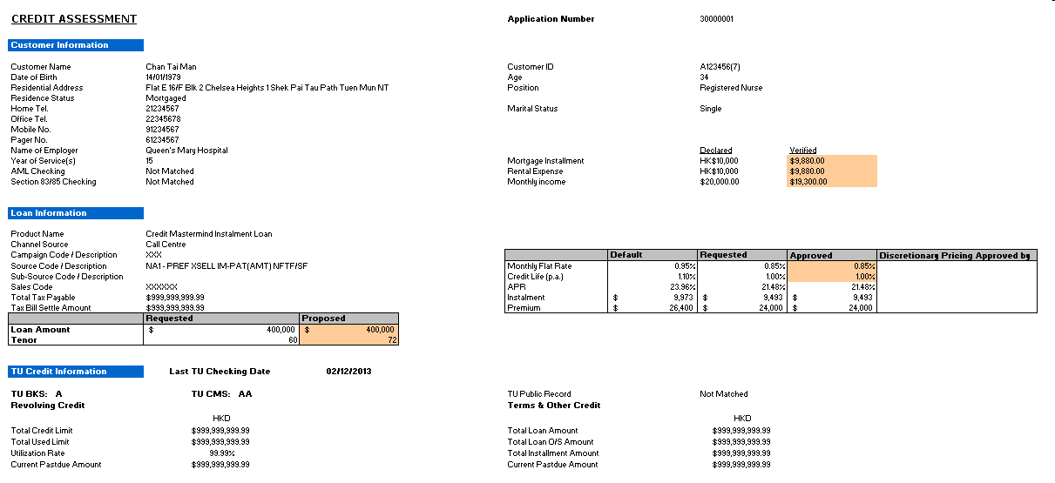
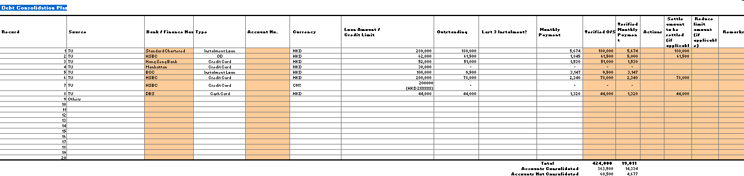
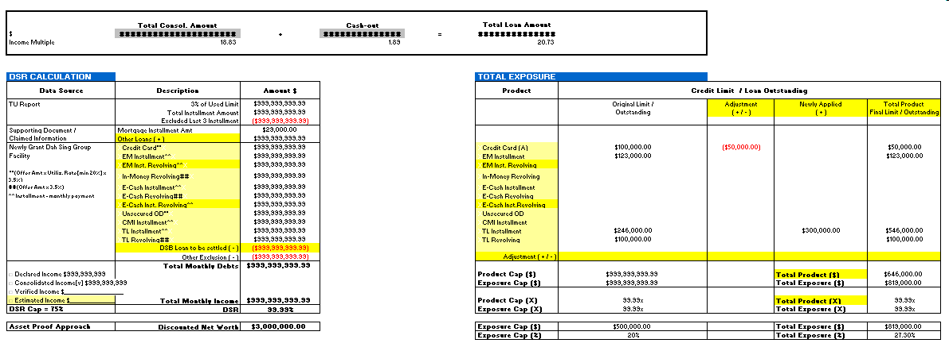
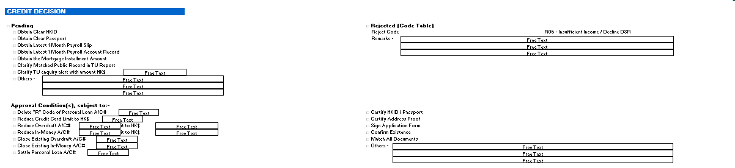
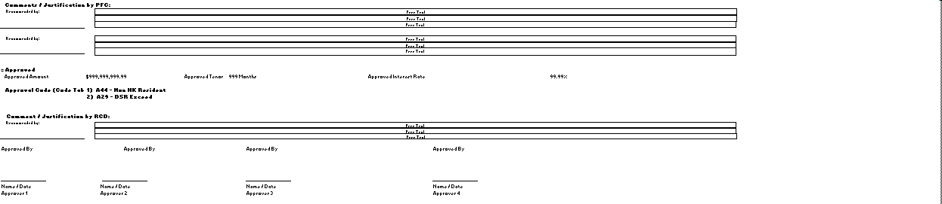

Remark:
- CMI Credit Assessment is printed into 2 parts.
- Part 1 contains Debit Consolidation Plan in Landscape.
- Part 2 contains remaining information in Portrait.
- Pending and Reject in Credit Decision Section is skipped according to Credit Decision.

Credit Assessment Checklist Field Mapping (CMI)

Application Number
It is unique number generated by the system for the application.

Customer Name
It is Surname + Space + Other Name inputted in Application Form’s Personal Data page.

Customer ID
Customer ID is formatted base on ID Type as follows:
ID Type | Customer ID
HKID | It is ID Number with check digit enclosed by bracket. E.g. A123456(7)
Passport | It is ID Number.
China ID | It is ID Number.

Date of Birth
It is Date of Birth inputted in Application Form’s Personal Data page.

Age
It is Adjusted Age if value is inputted by PFC. Otherwise, it is system calculated age. System Calculated Age = Year of Credit Assessment Data Refresh Date – Year of Date of Birth.

Residential Address
It is Home Address inputted in Application Form’s Personal Data page.

Position
It is Occupation inputted in Application Form’s Personal Data page.

Residence Status, Home Tel., Office Tel., Mobile No., Pager No., Marital Status
Residence Status
It is Residence inputted in Application Form’s Personal Data page.

Home Tel.
It is Home Tel. inputted in Application Form’s Personal Data page.

Office Tel.
It is Office Tel. inputted in Application Form’s Occupation page.

Mobile No.
It is Mobile Tel. inputted in Application Form’s Occupation page.

Pager No.
It is Pager No. inputted in Application Form’s Occupation page.

Marital Status
It is Marital Status inputted in Application Form’s Personal Data page.

Name of Employer
It is Employer Name inputted in Application Form’s Occupation page.

Year of Service(s)
It is (Y * 12 + M) / 12. Result is round down to integer.
Y is year part of “Years of Service” inputted in Application Form’s Personal Data page.
M is month part of “Years of Service” inputted in Application Form’s Personal Data page.

Declared Mortgage Installment
It is Mortgage Payment inputted in Application Form’s Personal Data page.

Verified Mortgage Installment
It is Verified Mortgage Installment inputted in Underwriting Manager.

Declared Rental Expense
It is Rent inputted in Application Form’s Personal Data page.

Verified Rental Expense
It is Verified Rental Expense inputted in Underwriting Manager.

Declared Monthly Income
It is Basic Mth Income inputted in Application Form’s Occupation page.

Verified Monthly Income
It is Verified Monthly Income inputted Underwriting Manager.

AML Checking
It is AML Checking inputted in Underwriting Manager.

Section 83/85 Checking
It is Section 83/85 Checking inputted in Underwriting Manager.

Product Name
It is Loan Product of the application.

Channel Source
It is Channel of the application.

Campaign Code / Description
It is Campaign Code and Description of the application.

Source Code / Description
It is Source Code and Description inputted in Application Form’s Loan Information page.

Sub-Source Code / Description
It is Sub-Source Code and Description inputted in Application Form’s Loan Information page.

Sales Code, Total Tax Payable, Tax Bill Settle Amount
Sales Code
It is Sales Code inputted in Application Form’s Loan Information page.

Total Tax Payable
It is Total Tax Payable inputted in Underwriting Manager.

Tax Bill Settle Amount
It is Tax Bill Settle Amount inputted in Underwriting Manager.

Requested Loan Amount
It is Loan Amt Request inputted in Application Form’s Loan Information page.

Proposed Loan Amount
It is Proposed Loan Amount inputted in Underwriting Manager.

Requested Tenor
It is Requested Repayment Period (mth) inputted in Application Form’s Loan Information page.

Proposed Tenor
It is Proposed Tenor inputted in Underwriting Manager.

Default Monthly Flat Rate
It is Monthly Flat Rate from Pricing Matrix of campaign of the application.
It is derived based on Proposed Loan Amount and Proposed Loan Tenor if values are inputted in Underwriting Manager. Otherwise, it is derived based on Requested Loan Amount and Requested Loan Tenor.

Requested Monthly Flat Rate, Approved Monthly Flat Rate
Requested Monthly Flat Rate
It is Interest Rate Request inputted in Application Form’s Loan Information page.

Approved Monthly Flat Rate
It is Approved Monthly Flat Rate inputted in Underwriting Manager.

Default Credit Life (p.a.)
It is Credit Life from Pricing Matrix of campaign of the application.
It is derived based on Proposed Loan Amount and Proposed Loan Tenor if values are inputted in Underwriting Manager. Otherwise, it is derived based on Requested Loan Amount and Requested Loan Tenor.

Requested Credit Life (p.a.), Approved Credit Life (p.a.)
Requested Credit Life (p.a.)
It is Credit Life (p.a.) in Application Form’s Loan Information page.

Approved Credit Life (p.a.)
If is Approved Credit Life (p.a.) inputted in Underwriting Manager.

Default APR
Please refer to section 5.5.2.9 APR Calculation. The calculation parameters are substituted by
B7 = Proposed Loan Amount
T = Proposed Tenor
B12 = 0 (Cash Rebate is always zero)
B31 = Default Instalment (It is defined in section 5.9.2.16.35)
H = 0 (Payment Holiday is always zero)

Requested APR, Approved APR
Requested APR
It is APR in Application Form’s Loan Information page.

Approved APR
Please refer to section 5.5.2.9 APR Calculation. The calculation parameters are substituted by
B7 = Proposed Loan Amount
T = Proposed Tenor
B12 = 0 (Cash Rebate is always zero)
B31 = Approved Instalment (It is defined in section 5.9.2.16.36)
H = 0 (Payment Holiday is always zero)

Default Instalment
Please refer to Section 5.5.2.5 Installment Amount Calculation. The calculation parameters are substituted by
P = Proposed Loan Amount
T = Proposed Loan Tenor
I = Default Monthly Flat Rate
C = Default Credit Life (p.a.)

Requested Instalment, Approved Instalment
Requested Instalment
It is Instalment Amount in Application Form’s Loan Information page.

Approved Instalment
Please refer to Section 5.5.2.5 Installment Amount Calculation. The calculation parameters are substituted by
P = Proposed Loan Amount
T = Proposed Loan Tenor
I = Approved Monthly Flat Rate
C = Approved Credit Life (p.a.)

Default Premium
It is Proposed Loan Amount * Default Credit Life (p.a.) * Proposed Tenor / 1200. Result is rounded to integer.

Requested Premium, Approved Premium
Requested Premium
It is Requested Loan Amount * Requested Credit Life (p.a.) * Requested Tenor / 1200. Result is rounded to integer.

Approved Premium
It is Proposed Loan Amount * Approved Credit Life (p.a.) * Proposed Tenor / 1200. Result is rounded to integer.

Discretionary Pricing Approved by
It is Approver Name with blank space for signing.
Approver Name is "Discretionary Pricing Approved by" if value is inputted in Underwriting Manager. Otherwise, it is name of user who approves the pricing deviation.

TU Credit Information
CMI Credit Assessment TU Credit Information is same as Normal PL Credit Assessment TU Credit Information. Please refer to section 5.9.2.4.15 – 5.9.2.4.26 for the corresponding field logic.

(Obsolete)
This section is obsolete.

(Obsolete)
This section is obsolete.

(Obsolete)
This section is obsolete.

(Obsolete)
This section is obsolete.

(Obsolete)
This section is obsolete.

(Obsolete)
This section is obsolete.

(Obsolete)
This section is obsolete.

(Obsolete)
This section is obsolete.

(Obsolete)
This section is obsolete.

(Obsolete)
This section is obsolete.

(Obsolete)
This section is obsolete.

Debt Consolidation Plan
It is debt records derived from TU report and inputted in Underwriting Manager.
To extract data from TU report, system will capture records from TUEF response message’s Account Segment (AC) with Segment Tag value starting with “O”. “O” is for open accounts.

Debt Consolidation Plan - Record
It is ordinal position of record.

Debt Consolidation Plan - Source
It is "TU" if record is derived from TU report. Otherwise, it is "Others".

Debt Consolidation Plan - Bank / Finance Name
It is Account Segment’s Subscriber Short Name or Generic Name (Tag 03).

Debt Consolidation Plan - Type
System will capture account type code from Account Segment’s Account Type (Tag 05). Then, lookup type from mapping table.

Debt Consolidation Plan - Account No.
It is Account Segment’s Account Number (Tag 01).

Debt Consolidation Plan - Currency
It is Account Segment’s Currency Code (Tag 07).

Debt Consolidation Plan - Loan Amount / Credit Limit
It is Account Segment’s Credit Limit / Loan Amount (Tag 14).

Debt Consolidation Plan - Outstanding
It is Account Segment’s Outstanding Balance (Tag 16).

Debt Consolidation Plan - Last 3 Instalment
It is Yes if Monthly Payment * 3 >= Outstanding. Otherwise, it is No.

Debt Consolidation Plan - Monthly Payment
It is Account Segment’s Installment Amount (Tag 15) if Type = Instalment Loan. Otherwise, it is Outstanding * 3%. 3% is system parameter.

Debt Consolidation Plan - Verified O/S
It is value inputted in Underwriting Manager. Default value is Account Segment’s Outstanding Balance (Tag 16).

Debt Consolidation Plan - Verified Monthly Payment
It is value inputted in Underwriting Manager. Default value is Account Segment’s Installment Amount (Tag 15) if Type = Instalment Loan. Otherwise, it is Outstanding * 3%. 3% is system parameter.

Debt Consolidation Plan - Actions
It is value selected in Underwriting Manager.

Debt Consolidation Plan - Settle Amount
It is value inputted in Underwriting Manager.

Debt Consolidation Plan – Reduce Limit Amount
It is value inputted in Underwriting Manager.

Debt Consolidation Plan - Remarks
It is value inputted in Underwriting Manager.

Debt Consolidation Plan - Verified O/S - Total
It is sum of Verified O/S in Debt Consolidation Plan.

Debt Consolidation Plan - Verified O/S - Accounts Consolidated
It is sum of Verified O/S in Debt Consolidation Plan where Actions is “Settle only & no action to A/C”, “Settle & close” or “Settle & reduce limit”.

Debt Consolidation Plan - Verified O/S - Accounts Not Consolidated
It is sum of Verified O/S in Debt Consolidation Plan where Actions is “Unsettle” or “Unsettle & reduce limit”.

Debt Consolidation Plan - Verified Monthly Payment - Total
It is sum of Verified Monthly Payment in Debt Consolidation Plan.

Debt Consolidation Plan - Verified Monthly Payment - Accounts Consolidated
It is sum of Verified Monthly Payment in Debt Consolidation Plan where Actions is “Settle only & no action to A/C”, “Settle & close” or “Settle & reduce limit”.

Debt Consolidation Plan - Verified Monthly Payment - Accounts Not Consolidated
It is sum of Verified Monthly Payment in Debt Consolidation Plan where Actions is “Unsettle” or “Unsettle & reduce limit”.

Debt Consolidation Plan – Total Consol. Amount ($)
It is sum of Settle Amount in Debt Consolidation Plan.

Debt Consolidation Plan – Cash-out ($)
It is "Proposed Loan Amount" - "Total Consol. Amount ($)".

Debt Consolidation Plan – Total Loan Amount($)
It is Proposed Loan Amount.

Debt Consolidation Plan – Total Consol. Amount (Income Multiple)
It is "Total Consol. Amount ($)" / "Total Monthly Income in DSR Calculation". Result is rounded to 2 decimal places.

Debt Consolidation Plan – Cash-out (Income Multiple)
It is "Cash-out ($)" / "Total Monthly Income in DSR Calculation". Result is rounded to 2 decimal places.

Debt Consolidation Plan – Total Loan Amount (Income Multiple)
It is "Total Loan Amount" / "Total Monthly Income in DSR Calculation". Result is rounded to 2 decimal places.

DSR Calculation, Total Exposure
CMI Credit Assessment DSR Calculation and Total Exposure are synchronized with those in Normal PL Credit Assessment (Asset Proof Approach is not applicable to CMI). Please refer to section 5.9.2.4.27 – 5.9.2.4.52 for the corresponding field logic.
In CMI Credit Assessment, “DSR Calculation – Verified Income” refers to “Verified Monthly Income” inputted in Customer Information section in Underwriting Manager.

(Obsolete)
This section is obsolete.

(Obsolete)
This section is obsolete.

(Obsolete)
This section is obsolete.

(Obsolete)
This section is obsolete.

(Obsolete)
This section is obsolete.

(Obsolete)
This section is obsolete.

(Obsolete)
This section is obsolete.

(Obsolete)
This section is obsolete.

(Obsolete)
This section is obsolete.

(Obsolete)
This section is obsolete.

(Obsolete)
This section is obsolete.

(Obsolete)
This section is obsolete.

(Obsolete)
This section is obsolete.

(Obsolete)
This section is obsolete.

(Obsolete)
This section is obsolete.

(Obsolete)
This section is obsolete.

(Obsolete)
This section is obsolete.

Applicant Type
It is Applicant Type inputted in Underwriting Manager.

Property Owner
Please refer to section 5.9.2.4.59.

Disposable Income
It is Total Monthly Income – Verified Rental Expense – Total Monthly Debts.
Total Monthly Income is defined in section 5.9.2.4.39.
Verified Rental Expense is defined in section 5.9.2.16.14.
Total Monthly Debts is defined in section 5.9.2.4.34.

Repayment Schedule
It is Payment Schedule inputted in Underwriting Manager.

CMI Special Program
It is CMI Special Program inputted in Underwriting Manager.

CMV, CMV Ref. No.
CMV
It is CMV inputted in Underwriting Manager.

CMV Ref. No.
It is CMV Ref. No. inputted in Underwriting Manager.

CMV Quota By, Current Property O/S
CMV Quota By
It is CMV Quota By inputted in Underwriting Manager.

Current Property O/S
It is Current Property O/S inputted in Underwriting Manager.

Preferred Industry
It is Preferred Industry inputted in Underwriting Manager.

Obsolete
(This section is obsolete.)

Obsolete
(This section is obsolete.)

Credit Decision – Pending
It is Credit Decision inputted in Underwriting Manager when Pending Document.

Credit Decision – Rejected
It is Credit Decision inputted in Underwriting Manager when reject.

Credit Decision – Approval Conditions
It is condition(s) inputted in Underwriting Manager when approve.

Credit Decision – Comments / Justification by PFC
It is comments and justification inputted in Underwriting Manager by PFC.

Credit Decision – Approved
It is Credit Decision inputted in Underwriting Manager when approve.

Credit Decision – Approval Code
It will show in the following priorities:
- If there is any rule with “Nature = Not Allowed” failed, it will show “1) Not Allowed”.
- If there is any rule with “Nature = Referral or Exception” failed, it is shown as “Sequence Number) Approval Code - Rule Name”. E.g. “1) A44 - Non HK Resident”. Multiple entries will be showed.
- If all rules with “Nature = Referral or Exception” pass, it is shown as “1) A00 - Standard Approval”.

Credit Decision – Comments / Justification by RCD
It is comments and justification inputted in Underwriting Manager by RCD when making approval decision.

Approved By
They are approver selected in Underwriting Manager. If approver name is inputted, it will override the default user name from CIPA.

Confirm Approval Decision
This function allows user to confirm approval decision. If it is the last approval, system will sent email notification to creation staff if application is created by retail branch or predefined group email address for call centre case. Email subject will indicate whether it is Quick Application or non-Quick Application.

(Obsolete)

(Obsolete)

Update Pending Document Condition
This function allows user to update pending document condition.
In Underwriting Manager,
- Switch to Pending Document page.
- Click Edit button.
- Input RCD / CMI Replied.
- Click Save button.

(Obsolete)

Refresh Credit Assessment Checklist
This function allows user to re-generate the Credit Assessment Checklist with the current values of the application.
LOS will store a snapshot of values of fields in the Credit Assessment Checklist and a ready-to-print copy of Credit Assessment Checklist will then be generated and available for user to download when user clicks the “Refresh Credit Proposal” button.

Submit Approval Decision
This function allows the user to submit approval decision.
Error message will be displayed if any of the following criteria is met:
- Download Credit Assessment Checklist has not been triggered after Credit Assessment Checklist is generated or refreshed;
- Changes are detected between current values and snapshot values of fields in the Credit Assessment Checklist.
- Approved Tenor is longer than Max. Tenor defined in section 5.9.2.25.
- Approved Loan Amount is larger than Max. Credit Limit defined in section 5.9.2.27.
- Approved Installment Amount is larger than Max. Installment Amount defined in section 5.9.2.26.
- Any entry in Pending Document has RCD / CMI Replied equal to TBO.
Otherwise, application will be submitted to RCD 1st Approval stage.

Return Credit Assessment Checklist
This function allows approver to return the Credit Assessment Checklist by route back application. User can input remark and upload attachment before routing.
Route back
Remark: | (text area)
Attachment: | (text) (Remove) (Add)
Action
Route back the application |  | (Route Back)
Cancel Route Back |  | (Cancel)

Section: Route
Screen Label | Type | Data Type | Mandatory | Validation | Possible Value | Source | Remarks
Remark | Text Area | String (1000) | Mandatory | N/A | N/A | User Input
Attachment | Text | String | Optional | Display Only | N/A | From LOS | Attached file name.
Remove | Button | N/A | N/A | N/A | N/A | N/A | Remove selected file.
Add | Button | N/A | N/A | N/A | N/A | N/A | When this button is clicked, system will allow user to add file for attachment.

Section: Action
Screen Label | Type | Data Type | Mandatory | Validation | Possible Value | Source | Remarks
Route Back | Button | N/A | N/A | N/A | N/A | N/A | Route back the application
Cancel | Button | N/A | N/A | N/A | N/A | N/A | Cancel Route Back
After routing, the application will go to Credit Processing Processor or Credit Approval Officer as follows:
Flow | Original Stage | Next Stage
Normal PL | RCD Proposal Signoff  RCD 1st-4th Approval | RCD Proposal Preparation
CMI | RCD Proposal Signoff | CPP Processing
CMI | RCD 1st-4th Approval | RCD Proposal Signoff

Max. Tenor
If Product Nature of the selected Product is “Revolving Installment”, the Max. Tenor is defined as follows:

Max. Tenor = Minimum between
- Maximum Tenor defined by Policy Rule #3 Max Tenor + Age; and
- Maximum Tenor defined by Policy Rule #19 Max Tenor

Max. Installment Amount
If Product Nature of the selected Product is “Revolving Installment”, the Max. Installment Amount is defined as follows:
Existing Total Monthly Debts
= “TU Report – 3% of Used Limit”
+ “TU Report – Total Installment Amount”
- “TU Report – Excluded Last 3 Installment”
+ “Supporting Document – Mortgage Installment Amt”
+ “Supporting Document – Other Loans”
- “DSB Loan to be settled”
- “Other Exclusion”

DSR Cap is defined by logic in section 5.10.2.10.1 DSR Cap.

If Override DSR Cap not equal to “0” or Blank, Override DSR Cap is required to consider in Max. Installment Amount Calculation using the following calculation formula instead of “Product DSR Cap” :

Max. Installment Amount = (“Override DSR Cap”) * Total Monthly Income - Existing Total Monthly Debts (Result is rounded to 2 decimal places.)

Max. Credit Limit
If Product Nature of the selected Product is “Revolving Installment”, the Max. Credit Limit is defined as follows:

a) Total Unsecured Exposure Cap - Total Unsecured Exposure is calculated as follows:
If DSR Calculation = Yes then
Total Unsecured Exposure Cap = Policy Rule #16 Maximum total Unsecured Exposure

Total Unsecured Exposure is calculated as sum of the following items:
Item | Source and Logic
Sum of outstanding principal of existing PL Product | It is sum of Total Exposure’s Original Limit or Outstanding of the following products defined in section 5.9.2.4.42:  - EXPRESS MONEY NORMAL INSTALLMENT  - EXPRESS MONEY REVOLVING INSTALLMENT  - E-CASH NORMAL INSTALMMENT  - E-CASH REVOLVING INSTALLMENT  - CREDIT MASTERMIND  - TAX LOAN
Sum of original loan amount of existing PL Product loan type = 07R (for revolving) | (This item is obsolete. It is included in “Sum of outstanding principal of existing PL Product.)
Sum of OD limit of existing OD Product account type = 359 & 360 (FMOD, RTL & ECOD)  (after Core Banking phase 2, should be revised to look for specific Product Codes, details TBC) | It is sum of Total Exposure’s Original Limit or Outstanding of the following products defined in section 5.9.2.4.42:  - FLEXIMONEY  - TAX REVOLVING LOAN
Customer level credit line of ‘Valid Credit Cards’ (For both DSB and Mevas) | It is Total Exposure’s Original Limit or Outstanding of Credit Card defined in section 5.9.2.4.42.
Credit line of ‘Valid Cash Card & You Buy Cash - cash card’ | It is sum of Total Exposure’s Original Limit or Outstanding of the following products defined in section 5.9.2.4.42:  - IN-MONEY REVOLVING  - E-CASH REVOLVING

c) Product Cap – Existing Outstanding of the Product Category is calculated as follows:
Product Cap = Policy Rule #13 Product Threshold / Times of Income

e) Max Credit Limit derived from Max Installment Amount and Max Tenor is calculated as follows:
Value = Maximum Inst. Amount / ((1 + Life Insurance * Maximum Tenor / 1200) * (Approved Monthly Flat Rate / 100 + 1 / Maximum Tenor))

Max. Credit Limit = Minimum of (a), (c), (e)

CAO is allowed to revise Max Credit Limit calculated by LOS

* Max. Credit Limit calculation logic is not directly change. However, when the Max. Installment Amount is changed because of using the Override DSR Cap. It will be revised indirectly.

Keep Approval Decision Information for Reference during application reapproval process

To aid RCD_CAO making the final approval decision on the previous approved application that requires re-approval due to appeal or update of critical information that affect the previous approval decision, the latest information at the following sections of the Underwriting Manager previously entered during the approval process shall NOT be initialized but be kept and displayed for reference:

Involved Section
- Credit Decision for Reject; Approved; Pending; Offer Other Loan
- Credit Decision (Others)
- Approval Conditions [for CMI]

Possible Application Flow:
- User submit back for preapproval after loan approved / Offere Other Loan.
- User appeal the application after load is rejected.
- User return the application back to approver after approver request Pending Document.
- User return the application back to approver after approver recall application to route back.
- User return the application back to approver after approver request further information.
- User return the application back to approver after approver request CPP Follow up.

Override Approved Tenor Logic

This logic is only for applicant’s age >= 65. For this case, “Approved Tenor” can’t be calculated base on existing calculation logic and policy for below product.

Products List:
    - EM Revolving Instalment Loan (Base on Requirment change of PDM16505, above condition has been released)
    - eCash Revolving Instalment Loan (Base on Requirment change of PDM16505, above condition has been released)
    - EM Normal Instalment Loan
    - eCash Normal Instalment

Therefore, a new field “Override Approved Tenor” is introduced to approver to provide a override value.

For Normal situation, “Overrride Approved Tenor” is not Ediable except applicant’s Age or Adjusted Age >= 65 and Approved Tenor is empty.

All related report, calculation and interface program is required to use the “Override Approved Tenor” instead of “Approved Tenor” if the condition is hited.

However, the Policy Rule Check Logic on Max Tenor + Age remain unchanged.

Mortgage Loan Application Warning
Warning message “There is a Mortgage Loan Application.” will be displayed when
- Customer ID of the applicant matches customer ID of any obligors in applications of LOS-ML or CSP with role equals to Borrower, Guarantor or Mortgagor; AND
- The matching application of LOS-ML or CSP is not Disbursed, Rejected or Cancelled.

Warning message “Disbursed Mortgage Loan Application < 14 calendar days.” will be displayed when
- Customer ID of the applicant matches customer ID of any obligors in applications of LOS-ML or CSP with role equals to Borrower, Guarantor or Mortgagor; AND
- The matching application of LOS-ML or CSP is Disbursed; AND
- Disbursement Date of the matching application of LOS-ML or CSP + 14 calendar days >= Current System Date.

Start ECCD Process
If the “ECCD Process” button is click, LOS will open a new window and pass the application data to ECCD system. The field mapping will be as follows:
ECCD |  | LOS
Section | Field | Applicant
Basic Information | Name in English (Surname first) | Surname + “ “ + Other Name
Basic Information | Name in Chinese (if any) | <blank>
Basic Information | ID Type | ID Type
Basic Information | ID Number | ID Number
Basic Information | ID Document Issue Country | Issue Country
Contact Information | Current Residential Address - Line1 | Home Address Line 1
Contact Information | Current Residential Address - Line2 | Home Address Line 2
Contact Information | Current Residential Address - Line3 | Home Address Line 3
Contact Information | Current Residential Address - Line4 | Home Address Line 4
Contact Information | Current Residential Address - Country | Home Address Country
Contact Information | Permanent Address - Line 1 | Permanent Address Line 1
Contact Information | Permanent Address - Line 2 | Permanent Address Line 2
Contact Information | Permanent Address - Line 3 | Permanent Address Line 3
Contact Information | Permanent Address - Line 4 | Permanent Address Line 4
Contact Information | Permanent Address - Country | Permanent Address Country
Contact Information | Correspondence Address - Line 1 | If Correspondence == Home  Then Home Address Line 1  Else Company Address Line 1
Contact Information | Correspondence Address - Line 2 | If Correspondence == Home  Then Home Address Line 2  Else Company Address Line 2
Contact Information | Correspondence Address - Line 3 | If Correspondence == Home  Then Home Address Line 4  Else Company Address Line 4
Contact Information | Correspondence Address - Line 4 | If Correspondence == Home  Then Home Address Line 4  Else Company Address Line 4
Contact Information | Correspondence Address - Country | If Correspondence == Home  Then Home Address Country  Else Company Address Country
Contact Information | Telephone Number (Mobile) - Country Code | Mobile No. Country Code
Contact Information | Telephone Number (Mobile) - Area Code | Mobile No. Area Code
Contact Information | Telephone Number (Mobile) - Phone No. | Mobile No. Number
Contact Information | Telephone Number (Office) - Country Code | Office Tel. Country Code
Contact Information | Telephone Number (Office) - Area Code | Office Tel. Area Code
Contact Information | Telephone Number (Office) - Phone No. | Office Tel. Number
Contact Information | Telephone Number (Home) - Country Code | Home Tel. Country Code
Contact Information | Telephone Number (Home) - Area Code | Home Tel. Area Code
Contact Information | Telephone Number (Home) - Phone No. | Home Tel. Number
Contact Information | Occupation | Occupation
Contact Information | Position | Position
Contact Information | Name of Employer | Current Employer
Contact Information | Business Nature | Business Nature
Contact Information | Type of Account(s) | Loan
Product Information | Purpose & Reason for Opening Account or Establishing Relationship | "Person Loan" if Loan Type is "Personal Loan" or "Cash Card".  "Business Loan" if Loan Type is "SME Loan".

After ECCD system has received the data, the ECCD system flow will begin and this is out of scope of LOS enhancement.

Debt Consolidation Plan and Settlement Instruction
Debt Consolidation Plan (View and Edit By CMI Team Only)
      - All the features of Debt Consolidation Plan is follow to Phase 2 Card Loan CMI Debt Consolidation Plan
      - Similar to CMI Loan application, the Debt Consolidation Plan Table shall list all Debt records (revolving & non-revolving) based on the TU Report.
      - For debt relating to DSB (revolving & non-revolving), the ‘Settle Amount’ and ‘Actions’ fields are disabled. This is configured in Campaigner Manager Product Level
      - Subject to the ‘Bank / Finance Name’ could NOT be found from the pick list, the Settle Amount for the related revolving facility record is NOT allowed to enter.
      - In case the address information of the selected Bank / Finance Name is NOT available, system shall prompt input of the address information. The entered address information shall be saved in the system database so that while the same Bank / Finance Name is selected subsequently, prompt for address information entry is NOT required.

Operation Flow:
If No Address is available, WARNING message is prompt to notify user that Bank Address is not available.
Message: “No Address is available for selected Bank”

Prompt a Dialog for user to update the Address for related Bank Code.

LOS will add a ““View Addr” below Drop down Box of Bank Name” Then, user can review the Address in the prompt dialog in View Mode

If no address available of bank, the dialog is prompt directly in Edit Mode for input address
Once, the address has been save in DB “PL_CODE_FI_ADDRESS”, please send an email to LOSSupport@dahsing.com for record this event.

For UI of Dialog

CODE : <CODE>
NAME : <DESCRIPTION>
ADDRESS :
<ADDR_LINE 1>
<ADDR_LINE 2>
<ADDR_LINE 3>

Button: “Edit” , “Save”

      - Validation Logic
- Only the revolving portion (i.e. used limit) of a Credit Card account debt record is marked ‘Settle’ entered with the ‘Settle Amount’ but NOT the Card Loan Debt record of the same Card account (if any). In other words, both revolving portion (i.e. used limit) and Card Loan portion (if any) of a Card account must be marked ‘Settle’ and entered with ‘Settle Amount’ simultaneously; or
- The ‘Settle Amount’ entered for the related revolving facility is < the lower of the Declared O/S & TU O/S; or
- The Total Settle Amount entered (or Total Consolid. Amount) > *[50%] of the Accepted Loan Amount (if any) or the Requested Loan Amount; or
- The Total Settle Amount entered (or Total Consolid. Amount) > *[5] times of the Verified Income if any otherwise Declared Income

* The check value is a parameter store in LOS. It can be change by raising SAR without program update.

Settlement Instruction(View by All User, Edit by CMI Team Only)
- In Edit Mode, User is only allowed to edit “Payee” Field. For the rest, it should be Read only for display.
- Only “Debt Consolidation Plan” Action = “Settle” entry, which is retrieve to generate “Settlement Instruction.

DSR Calculation Logic for MP / VP Application
The calculation logic is required to follow Card Loan – Cash In Plus (CIPP). Therefore, the layout has been also change for MP / VP Application.

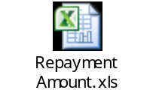

Approver override On-us Mortgage Indicator
Actually, finalized On-us Mortgage Indicator is required to approve further the customer information such the mortage property nature. Therefore, one override field is available in Underwritting Manger for approver to override the system obtained value.

The Decision logic is listed below:

If Approver Adjusted value is “Blank”, System will assume On-us Mortgage Indicator as “N” to obtain the Product Threshold and Income Mulipier.

If Approver Adjust value is NOT “Blank”, The Approver Adjust Value will be used to obtain the Product Threshold and Income Mulipier instead the system defined value.

If Accept On-us Mortgage indicator is “Y”, Approver override On-us Mortgage Indicator is mandatory to input;
If Accept On-us Mortgage indicator is “N”, Approver override On-us Mortgage Indicator must be N/A

TU Proxy Income Date Validataion in Underwritting Manager

Action Point for trigger Validation
- Loading Credit Assessment Page for Normal PL Application
- Approval Normal PL Application
  - When Approver click on the “approve” button
- Perform “Hold Fund” in Card Loan
- Passing the application to “Loan Acceptance Stage” for Phase 2 Top up Loan
- Click on “Save” of application Manager / Underwritting Manager / Card Loan Manager / Revolving Top up Loan Manager
System will perform the validation of “TU Proxy Income” is valid or not.
The detail logic is covered in “Section 5.6.2.83 Capture “Score 1” in DSB LOS PL FS Part 1 v1.54.doc”

For Validation Checking point 1 and 5
If the TU Proxy Income Date become “Invalid”
System will prompt a Warning Message is required to display
Message Content : “TU Proxy Income has expired”
Then, Trigger a Prompt Message for user to confirm “Yes” or “No”
Prompt confirmation Message“Perform TU Proxy Income Check again and clean up the value if it is not available ?”
If user confirm as “Yes”, system wil try to check again the system to table see any “Valid” TU Proxy Income available, if yes, replace the existing value. If no more valid TU Proxy Income, please clean up the previous captured TU Proxy Income Value.
If user confirm as “No”, Keep the previous Captured TU Proxy Income Value un-change.

For Validation Checking point 2, 3 and 4
System will prompt an ALERT Message is required to display and block the operation.
Message Content: “TU Proxy Income has expired. Please perform edit and save to refresh TU PROXY Income.”

Calculation Logic on Currency Mismatch Indicator

Calculation of Max. Installment Amount

The calculation logic is the same as existing Monthly Installment Amount

The different is that :
- Calculated at Acceptance Stage
- If Product with Approved “Credit Limit”, Credit Limit will be used for calculate the Max Installment Amount. Otherwise, it will be equal to Monthly Installment Amount
- Base on Customer Accepted Credit Limit to replace accepted Loan Amount within the calculation logic.

“Max. Monthly Installment Amount / Credit Limit 3.5%”
- will be changed depend on different application stage and different Product. The detail is covered in 5.9.4.2.1 and 5.9.4.2.2

Calculation Logic of Currency Mismatch Indicator

If Total Income Amount in HKD / Max. Monthly Installment Amount / Credit Limit 3.5% > 90 %
Then, Currency Mismatch Indicator = “N”

Else
Currency Mismatch Indicator = “Y”

Handling of Online Straight Through Application on Currency Mismatch Indicator

For all the online Straight Through PL Application

Currency Mismatch Indicator is not required to calculate. The value will set as default “N”

Conditions for apply Simplified Policy Rule Approach

There are 10 criteria which is impact the Simplified Policy Rule Approach.

Criteria 1

If Application Product Code = (EN, EM, EI, EV), then PASS else Fail

Criteria 2

The PL application is created via DM List, then PASS else Fail

Criteria 3

The value of ‘TU Check’ field included in the DM List = ‘Y’ (i.e. the PA_AMT_FLAG field at DM List = T), then PASS else Fail

Criteria 4

The ‘Declared Total Monthly Instalment Repayment Amount’ located at the Application Manager -> Application Form -> Credit Ref. Tab -> Other Loan Information Section <= ‘Total Installment Amount’ located at the Underwriting Manager -> Credit Assessment Tab -> TU Credit Information Section then PASS else Fail

Criteria 5

The ‘Total Declared Revolving Loan (including Credit Cards) / OD Used Amount’ located at the Application Manager -> Application Form -> Credit Ref. Tab -> Other Loan Information Section <= summation of ‘Total Used Limit’ and ‘Total O/S Loan Amount’ located at the Underwriting Manager -> Credit Assessment Tab -> TU Credit Information Section then PASS else Fail

Criteria 6

Income used for DSR calculation >= DM List Income; then PASS else Fail

Criteria 7

If Active Application in APS or LOS Application is available, Then “Fail” Else “Pass”

The same logic has been applied in CLI of Credit Card of Policy Rule “R000000133 - Pending application in APS or LOS”

Criteria 8

If LOS Calculated Unsecure Exposure > DM List unsecured Expsure
Then, Fail
Else
Pass
End if

Criteria 9

‘Outside DSB Mortgage’ located at Underwriting Manager -> Credit Assessment Tab -> Customer Information Section = N or Blank, then PASS else Fail

Criteria 10

- Base on the requested loan amount to locate the pre-approved loan amount bracket
- Then look up the corresponding pre-approved tenor. If requested repayment period is more than or equal to the corresponding pre-approved tenor, the criteria is passed. Otherwise, it is failed.
- Detail please refer to below example

Example:
There are 7 sets of Pre-approved Information set as below:
Ref | Pre-approved Tenor | Pre-approved Loan Amount | Pre-approved Loan Amt Bracket
 | 6 | 100,000 | Min. loan amount to 100,000
 | 12 | 120,000 | 100,001 to 120,000
 | 18 | 140,000 | 120,001 to 140,000
 | 24 | 160,000 | 140,001 to 160,000
 | 36 | 180,000 | 160,001 to 180,000
 | 48 | 200,000 | 180,001 to 200,000
 | 60 | 220,000 | 200,001 to 220,000

If Loan Amt Requested = 110,000,
Loan Amt Requested: 110,000 is < 120,000
If Requested Repayment Period (mth) >= 12
Pass
Else
Fail
End if

On the contrary, the application shall be treated as ‘Fail’ the subject criterion if the Loan Amount Requested is > 120,000 but the Requested Repayment Period (mth) is 12.

Set up Max. Credit Limit / Tenor / Instalment Amount

If Above 5.9.2.38 Criteria 1 to 10 are PASS
In Underwriting Manager -> Credit Assessment Tab -> Credit Decision Section
1. Maximum Credit Limit override by PL_APP_DM_INFO.MAX_CR_LIM
2. Maximum Tenor shall override by PL_APP_DM_INFO.MAX_TENOR
3. Maximum Inst. Amount override by PL_APP_DM_INFO.MAX_INST_AMT
Else
Work as existing logic. The 3 fields are calculated by LOS.
End if
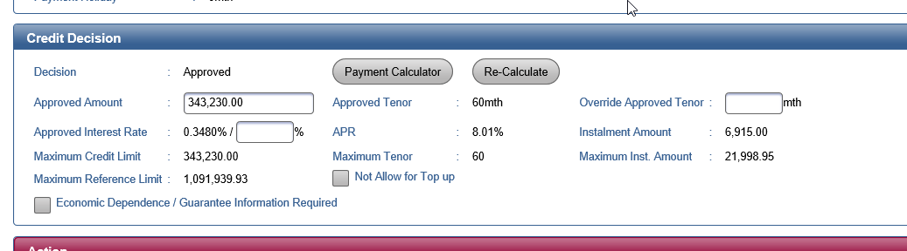

Execution Control of Simplified Policy Rule

For 5.9.2.38 Criteria 1, 2, 3 and 10 any one of result is FAIL
The application is required to execute current existing Normal Policy Rule
Othwrwise :
LOS will execute Simplified Policy Rule instead of Normal Policy Rule
Note: Criteria 4 to 9 may be fail. However, it does NOT impact the Simplified Policy Rule execution

Logic for determine the value of Simplified Rule Indicator

If 5.9.2.38, Criteria 1, 2, 3 are PASS but Criteria 10 are Fail
LOSDB.PL_UDW_CRD_ASSESS.SIMPLE_POLICY_RULE_IND = “N”
Else
5.9.2.38, Criteria 1, 2, 3 , 10 are PASS
LOSDB.PL_UDW_CRD_ASSESS.SIMPLE_POLICY_RULE_IND = “Y”
Else
LOSDB.PL_UDW_CRD_ASSESS.SIMPLE_POLICY_RULE_IND = NULL
This case is cover all the Normal Case
End if

Screen

Main
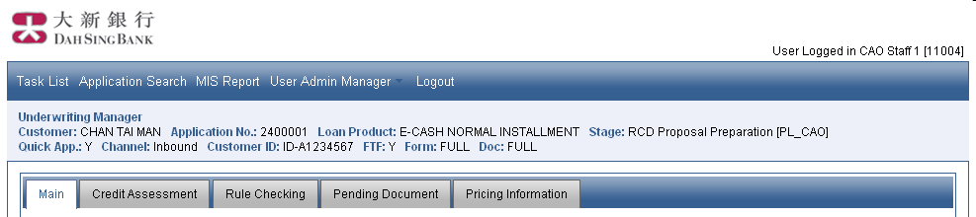
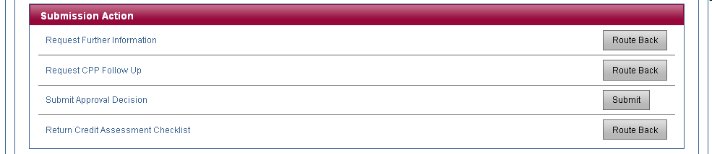
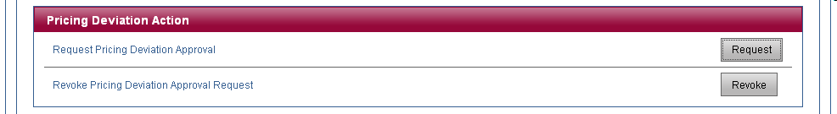

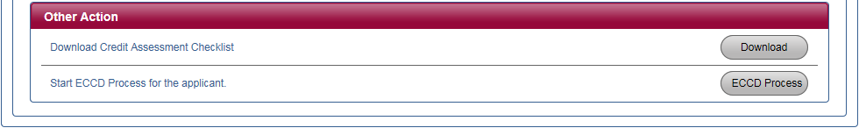
Rule Checking Tab Page is not available for “CL” – Capital Contribution Loan.

Credit Assessment

Normal PL
Rule Checking Tab Page is not available for “CL” – Capital Contribution Loan.
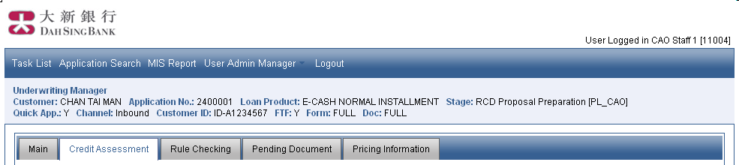

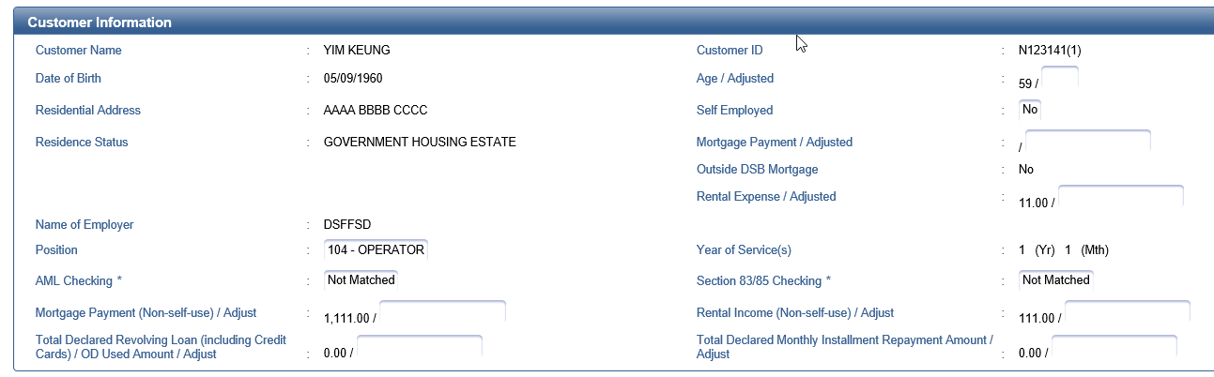
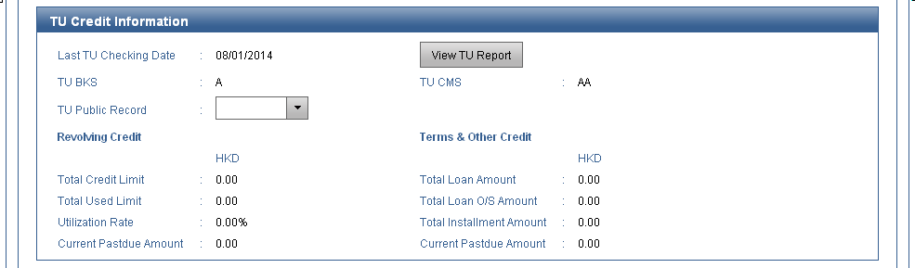
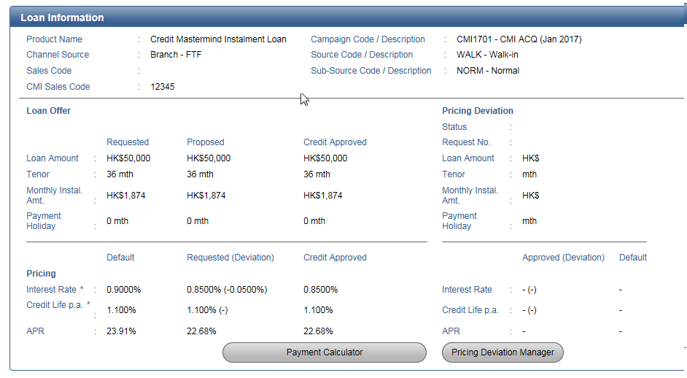
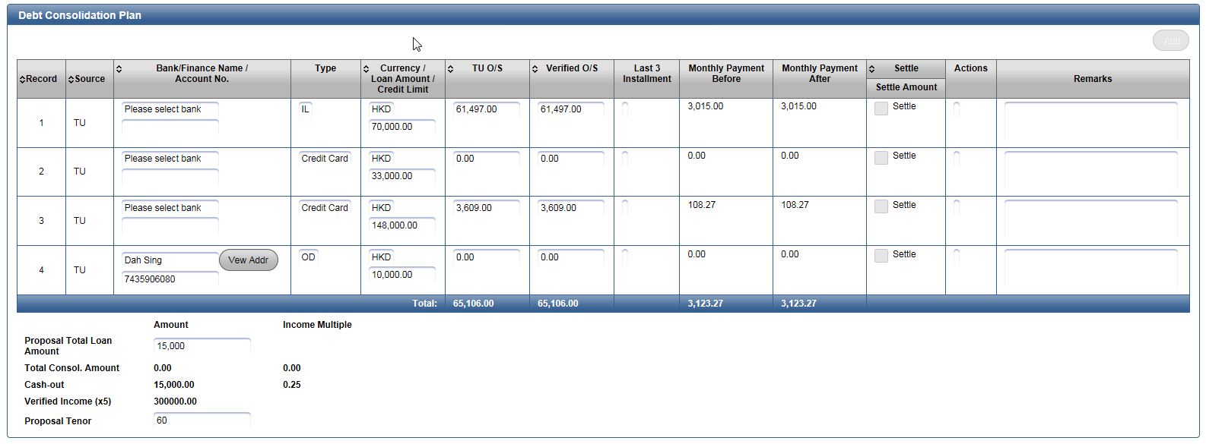
Normal PL 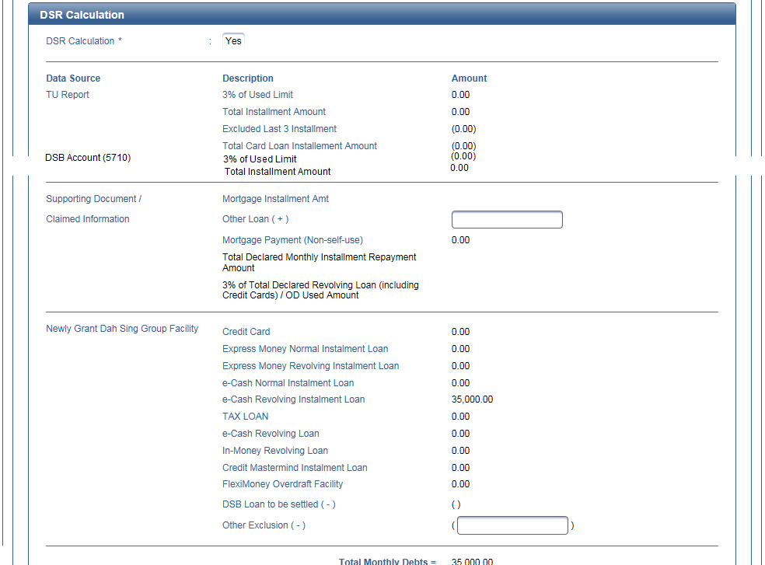
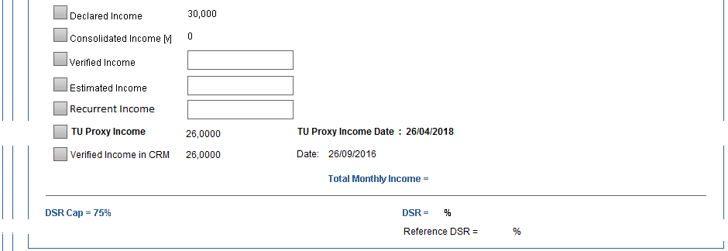

For MP / VP
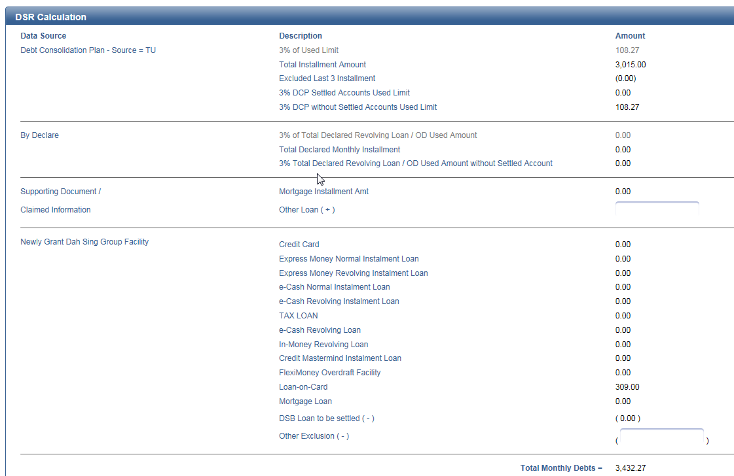
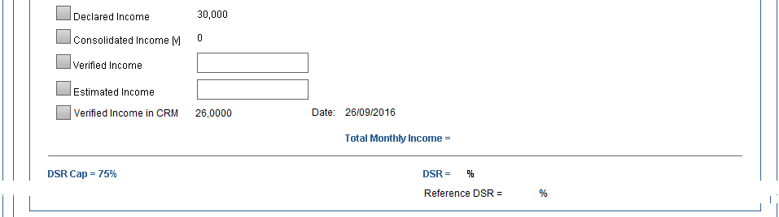
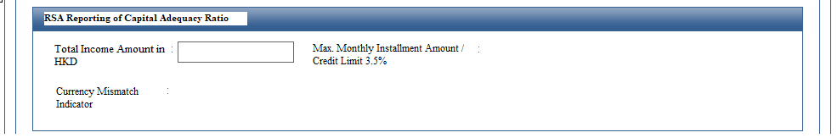
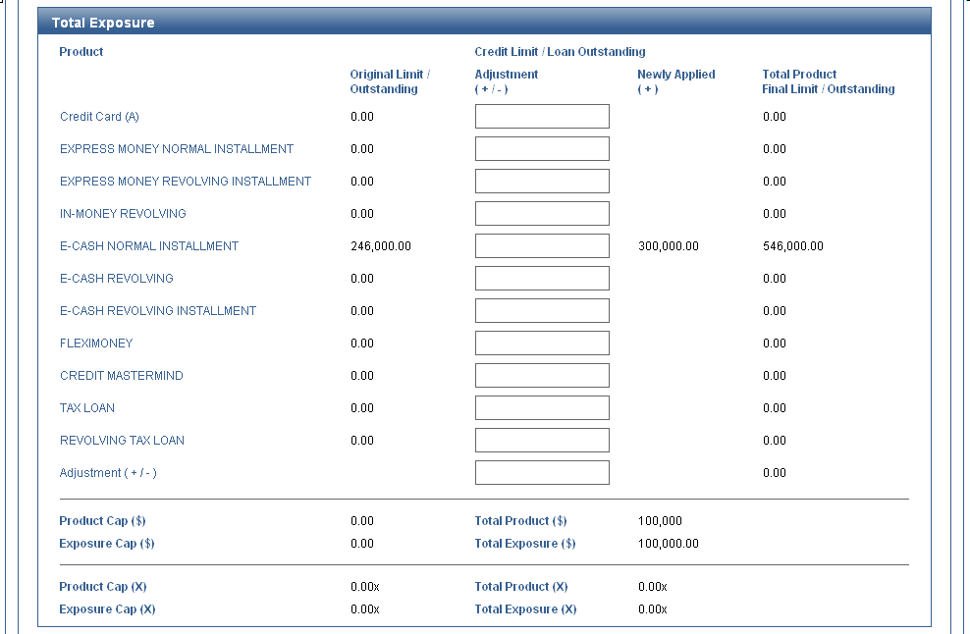
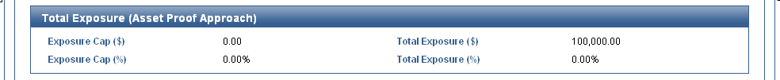
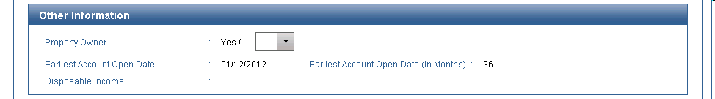
RCD On-us Mortgage : <Indicator> (Read Only) / <RCD Input Value> (Editable)
(Available for eCash and eCash Plus Revolving Instalment Loan, Express Money Revolving Installment Loan, Express Money Plus Revolving Installment Loan, FMOD, eCash Normal Instalment Loan and Express Money Normal Instalment Loan ONLY)

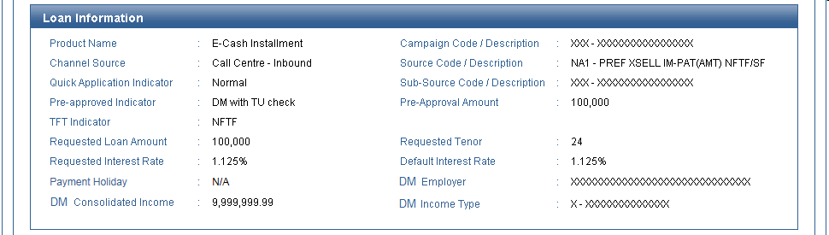
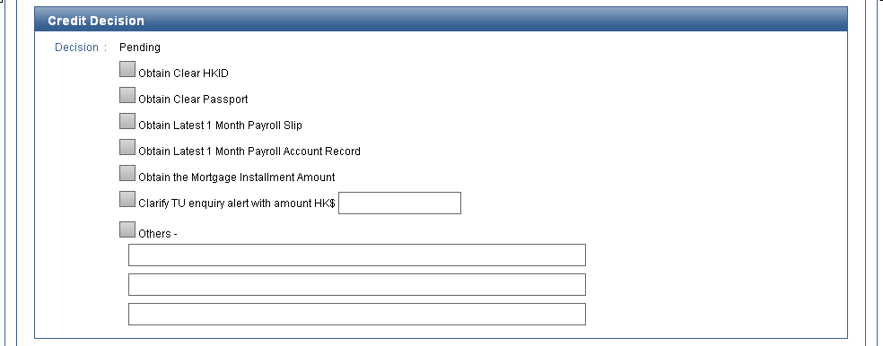
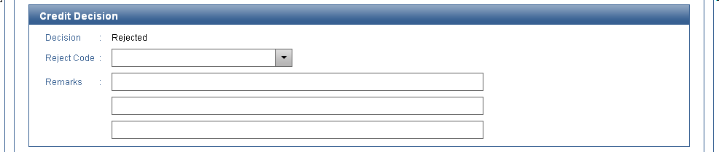
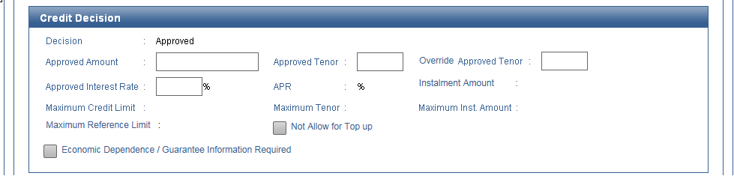
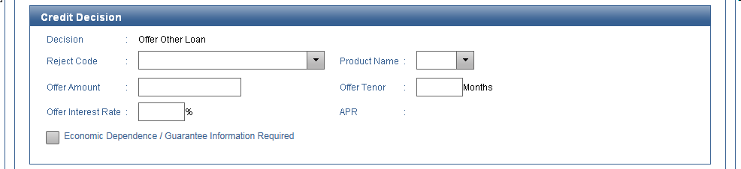
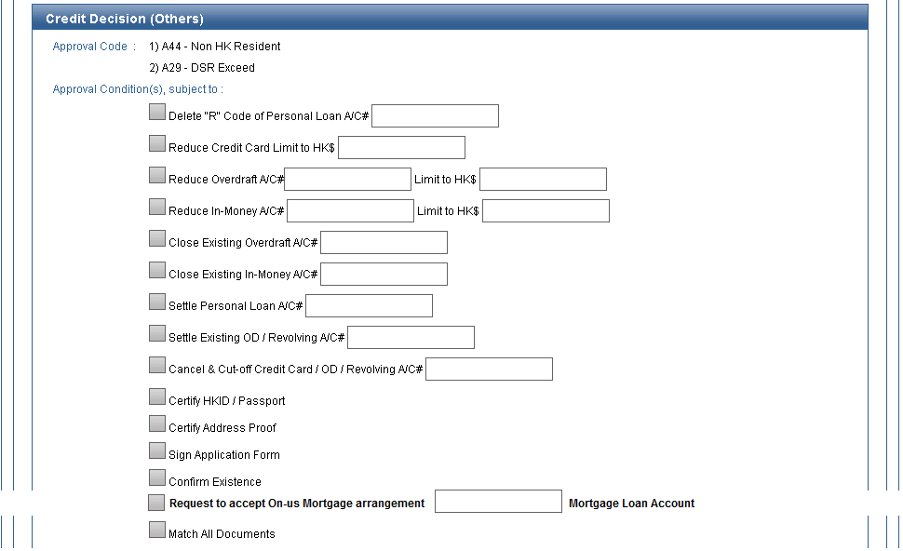
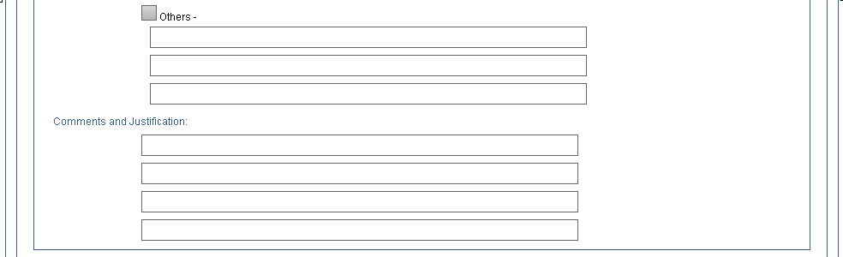
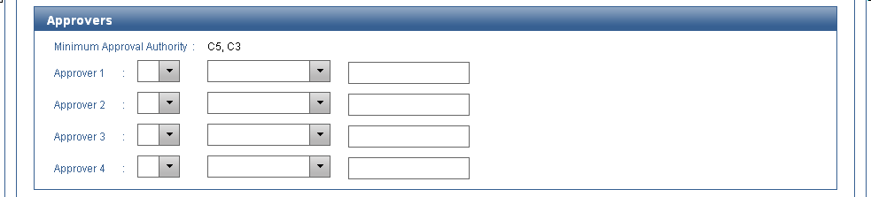
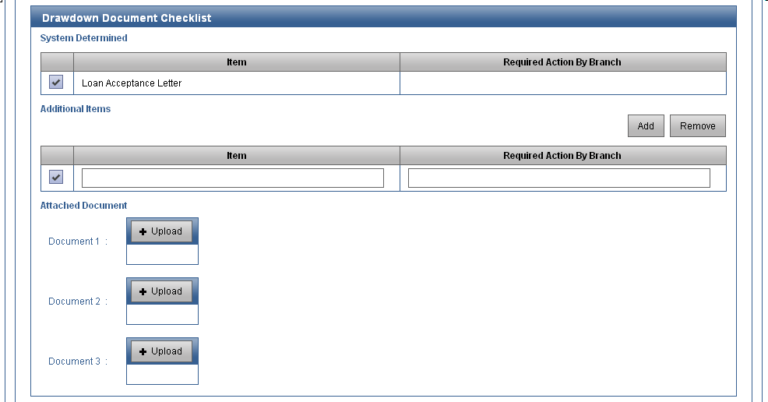
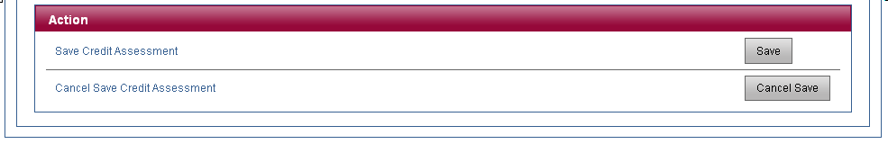

CMI
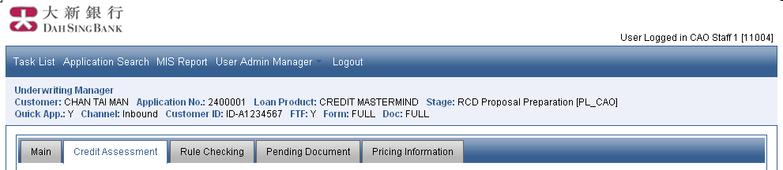
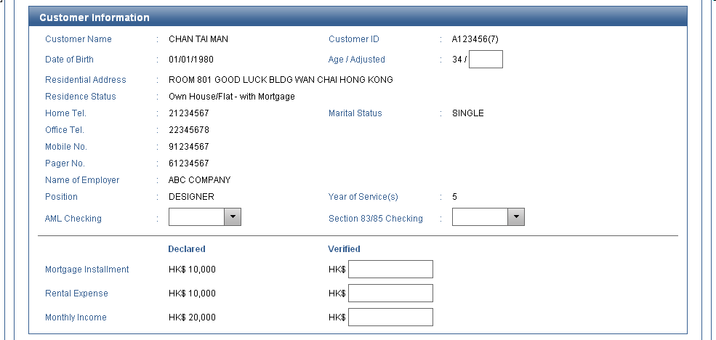
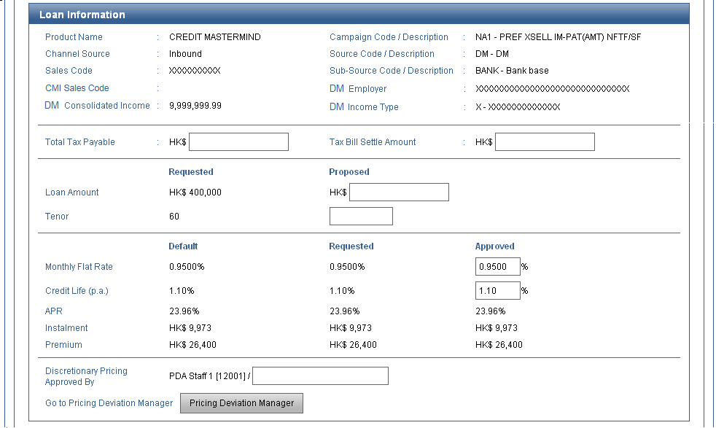
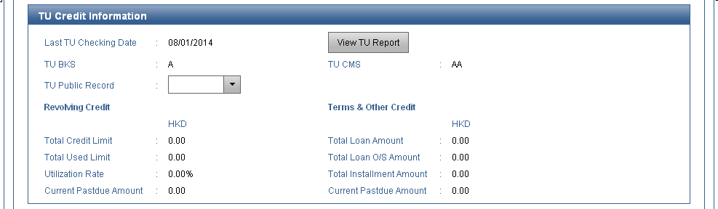
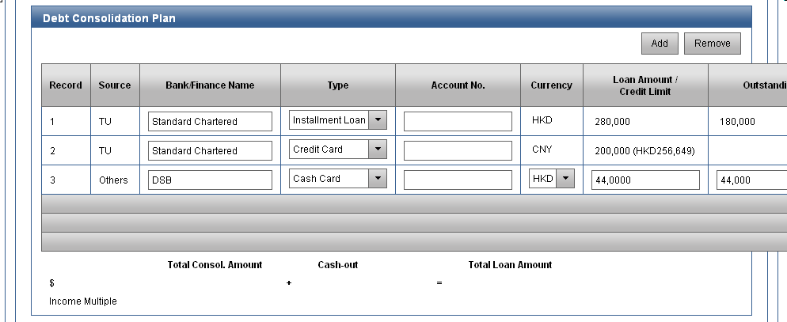
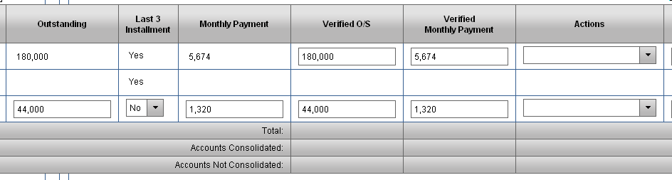
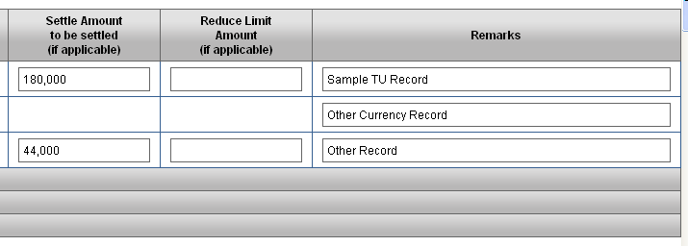
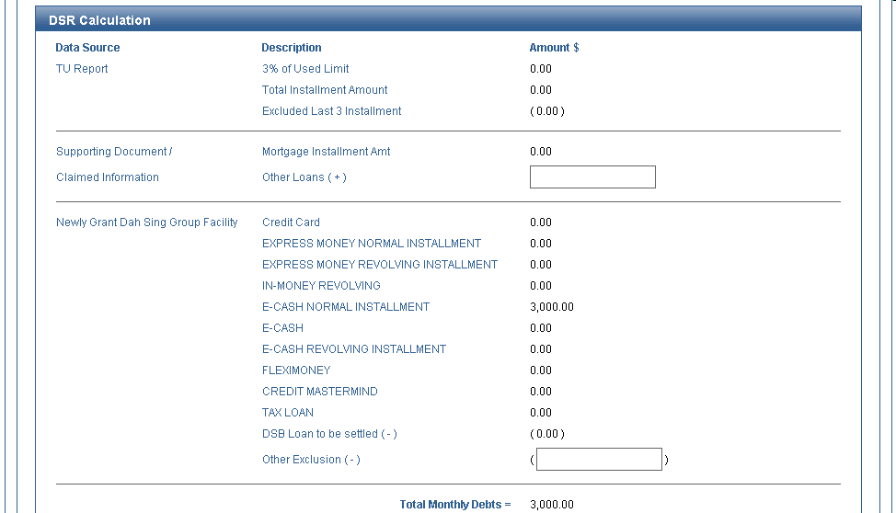
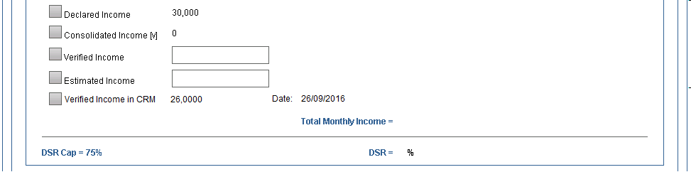
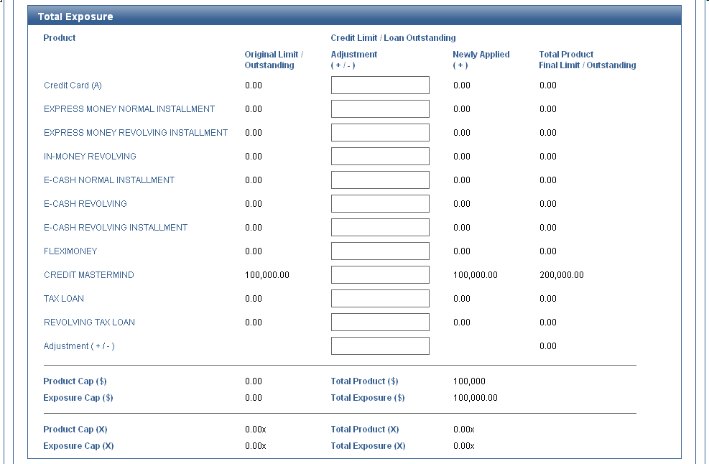
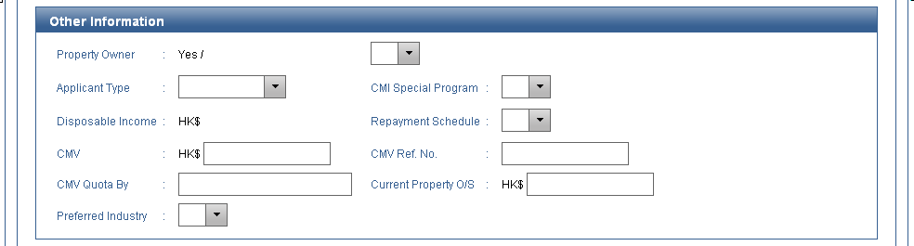
RCD On-us Mortgage : <Indicator> (Read Only) / <RCD Input Value> (Editable)
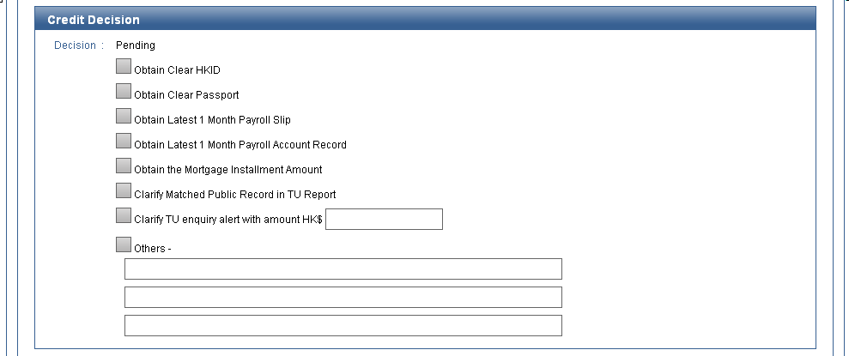
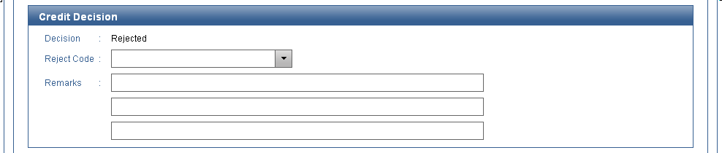
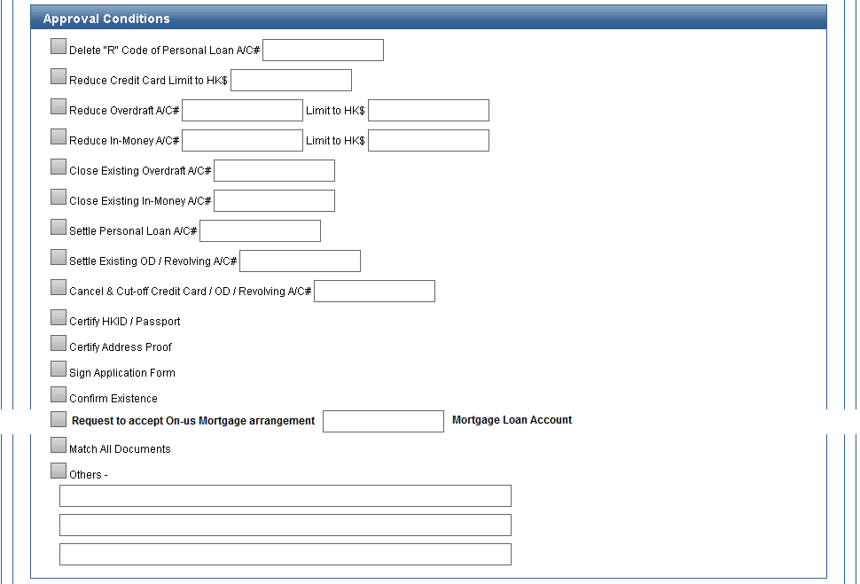
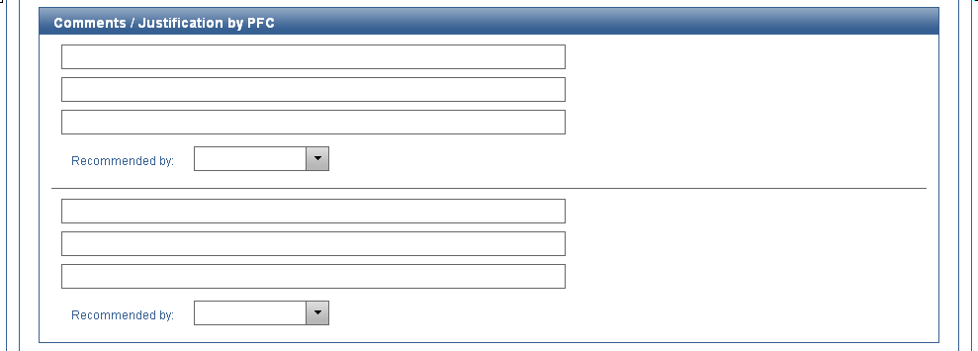
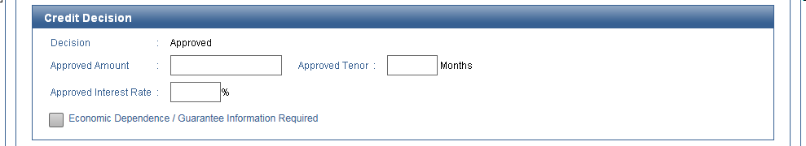
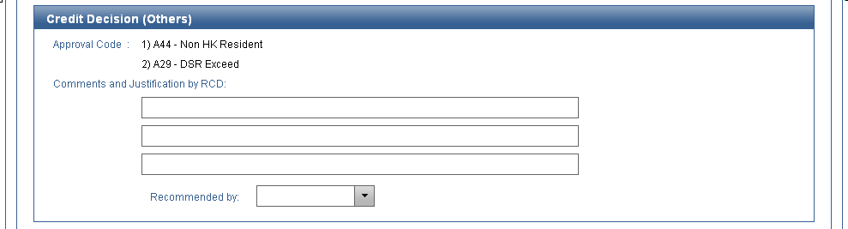
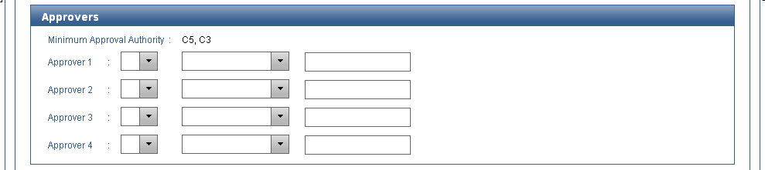
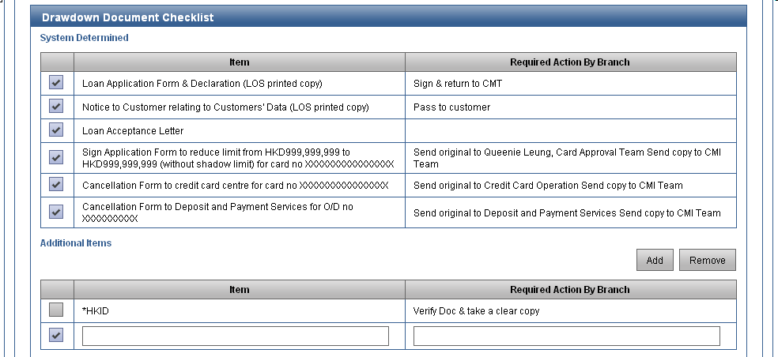
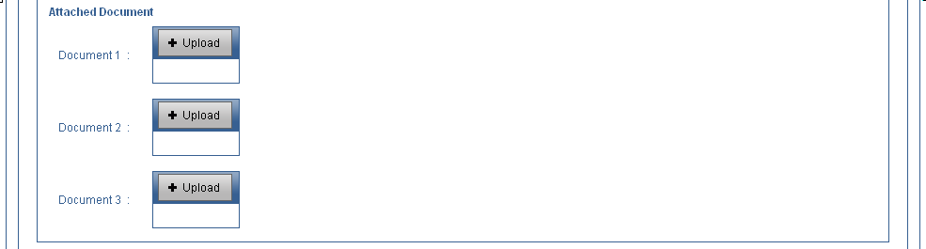

Rule Checking
Rule Checking Tab Page is not available for “CL” – Capital Contribution Loan.
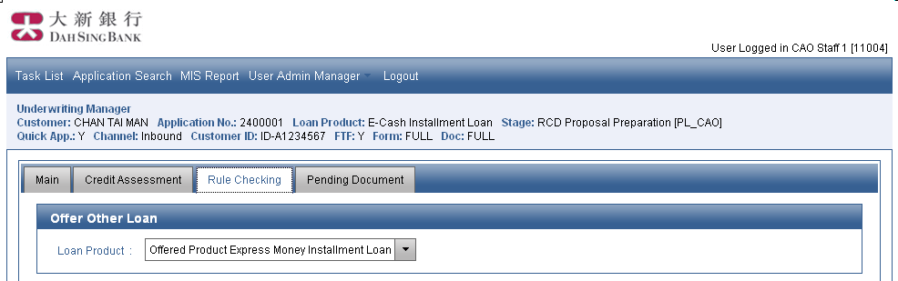
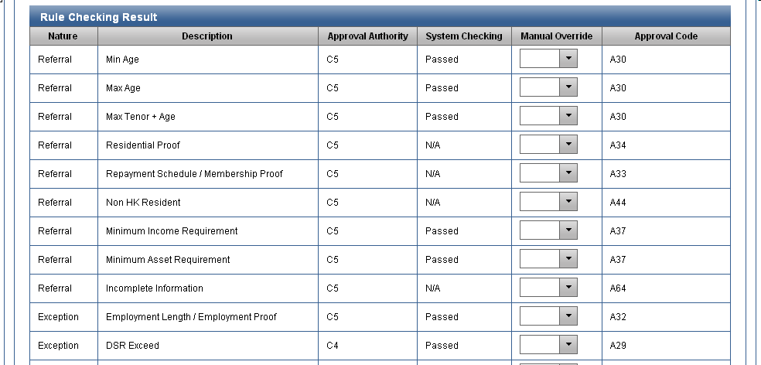
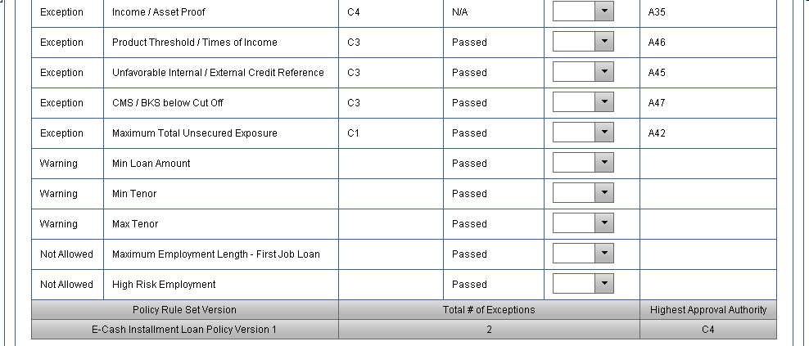
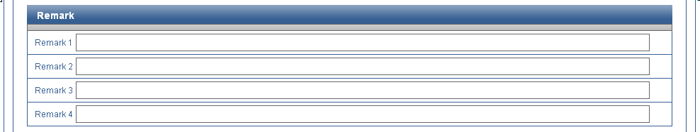
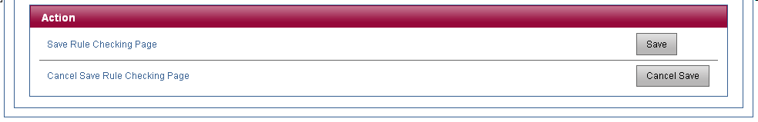

Pending Document
Rule Checking Tab Page is not available for “CL” – Capital Contribution Loan.
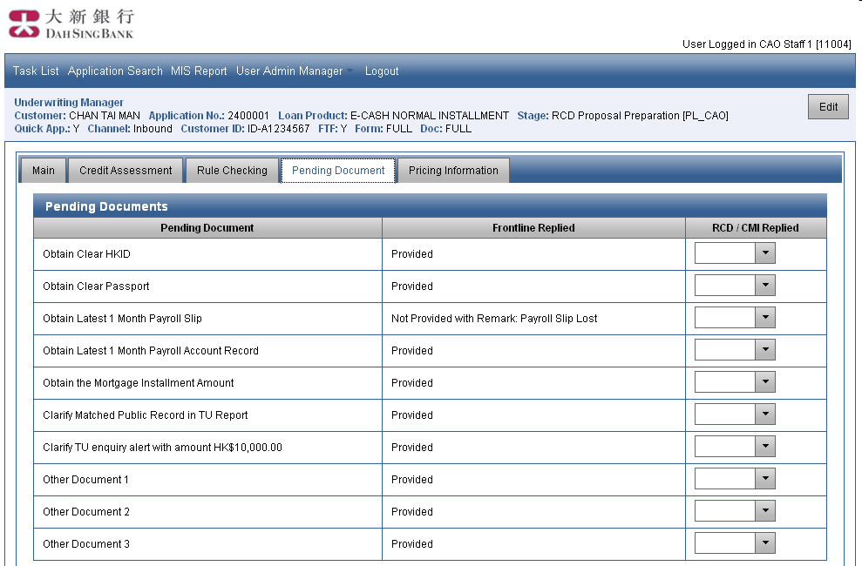
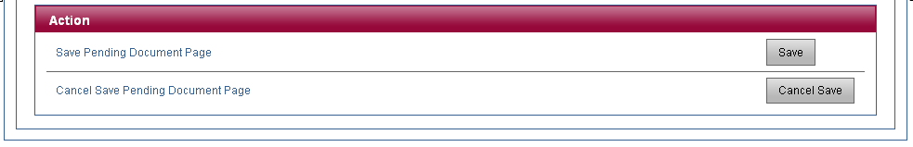

(Obsolete)

Fields and Validations

Main
Section: Submission Action
Screen Label | Type | Data Type | Mandatory | Validation | Possible Value | Source | Remarks
Route Back | Button | N/A | N/A | N/A | N/A | N/A | Request Further Information.
Route Back | Button | N/A | N/A | N/A | N/A | N/A | Request CPP Follow Up.
Submit | Button | N/A | N/A | N/A | N/A | N/A | Submit Approval Decision.
Route Back | Button | N/A | N/A | N/A | N/A | N/A | Return Credit Assessment Checklist.

Section: Pricing Deviation Action
Screen Label | Type | Data Type | Mandatory | Validation | Possible Value | Source | Remarks
Request | Button | N/A | N/A | N/A | N/A | N/A | Request Pricing Deviation Approval.
Revoke | Button | N/A | N/A | N/A | N/A | N/A | Revoke Pricing Deviation Approval Request.

Section: Other Action
Screen Label | Type | Data Type | Mandatory | Validation | Possible Value | Source | Remarks
Download | Button | N/A | N/A | N/A | N/A | N/A | Download Credit Assessment Checklist.
ECCD Process | Button | N/A | N/A | N/A | N/A | N/A | Start ECCD Process for the applicant.

Credit Assessment

Normal PL
For system calculated fields in Credit Assessment page, please refer to section 5.10.2.4 Credit Assessment Checklist Field Mapping for the extraction logic.
Section: Offer Other Loan
Screen Label | Type | Data Type | Mandatory | Validation | Possible Value | Source | Remarks
This section is shown if the latest credit decision is Offer Other Loan.
Loan Product | Drop Down List | String | Mandatory | N/A | Requested Product <Product Name>, Offered Product <Product Name> | User Input | Default: Offered Product <Product Name>  If this value is changed, the page will show the result of selected product.  It is editable in view mode. Otherwise, it is display only.

Section: Customer Information
Screen Label | Type | Data Type | Mandatory | Validation | Possible Value | Source | Remarks
Customer Name | Text | String | Mandatory | Display Only | N/A | From LOS
Customer ID | Text | String | Mandatory | Display Only | N/A | From LOS
Date of Birth | Text | Date | Mandatory | Display Only | N/A | From LOS
Age / Adjusted | Text | Number | Mandatory | Display Only | N/A | From LOS
Age / Adjusted | Text Box | Number (3) | Optional | > 0 | N/A | User Input
Residential Address | Text | String | Mandatory | Display Only | N/A | From LOS
Residence Status | Text | String | Mandatory | Display Only | N/A | From LOS
Mortgage Payment / Adjusted | Text | Number (11,2) | Optional | Display Only | N/A | From LOS
Mortgage Payment / Adjusted | Text Box | Number (11,2) | Optional | >= 0 | N/A | User Input
Outside DSB Mortgage | Text Box | String | Optional | If Martgage Payment has inputed with value, it become mandatory | “Y” / “N” | Display | According to PDM21102:  If Product = (EN, EM, EI and EV) and application create from DM List and Pre-Approved Amount Flag = ‘T’  It become display
Rental Expense / Adjusted | Text | Number (11,2) | Optional | Display Only | N/A | From LOS
Rental Expense / Adjusted | Text Box | Number (11,2) | Optional | >= 0 | N/A | User Input
Name of Employer | Text | String | Optional | Display Only | N/A | From LOS
Position | Text | String | Optional | Display Only | N/A | From LOS
Year of Service(s) | Text | Number | Optional | Display Only | N/A | From LOS
AML Checking | Drop Down List | String | Mandatory | N/A | Matched, Not Matched | User Input
Section 83/85 Checking | Drop Down List | String | Mandatory | N/A | Matched, Not Matched | User Input
Total Declared Monthly Installment Repayment Amount | Text | Number (11, 2) | Optional | >= 0 | N/A | From LOS
Total Declared Revolving Loan (including Credit Cards) / OD Used Amount | Text | Number (11, 2) | Optional | >= 0 | N/A | From LOS

Section: TU Credit Information
Screen Label | Type | Data Type | Mandatory | Validation | Possible Value | Source | Remarks
Last TU Checking Date | Text | Date | Optional | Display Only | N/A | From LOS
View TU Report | Button | N/A | N/A | N/A | N/A | N/A | Pop-up new window to show TU Report. This button is available if current user has PL_CAO, PL_PFC or PL_TUV role.
TU BKS | Text | String | Optional | Display Only | N/A | From LOS
TU CMS | Text | String | Optional | Display Only | N/A | From LOS
TU Public Record | Drop Down List | String | Mandatory | N/A | Matched, Not Matched | User Input
Revolving Credit
Total Credit Limit | Text | Number (11,2) | Optional | Display Only | N/A | From LOS
Total Used Limit | Text | Number (11,2) | Optional | Display Only | N/A | From LOS
Utilization Rate | Text | Number (4,2) | Optional | Display Only | N/A | From LOS
Current Pastdue Amount | Text | Number (11,2) | Optional | Display Only | N/A | From LOS
Terms & Other Credit
Total Loan Amount | Text | Number (11,2) | Optional | Display Only | N/A | From LOS
Total Loan O/S Amount | Text | Number (11,2) | Optional | Display Only | N/A | From LOS
Total Installment Amount | Text | Number (11,2) | Optional | Display Only | N/A | From LOS
Current Pasdue Amount | Text | Number (11,2) | Optional | Display Only | N/A | From LOS

Section: Loan Information
Screen Label | Type | Data Type | Mandatory | Validation | Possible Value | Source | Remarks
Product Name | Text | String | Mandatory | Display Only | N/A | From LOS
Campaign Code / Description | Text | String | Mandatory | Display Only | N/A | From LOS
Channel Source | Text | String | Mandatory | Display Only | N/A | From LOS
Source Code / Description | Text | String | Mandatory | Display Only | N/A | From LOS
Sales Code | Text | String | Mandatory | Display Only | N/A | From LOS
Sub-Source Code / Description | Text | String | Mandatory | Display Only | N/A | From LOS
CMI Sales Code | Text | String | Mandatory | Display Only | N/A | From LOS
DM Employer | Text | String | Optional | Display Only | N/A | From LOS | EMPLOYER_NAME of the DM List.
DM Consolidated Income | Text | String | Optional | Display Only | N/A | From LOS | INFLATED_INCOME of the DM List.
DM Income Type | Text | String | Optional | Display Only | P – Payroll, V – Verified Income, C – Claimed Income, D – Derived Income: Card, L – Derived Income: Non-Card | From LOS | INFLATED_INCOME_TYPE of the DM List.
Requested Loan Amount | Text | Number | Mandatory | Display Only | N/A | From LOS
Requested Tenor | Text | Number (3) | Mandatory | Display Only | N/A | From LOS
Proposed Loan Amount | Text Box | Number (11,2) | Optional | > 0 | N/A | User Input
Proposed Tenor | Text Box | Number (3) | Optional | > 0 | N/A | User Input
Default Monthly Flat Rate | Text | Number | Mandatory | Display Only | N/A | From LOS
Default Credit Life (p.a.) | Text | Number | Mandatory | Display Only | N/A | From LOS
Default APR | Text | Number | Mandatory | Display Only | N/A | From LOS
Default Instalment | Text | Number | Mandatory | Display Only | N/A | From LOS
Default Premium | Text | Number | Mandatory | Display Only | N/A | From LOS
Requested Monthly Flat Rate | Text | Number | Mandatory | Display Only | N/A | From LOS
Requested Credit Life (p.a.) | Text | Number | Mandatory | Display Only | N/A | From LOS
Requested APR | Text | Number | Mandatory | Display Only | N/A | From LOS
Requested Instalment | Text | Number | Mandatory | Display Only | N/A | From LOS
Requested Premium | Text | Number | Mandatory | Display Only | N/A | From LOS
Offered Monthly Flat Rate | Text Box | Number (6,4) | Mandatory | >0 | N/A | User Input | Default: Default Monthly Flat Rate
Offered Credit Life (p.a.) | Text Box | Number (5,2) | Mandatory | >0 | N/A | User Input | Default: Default Credit Life (p.a.)
Offered APR | Text | Number | Mandatory | Display Only | N/A | From LOS
Offered Instalment | Text | Number | Mandatory | Display Only | N/A | From LOS
Offered Premium | Text | Number | Mandatory | Display Only | N/A | From LOS
Discretionary Pricing Approved By | Text | String | Mandatory | Display Only | N/A | From LOS
Discretionary Pricing Approved By | Text Box | String (50) | Optional | N/A | N/A | User Input | For override name of Discretionary Pricing Approver
Pricing Deviation Manager | Button | N/A | N/A | N/A | N/A | N/A | Go to Pricing Deviation Manager

Section: Debt Consolidation Plan (Display for CMI Team use Only)(For EM / eCash Plus Revolving Instalment Loan ONLY)
Screen Label | Type | Data Type | Mandatory | Validation | Possible Value | Source | Remarks
Add | Button | N/A | N/A | N/A | N/A | From LOS | Add entry with Source equaled to Other to this section.  It is disabled if number of entries is more than [50].
Debt records are retrieved from TU report automatically according to logic in section 1.2. Allow [50] entries in maximum. For each entry, it has the following fields:
Record | Text | Number | Mandatory | Display Only | N/A | From LOS | Ordinal Position of Record
Source | Text | String | Mandatory | Display Only | TU, Others | From LOS
Remove | Button | N/A | N/A | N/A | N/A | From LOS | Remove this entry.  It is disabled if Source of the entry is TU.
Bank / Finance Name | Drop Down List | String (30) | Mandatory | N/A | Finance/Bank Code Table | User Input | It is disabled if Source is TU and the debt is originated from DSB.
View Addr | Button | N/A | N/A | N/A | N/A | User Input | To view the Bank Address and input
Type | Drop Down List | String | Mandatory | N/A | Installment Loan, OD, Credit Card, Cash Card | User Input | It is disabled and lookup from mapping table if Source is TU and Account No is available. Otherwise, It is allowed to updated.
Account No. | Text Box | String (20) | Optional | N/A | N/A | User Input | It is disabled if Source is TU and the debt is originated from DSB.
Currency | Drop Down List | String | Mandatory | N/A | HKD, CNY, USD | User Input | It is disabled if Source is TU.
Loan Amount / Credit Limit | Text Box | Number (11,2) | Mandatory | >0 | N/A | User Input | It is disabled if Source is TU.
Loan Amount / Credit Limit | Text | Number | Optional |  | N/A | From LOS | It is HKD equivalent value and shown when Currency is not HKD.
TU / O/S | Text Box | Number (11,2) | Mandatory | > 0 | N/A | User Input | It is disabled if Source is TU or Currency is not HKD.
Verified O/S | Text Box | Number (11,2) | Mandatory | > 0 | N/A | User Input | Default: Outstanding  It is disabled if Source is TU and the debt is originated from DSB.
Last 3 Installment | Drop Down List | String | Mandatory | N/A | Yes, No | User Input | It is disabled and has value of “N/A if Type is OD, Credit Card or Cash Card.
Monthly Payment | Text Box | Number (11,2) | Mandatory | > 0 | N/A | User Input | It is disabled if Source is TU or Currency is not HKD.
Verified Monthly Payment | Text Box | Number(11,2) | Mandatory | > 0 | N/A | User Input | It is disabled if Currency is not HKD.  It is disabled and has value of 0 if Verified Monthly Payment is 0.  It is disabled if Source is TU and the debt is originated from DSB.
Actions | Drop Down List | String | Mandatory | N/A | Refer to Loan Action Mapping | User Input | If Currency is not HKD, it is disabled and defaulted to Unsettle. Otherwise, it is mandatory.
Settle Amount to be settled (if applicable) | Text Box | Number (11,2) | Mandatory | > 0 and <= Verified O/S | N/A | User Input | It is enabled if Actions is “Settle only & no action to A/C”, “Settle & close” or “Settle & reduce limit” and Type is not Installment Loan.  It is disabled and has value set to Verified O/S if Actions is “Settle only & no action to A/C”, “Settle & close” or “Settle & reduce limit” and Type is Installment Loan.  Otherwise, it is disabled.
Remarks | Text Box | String (100) | Optional | N/A | N/A | User Input
Total (TU O/S) | Text | Number | Mandatory | N/A | N/A | From LOS
Total (Monthly Payment Before) | Text | Number | Mandatory | N/A | N/A | From LOS
Total (Verified O/S) | Text | Number | Mandatory | N/A | N/A | From LOS
Total (Monthly Payment After) | Text | Number | Mandatory | N/A | N/A | From LOS
Total Consol. Amount | Text | Number | Mandatory | N/A | N/A | From LOS
Cash-out | Text | Number | Mandatory | N/A | N/A | From LOS
Proposal Total Loan Amount | Text | Number | Mandatory | N/A | N/A | User Input
Income Multiple (Total Consol. Amount) | Text | Number | Mandatory | N/A | N/A | From LOS
Income Multiple (Cash-out) | Text | Number | Mandatory | N/A | N/A | From LOS
Verified Income (X5) | Text | Number | Mandatory | N/A | N/A | From LOS
Proposal Tenor | Text | Number | Mandatory | N/A | N/A | User Input

Section: DSR Calculation (For Normal PL – Exclude MP / VP Application)
Screen Label | Type | Data Type | Mandatory | Validation | Possible Value | Source | Remarks
DSR Calculation | Drop Down List | String | Mandatory | N/A | Yes, No | User Input | Default: Yes
TU Report
3% of Used Limit | Text | Number (11,2) | Optional | Display Only | N/A | From LOS | [3%] is system parameter.
Total Installment Amount | Text | Number (11,2) | Optional | Display Only | N/A | From LOS
Excluded Last 3 Installment | Text | Number (11,2) | Optional | Display Only | N/A | From LOS
Total Card Loan Installment Amount | Text | Number (11,2) | Optional | Display Only | N/A | From LOS
DSB Account (5710) – Apply to All general product except “CMI” and Card Loan (Cash-in Plus)
3% of Used Limit | Text | Number (11,2) | Optional | Display Only | N/A | From LOS | [3%] is system parameter.
Total Installment Amount | Text | Number (11,2) | Optional | Display Only | N/A | From LOS
Supporting Document / Claimed Information
Mortgage Installment Amt | Text | Number (11,2) | Optional | Display Only | N/A | From LOS
Other Loan ( + ) | Text Box | Number (11,2) | Optional | >= 0 | N/A | User Input
Total Declared Monthly Installment Repayment Amount | Text | Number (11, 2) | Optional | >= 0 | N/A | From LOS
3% of Total Declared Revolving Loan (including Credit Cards) / OD Used Amount | Text | Number (11, 2) | Optional | >= 0 | N/A | From LOS
Newly Grant Dah Sing Group Facility
One row for each product. Each row has the following columns
Description | Text | String | Mandatory | Display Only | Credit Card, Products defined in the system | From LOS
Amount $ | Text | Number (11,2) | Mandatory | Display Only | N/A | From LOS
DSB Loan to be settled ( - ) | Text | Number (11,2) | Optional | Display Only | N/A | From LOS
Other Exclusion ( - ) | Text Box | Number (11,2) | Optional | >= 0 | N/A | User Input
Total Monthly Debts | Text | Number (11,2) | Mandatory | Display Only | N/A | From LOS
Declared Income | Checkbox | Boolean | Optional | One and only one income must be checked. | N/A | User Input | Not Apply “CL” Loan
Declared Income | Text | Number (11,2) | Mandatory | Display Only | N/A | From LOS | Not Apply “CL” Loan
Consolidated Income | Checkbox | Boolean | Optional | One and only one income must be checked. | N/A | User Input | Not Apply “CL” Loan
Consolidated Income | Text | String | Optional | Display Only | N/A | From LOS | Income Type from DM List.  Not Apply “CL” Loan
Consolidated Income | Text | Number (11,2) | Optional | Display Only | N/A | From LOS | Consolidated Income from DM List.  Not Apply “CL” Loan
Verified Income | Checkbox | Boolean | Optional | One and only one income must be checked. | N/A | User Input
Verified Income | Text Box | Number (11,2) | Optional | Mandatory if “Verified Income” is checked. | N/A | User Input
Estimated Income | Checkbox | Boolean | Optional | One and only one income must be checked. | N/A | User Input | Not Apply “CL” Loan
Estimated Income | Text Box | Number (11,2) | Optional | Mandatory if “Estimated Income” is checked. | N/A | User Input | Not Apply “CL” Loan
Recurrent Income | Checkbox | Boolean | Optional | One and only one income must be checked. | N/A | User Input | For Product = “EM Normal Instalment Loan” + 100% PLGS = “Y” ONLY
Recurrent Income | Text Box | Number (11,2) | Optional | Mandatory if “Estimated Income” is checked. | N/A | User Input | For Product = “EM Normal Instalment Loan” + 100% PLGS = “Y” ONLY
Tu Proxy Income | Checkbox | Boolean | Optional | One and only one income must be checked. | N/A | User Input | Apply for :EM / eCash Revolving Instalment Loan , EM / eCash Plus Revolving Instalment Loan and Tax Loan  “NOT” Display Condition :  If Income Proof Indicator = “WAIVE” and CRM Verified Income Date + [47] > = Application Creation Date  Not Apply “CL” Loan
Tu Proxy Income | Text Box | Number (11,2) | Optional | Display Only | N/A | User Input | From Captured TU Proxy Income  Apply for :EM / eCash Revolving Instalment Loan , EM / eCash Plus Revolving Instalment Loan and Tax Loan  “NOT” Display Condition :  If Income Proof Indicator = “WAIVE” and CRM Verified Income Date + [47] > = Application Creation Date  Not Apply “CL” Loan
TU Proxy Income Date | Text | Date | Optional | Display Only | N/A | From LOS | From Captured TU Proxy Income  Format : YYYY-MM-DD  Not Apply “CL” Loan
Verified Income in CRM | Checkbox | Boolean | Optional | One and only one income must be checked. | N/A | User Input | Not Apply “CL” Loan
Verified Income in CRM | Text | Number (11,2) | Optional | Display Only | N/A | From LOS | Verified Income from CRM  Not Apply “CL” Loan
Verified Income in CRM | Text | Date | Optional | Display Only | N/A | From LOS | Verified Income Date from CRM  Not Apply “CL” Loan
Total Monthly Income | Text | Number (11,2) | Optional | Display Only | N/A | From LOS
DSR Cap | Text | Number (3) | Optional | Display Only | N/A | From LOS
DSR | Text | Number (4,2) | Optional | Display Only | N/A | From LOS
Override DSR Cap | Text | Number (5,3) | Optional | Allow Input for “EM / eCash Revolving Instalment Loan” Only | “0”, “Blank”, “99.99”  Default : Blank | User Input | Error Message hall be display if the Override DSR Cap > Max PL DSR Cap
Reference DSR | Text | Number (4,2) | Optional | Display Only | N/A | From LOS | This field is only available for Express Money and e-Cash Revolving Installment Loan Product.

Section: DSR Calculation (For Exclude MP / VP Application)
Screen Label | Type | Data Type | Mandatory | Validation | Possible Value | Source | Remarks
DSR Calculation | Drop Down List | String | Mandatory | N/A | Yes, No | User Input | Default: Yes
Debt Consolidation Plan - Source = TU
3% of Used Limit | Text | Number (11,2) | Optional | Display Only | N/A | From LOS | [3%] is system parameter.  (Reference ONLY) in Grey Color
Total Installment Amount | Text | Number (11,2) | Optional | Display Only | N/A | From LOS
Excluded Last 3 Installment | Text | Number (11,2) | Optional | Display Only | N/A | From LOS
3% DCP Settled Account Used Limit | Text | Number (11,2) | Optional | Display Only | N/A | From LOS
3% DCP without Settled Account Used Limit | Text | Number (11,2) | Optional | Display Only | N/A | From LOS
By Declare
3% of Total Declared Revolving Loan / OD Used Amount | Text | Number (11,2) | Optional | Display Only | N/A | From LOS | [3%] is system parameter.  (Reference ONLY) in Grey Color
Total Declared Monthly Installment | Text | Number (11,2) | Optional | Display Only | N/A | From LOS
3% Total Declared Revolving Loan / OD Used Amount without Settled Account | Text | Number (11,2) | Optional | Display Only | N/A | From LOS
Supporting Document / Claimed Information
Mortgage Installment Amt | Text | Number (11,2) | Optional | Display Only | N/A | From LOS
Other Loan ( + ) | Text Box | Number (11,2) | Optional | >= 0 | N/A | User Input
Newly Grant Dah Sing Group Facility
One row for each product. Each row has the following columns
Description | Text | String | Mandatory | Display Only | Credit Card, Products defined in the system | From LOS
Amount $ | Text | Number (11,2) | Mandatory | Display Only | N/A | From LOS
DSB Loan to be settled ( - ) | Text | Number (11,2) | Optional | Display Only | N/A | From LOS
Other Exclusion ( - ) | Text Box | Number (11,2) | Optional | >= 0 | N/A | User Input
Total Monthly Debts | Text | Number (11,2) | Mandatory | Display Only | N/A | From LOS
Declared Income | Checkbox | Boolean | Optional | One and only one income must be checked. | N/A | User Input
Declared Income | Text | Number (11,2) | Mandatory | Display Only | N/A | From LOS
Consolidated Income | Checkbox | Boolean | Optional | One and only one income must be checked. | N/A | User Input
Consolidated Income | Text | String | Optional | Display Only | N/A | From LOS | Income Type from DM List.
Consolidated Income | Text | Number (11,2) | Optional | Display Only | N/A | From LOS | Consolidated Income from DM List.
Verified Income | Checkbox | Boolean | Optional | One and only one income must be checked. | N/A | User Input
Verified Income | Text Box | Number (11,2) | Optional | Mandatory if "Verified Income" is checked. | N/A | User Input
Estimated Income | Checkbox | Boolean | Optional | One and only one income must be checked. | N/A | User Input
Estimated Income | Text Box | Number (11,2) | Optional | Mandatory if "Estimated Income" is checked. | N/A | User Input
Verified Income in CRM | Checkbox | Boolean | Optional | One and only one income must be checked. | N/A | User Input
Verified Income in CRM | Text | Number (11,2) | Optional | Display Only | N/A | From LOS | Verified Income from CRM
Verified Income in CRM | Text | Date | Optional | Display Only | N/A | From LOS | Verified Income Date from CRM
Total Monthly Income | Text | Number (11,2) | Optional | Display Only | N/A | From LOS
DSR Cap | Text | Number (3) | Optional | Display Only | N/A | From LOS
DSR | Text | Number (4,2) | Optional | Display Only | N/A | From LOS
Reference DSR | Text | Number (4,2) | Optional | Display Only | N/A | From LOS | This field is only available for Express Money and e-Cash Revolving Installment Loan Product.

Section: Asset Proof Approach
Screen Label | Type | Data Type | Mandatory | Validation | Possible Value | Source | Remarks
This section is shown if DSR Calculation is No. Otherwise, it is hidden.
Discounted Net Worth | Text Box | Number (11,2) | Mandatory | >= 0 | N/A | User Input

Section: RSA Reporting of Capital Adequacy Ratio
Screen Label | Type | Data Type | Mandatory | Validation | Possible Value | Source | Remarks
This section is shown if Product = (EN, EM, MP, EI, EV, VP, IM, EC, FM and TL). Otherwise, it is hidden.
Total Income Amount in HKD | Text Box | Number (11,2) | Mandatory for approval | >= 0 | N/A | User Input
Max. Monthly Installment Amount / Credit Limit 3.5% | Text Box | Number (11,2) | Display Field | N/A | N/A | From LOS | For PL  Before Acceptance: = Approved Monthly Instalment  At or After Acceptance = Max Instalment Amount  For Cash Card or FMOD  Before Acceptance: = Approved Amount * 3.5 %  At or After Acceptance = Accepted Loan Amount * 3.5%
Currency Mismatch Indicator | Text Box | String | Display Field | N/A | “Y” / “N” | From LOS | Refer to calculation logic at 5.9.2.36

Section: Total Exposure
Screen Label | Type | Data Type | Mandatory | Validation | Possible Value | Source | Remarks
One row for each product. Each row has the following columns
Product | Text | String | Mandatory | Display Only | Credit Card, Products defined in the system | From LOS
Original Limit / Outstanding | Text | Number (11,2) | Optional | Display Only | N/A | From LOS
Adjustment ( + / - ) | Text Box | Number (11,2) | Optional | N/A | N/A | User Input
Newly Applied ( + ) | Text | Number (11,2) | Optional | Display Only | N/A | From LOS
Total Product Final Limit / Outstanding | Text | Number (11,2) | Optional | Display Only | N/A | From LOS
Adjustment ( + / - )
Adjustment ( + / - ) | Text Box | Number (11,2) | Optional | N/A | N/A | User Input
Total Product Final Limit / Outstanding | Text | Number (11,2) | Optional | Display Only | N/A | From LOS
Product Cap ($) | Text | Number (11,2) | Optional | Display Only | N/A | From LOS
Total Product ($) | Text | Number (11,2) | Optional | Display Only | N/A | From LOS
Exposure Cap ($) | Text | Number (11,2) | Optional | Display Only | N/A | From LOS
Total Exposure ($) | Text | Number (11,2) | Optional | Display Only | N/A | From LOS
Product Cap (X) | Text | Number (4,2) | Optional | Display Only | N/A | From LOS
Total Product (X) | Text | Number (4,2) | Optional | Display Only | N/A | From LOS
Exposure Cap (X) | Text | Number (4,2) | Optional | Display Only | N/A | From LOS
Total Exposure (X) | Text | Number (4,2) | Optional | Display Only | N/A | From LOS

Section: Total Exposure (Asset Proof Approach)
Screen Label | Type | Data Type | Mandatory | Validation | Possible Value | Source | Remarks
This section is shown if DSR Calculation is No. Otherwise, it is hidden.
Exposure Cap ($) | Text | Number (11,2) | Optional | Display Only | N/A | From LOS
Total Exposure ($) | Text | Number (11,2) | Optional | Display Only | N/A | From LOS
Exposure Cap (%) | Text | Number (2) | Optional | Display Only | N/A | From LOS
Total Exposure (%) | Text | Number (4,2) | Optional | Display Only | N/A | From LOS

Section: Other Information
Screen Label | Type | Data Type | Mandatory | Validation | Possible Value | Source | Remarks
Property Owner | Text | String | Mandatory | Display Only | Yes, No | From LOS
Property Owner | Drop Down List | String | Optional | N/A | Yes, No | User Input
RCD On-us Mortgage | Text | String | Optional | Display Only | N/A | From LOS
RCD On-us Mortgage | Drop Down List | String | Optional |  | “Y” / “N” / Blank | User Input | Refer to Control Logic of RCD On-us Mortgage Section 5.9.4.2.3
Earliest Account Open Date | Text | Date | Optional | Display Only | N/A | From LOS
Earliest Account Open Date (in Months) | Text | Number | Optional | Display Only | N/A | From LOS
Disposable Income | Text | Number (11,2) | Mandatory | Display Only | N/A | From LOS

Section: Loan Information
Screen Label | Type | Data Type | Mandatory | Validation | Possible Value | Source | Remarks
Product Name | Text | String | Mandatory | Display Only | N/A | From LOS
Campaign Code / Description | Text | String | Mandatory | Display Only | N/A | From LOS
Channel Source | Text | String | Mandatory | Display Only | N/A | From LOS
Source Code / Description | Text | String | Mandatory | Display Only | N/A | From LOS
Quick Application Indicator | Text | String | Mandatory | Display Only | N/A | From LOS
Sub-Source Code / Description | Text | String | Mandatory | Display Only | N/A | From LOS
Pre-Approval Indicator | Text | String | Optional | Display Only | DM with TU check, DM wo TU check, N/A | From LOS
Pre-Approval Amount | Text | Number | Optional | Display Only | N/A | From LOS
FTF Indicator | Text | String | Optional | Display Only | FTF, NFTF | From LOS
Requested Loan Amount | Text | Number (11,2) | Mandatory | Display Only | N/A | From LOS
Requested Tenor | Text | Number (3) | Mandatory | Display Only | N/A | From LOS
Request Interest Rate | Text | Number (6,4) | Mandatory | Display Only | N/A | From LOS
Default Interest Rate | Text | Number (6,4) | Mandatory | Display Only | N/A | From LOS
Payment Holiday | Text | String | Optional | Display Only | N/A | From LOS
DM Employer | Text | String | Optional | Display Only | N/A | From LOS | EMPLOYER_NAME of the DM List.
DM Consolidated Income | Text | String | Optional | Display Only | N/A | From LOS | INFLATED_INCOME of the DM List.
DM Income Type | Text | String | Optional | Display Only | P - Payroll, V - Verified Income, C - Claimed Income, D - Derived Income: Card, L - Derived Income: Non-Card | From LOS | INFLATED_INCOME_TYPE of the DM List.

Section: Credit Decision
Screen Label | Type | Data Type | Mandatory | Validation | Possible Value | Source | Remarks
This section is shown if the latest credit decision is Pending.
Decision | Text | String | Mandatory | Display Only | Pending | From LOS
 | Checkbox | Boolean | Optional | At least one reason must be checked. | N/A | User Input | It is shown as “Obtain Clear HKID”.
 | Checkbox | Boolean | Optional | At least one reason must be checked. | N/A | User Input | It is shown as “Obtain Clear Passport”.
 | Checkbox | Boolean | Optional | At least one reason must be checked. | N/A | User Input | It is shown as “Obtain Latest 1 Month Payroll Slip”.
 | Checkbox | Boolean | Optional | At least one reason must be checked. | N/A | User Input | It is shown as “”Obtain Latest 1 Month Payroll Account Record.
 | Checkbox | Boolean | Optional | At least one reason must be checked. | N/A | User Input | It is shown as “Obtain the Mortgage Installment Amount”.
 | Checkbox | Boolean | Optional | At least one reason must be checked. | N/A | User Input | It is shown as “Clarify TU enquiry alert with amount HK$”.
 | Text Box | Number (11,2) | Optional | At least one reason must be checked. | N/A | User Input | It is mandatory if corresponding checkbox is selected.
 | Checkbox | Boolean | Optional | At least one reason must be checked. | N/A | User Input | It is shown as “Others”.
 | Text Box * 3 | String (100) | Optional | At least one remark must be filled if "Others" is checked. | N/A | User Input

Section: Credit Decision
Screen Label | Type | Data Type | Mandatory | Validation | Possible Value | Source | Remarks
This section is shown if the latest credit decision is Rejected.
Decision | Text | String | Mandatory | Display Only | Rejected | From LOS
Reject Code | Drop Down List | String | Mandatory | N/A | Decision Code Table with Type = REJ | User Input
Remarks | Text Box * 3 | String (100) | Optional | N/A | N/A | User Input

Section: Credit Decision
Screen Label | Type | Data Type | Mandatory | Validation | Possible Value | Source | Remarks
This section is shown if the latest credit decision is Approved.
Decision | Text | String | Mandatory | Display Only | Approved | From LOS
Approved Amount | Text Box | Number (11,2) | Optional | > 0 | N/A | User Input | Default: Requested Loan Amount or Max. Credit Limit if applied product’s Product Nature is Revolving Installment.  For Product = “EM Normal Instalment Loan” + 100% PLGS = “Y”,  If Approved Amount > 6 X Recurrent Income or > 80,000  Error message: ‘Approved Amount > HK$80,000 or 6 X Recurrent Income’  End if  Trigger during “Save”
Approved Tenor | Text Box | Number (3) | Optional | > 0 | N/A | User Input | Default: Requested Tenor or Max. Tenor if applied product’s Product Nature is Revolving Installment.  If the applied product does not have Tenor, this field will be disabled and shown as “NA”.  For Product = “EM Normal Instalment Loan” + 100% PLGS = “Y”,  If Approved Loan Tenor > 72.  Error message: ‘Approved Tenor > 72 months’  End if  Trigger during “Save”
Override Approved Tenor | Text Box | Number (3) | Optional | > 0 | N/A | User Input | Default: Empty  It will be editable if the “approved tenor” is empty and Age / Adjusted Age >= 65
Interest Rate Base | Drop Down List | String | Mandatory | N/A | - Prime  - Hibor  - Flat | User Input | For “CL” Loan Only
Approved Interest Rate | Text Box | Number (6,4) | Optional | >= 0 | N/A | User Input | Default: Source from the approved pricing in Pricing Deviation Manager; if not yet approved, then, the higher of Requested Pricing or Default Pricing.
APR | Text | Number (4,2) | Optional | Display Only | N/A | From LOS | For “CL” Loan, It will become editable.
Instalment Amount | Text | Number (11,2) | Optional | Display Only | N/A | From LOS | For “CL” Loan, It will become editable.  For “CL” Loan, The label change to “Mthly Instal. / Mthly Int.”
Maximum Credit Limit | Text | Number (11,2) | Optional | Display Only | N/A | From LOS | Not Apply to “CL” Loan
Maximum Tenor | Text | Number (3) | Optional | Display Only | N/A | From LOS | Not Apply to “CL” Loan
Maximum Inst. Amount | Text | Number (11,2) | Optional | Display Only | N/A | From LOS | Not Apply to “CL” Loan
Maximum Reference Limit | Text | Number (11,2) | Optional | Display Only | N/A | From LOS | Not Apply to “CL” Loan
Not Allow for Top up | Check Box | String | Optional |  | N/A | User Input | Checked : Not Allow to perform Top up  Unchecked: Allow to perform Top up  This field will pass to PL System during Drawdown Interface  This field will pass to CRM during regular CRM data update.  Not Apply to “CL” Loan
Request Repayment Option | Text | String | Mandatory | Display | - “The whole loan amt will be repaid by equal mthly inst. over the loan tenor.” (“WHOLE_AMT”)  - “Only interest will have to be paid on a mthly basis & the loan principal will be repaid upon maturity” (“INTEREST_ONLY”) | From LOS | For “CL” Loan Only
Approved Repayment Option | Check Box | String | Mandatory | N/A | 1. “The whole loan amt will be repaid by equal mthly inst. over the loan tenor.” (“WHOLE_AMT”)  2. “Only interest will have to be paid on a mthly basis & the loan principal will be repaid upon maturity” (“INTEREST_ONLY”) | User Input | For “CL” Loan Only
Economic Dependence / Guarantee Information Required | Check Box | String | Optional | N/A | N/A | User Input | Checked: Economic Dependence and guarantee information is required from applicant  Economic Dependence / Guarantee Information section in Application Manager will be shown if this check box is checked.  Otherwise Economic Dependence / Guarantee Information section in Application Manager will be hidden.

Section: Credit Decision
Screen Label | Type | Data Type | Mandatory | Validation | Possible Value | Source | Remarks
This section is shown if the latest credit decision is Offer Other Loan.
Decision | Text | String | Mandatory | Display Only | Offer Other Loan | From LOS
Reject Code | Drop Down List | String | Mandatory | N/A | Decision Code Table with Type = REJ | User Input
Product Name | Drop Down List | String | Mandatory | N/A | Counter Offer Product List of Requested Product | User Input
Offer Amount | Text Box | Number (11,2) | Mandatory | > 0 | N/A | User Input
Offer Tenor | Text Box | Number (3) | Optional | > 0 | N/A | User Input
Offer Interest Rate | Text Box | Number (6,4) | Optional | >= 0 | N/A | User Input | Default: Source from Default Pricing looked up by Offer Amount and Offer Tenor.
APR | Text | Number (4,2) | Optional | Display Only | N/A | From LOS
Economic Dependence / Guarantee Information Required | Check Box | String | Optional | N/A | N/A | User Input | Checked: Economic Dependence and guarantee information is required from applicant  Economic Dependence / Guarantee Information section in Application Manager will be shown if this check box is checked.  Otherwise Economic Dependence / Guarantee Information section in Application Manager will be hidden.

Section: Credit Decision (Others)
Screen Label | Type | Data Type | Mandatory | Validation | Possible Value | Source | Remarks
This section is shown if the latest credit decision is Approved or Offer Other Loan.
Approval Code | Text | String | Mandatory | Display Only | N/A | From LOS | For “CL” Loan, It will become editable.
Approval Condition(s), subject to:
(Nil) | Checkbox | Boolean | Optional | N/A | N/A | User Input | It is shown as “Delete "R" Code of Personal Loan A/C #”.
(Nil) | Text Box | String (20) | Optional | N/A | N/A | User Input | It is mandatory if “Delete "R" Code of Personal Loan A/C #” is checked.
(Nil) | Checkbox | Boolean | Optional | N/A | N/A | User Input | It is shown as “Reduce Credit Card Limit to HK$”.
(Nil) | Text Box | Number (11,2) | Optional | >= 0 | N/A | User Input | It is mandatory if “Reduce Credit Card Limit to HK$” is checked
(Nil)  (Nil) | Checkbox | Boolean | Optional | N/A | N/A | User Input | It is shown as “Reduce Overdraft A/C # {x} Limit to HK$ {y}”.
(Nil)  (Nil) | Text Box | String (20) | Optional | N/A | N/A | User Input | It is mandatory if “Reduce Overdraft A/C # {x} Limit to HK$ {y}” is checked.
(Nil)  (Nil) | Text Box | Number (11,2) | Optional | >= 0 | N/A | User Input | It is mandatory if “Reduce Overdraft A/C # {x} Limit to HK$ {y}” is checked.
(Nil) | Checkbox | Boolean | Optional | N/A | N/A | User Input | It is shown as “Reduce In-Money A/C # {x} Limit to HK$ {y}”.
(Nil) | Text Box | String (20) | Optional | N/A | N/A | User Input | It is mandatory if “Reduce In-Money A/C # {x} Limit to HK$ {y}” is checked.
(Nil) | Text Box | Number (11,2) | Optional | >= 0 | N/A | User Input | It is mandatory if “Reduce In-Money A/C # {x} Limit to HK$ {y}” is checked.
(Nil) | Checkbox | Boolean | Optional | N/A | N/A | User Input | It is shown as “Close Existing Overdraft A/C #”.
(Nil) | Text Box | String (20) | Optional | N/A | N/A | User Input | It is mandatory if “Close Existing Overdraft A/C #” is checked
(Nil) | Checkbox | Boolean | Optional | N/A | N/A | User Input | It is shown as “Close Existing In-Money A/C”.
(Nil) | Text Box | String (20) | Optional | N/A | N/A | User Input | It is mandatory if “Close Existing In-Money A/C” is checked
(Nil) | Checkbox | Boolean | Optional | N/A | N/A | User Input | It is shown as “Settle Personal Loan A/C #”.
(Nil) | Text Box | String (20) | Optional | N/A | N/A | User Input | It is mandatory if “Settle Personal Loan A/C #” is checked
(Nil) | Checkbox | Boolean | Optional | N/A | N/A | User Input | It is shown as “Settle Existing OD / Revolving A/C#”.
(Nil) | Text Box | String (20) | Optional | N/A | N/A | User Input | It is mandatory if “Settle Existing OD / Revolving A/C#” is checked
(Nil) | Checkbox | Boolean | Optional | N/A | N/A | User Input | It is shown as “Cancel & Cut-off Credit Card / OD / Revolving A/C#”.
(Nil) | Text Box | String (20) | Optional | N/A | N/A | User Input | It is mandatory if “Cancel & Cut-off Credit Card / OD / Revolving A/C#” is checked
(Nil) | Checkbox | Boolean | Optional | N/A | N/A | User Input | It is shown as “Certify HKID / Passport”.
(Nil) | Checkbox | Boolean | Optional | N/A | N/A | User Input | It is shown as “Certify Address Proof”.
(Nil) | Checkbox | Boolean | Optional | N/A | N/A | User Input | It is shown as “Sign Application Form”.
(Nil) | Checkbox | Boolean | Optional | N/A | N/A | User Input | It is shown as “Confirm Existence”.
(Nil) | Checkbox | Boolean | Optional | Mandatory – if RCD On-us Mortgage Indicator = Y | N/A | User Input | It is show as “Request to accept On-us Mortgage arrangement”
(Nil) | Text Box | Boolean | Optional / Mandatory | Mandatory – When “Request to accept On-us Mortgage arrangement” is checked | N/A | User Input | It is show as “Mortgage Loan Account”
(Nil) | Checkbox | Boolean | Optional | N/A | N/A | User Input | It is shown as “Match All Documents”.
(Nil) | Checkbox | Boolean | Optional | N/A | N/A | User Input | It is shown as “Others - ”.
(Nil) | Text Box * 3 | String (100) | Optional | N/A | N/A | User Input | It is mandatory if “Others - ” is checked.
Comments and Justification | Text Box * 4 | String (100) | Optional | N/A | N/A | User Input

Section: Approvers
Screen Label | Type | Data Type | Mandatory | Validation | Possible Value | Source | Remarks
Minimum Approval Authority | Text | String | Mandatory | Display Only | N/A | From LOS | For “CL” Loan, It will become editable.
There are 4 approvers. Each one has the following fields:
(Nil) | Drop Down List | String | Optional | N/A | PL_GCC, PL_SBO, PL_CCO, PL_CAO_C1, PL_CAO_C2, PL_CAO_C3, PL_CAO_C4 , PL_CAO_C5 | User Input | Approver Role
(Nil) | Drop Down List | String | Optional | N/A | User with selected approver role | User Input | Display value has pattern “User Name [User ID]”.
(Nil) | Text Box | String (100) | Optional | N/A | N/A | User Input | It is overridden user name to be printed in credit assessment checklist.

Section: Drawdown Document Checklist
Screen Label | Type | Data Type | Mandatory | Validation | Possible Value | Source | Remarks
System Determined
System will add entry to this table automatically base on data inputted in credit assessment. Please refer to section 5.6.2.58 for the logic. Each entry has the following fields:
(Nil) | Checkbox | Boolean | Optional | N/A | Selected, Unselected | User Input | Default: Selected
Item | Text | String | Mandatory | Display Only | N/A | From LOS | Please refer to section 5.6.2.58.
Required Action By Branch | Text | String | Optional | Display Only | N/A | From LOS | Please refer to section 5.6.2.58.
Additional Items
System will add entry to this table according to Drawdown Document Code Table with Type = Manual and Normal PL = Yes. User can add new entry manually.
Add | Button | N/A | N/A | N/A | N/A | N/A | Add new entry to table below.
Remove | Button | N/A | N/A | N/A | N/A | N/A | Remove selected entry. Only entry added manually can be removed.
Each entry has the following fields:
(Nil) | Checkbox | Boolean | Optional | N/A | Selected, Unselected | User Input | Default:  Unselected if entry is retrieved from code table.  Selected if entry is added manually.
Item | Text Box | String (200) | Mandatory | N/A | N/A | From LOS / User Input | It is display only if entry is retrieved from code table.  It is editable if entry is added manually.
Required Action By Branch | Text Box | String (200) | Optional | N/A | N/A | From LOS / User Input | It is display only if entry is retrieved from code table.  It is editable if entry is added manually.
Attached Document
This section allows user to upload additional 3 documents to Drawdown Document Checklist.
Document 1 | Text | String | Optional | Display Only | N/A | N/A | Attached file name.
Remove | Button | N/A | N/A | N/A | N/A | N/A | When this button is clicked, system will remove uploaded document 1.  This button is shown if document 1 is uploaded. Otherwise, it is hidden.
Upload | Button | N/A | N/A | N/A | N/A | N/A | When this button is clicked, system will allow user to add file for document 1.
Download | Button | N/A | N/A | N/A | N/A | N/A | Click to download the document.  It is shown if document 1 is available. Otherwise, it is hidden.
Document 2 | Text | String | Optional | Display Only | N/A | N/A | Attached file name.
Remove | Button | N/A | N/A | N/A | N/A | N/A | When this button is clicked, system will remove uploaded document 2.  This button is shown if document 2 is uploaded. Otherwise, it is hidden.
Upload | Button | N/A | N/A | N/A | N/A | N/A | When this button is clicked, system will allow user to add file for document 2.
Download | Button | N/A | N/A | N/A | N/A | N/A | Click to download the document.  It is shown if document 2 is available. Otherwise, it is hidden.
Document 3 | Text | String | Optional | Display Only | N/A | N/A | Attached file name.
Remove | Button | N/A | N/A | N/A | N/A | N/A | When this button is clicked, system will remove uploaded document 3.  This button is shown if document 3 is uploaded. Otherwise, it is hidden.
Upload | Button | N/A | N/A | N/A | N/A | N/A | When this button is clicked, system will allow user to add file for document 3.
Download | Button | N/A | N/A | N/A | N/A | N/A | Click to download the document.  It is shown if document 3 is available. Otherwise, it is hidden.

Section: Action
Screen Label | Type | Data Type | Mandatory | Validation | Possible Value | Source | Remarks
These buttons are shown if
- Application is picked up from Task List.
- And Application stage is RCD Proposal Preparation.
- And Credit Assessment page is in read mode.
Pending | Button | N/A | N/A | N/A | N/A | N/A | Request for Pending Document
Approve | Button | N/A | N/A | N/A | N/A | N/A | Approve Application
Offer Other Loan | Button | N/A | N/A | N/A | N/A | N/A | Offer Other Loan
Reject | Button | N/A | N/A | N/A | N/A | N/A | Reject Application
Download | Button | N/A | N/A | N/A | N/A | N/A | Download Credit Assessment Checklist
These buttons are shown if Credit Assessment page is in edit mode.
Save | Button | N/A | N/A | N/A | N/A | N/A | Save Credit Assessment
Cancel Save | Button | N/A | N/A | N/A | N/A | N/A | Cancel Save Credit Assessment
These buttons are shown if Request for Pending Document button is clicked
Confirm Pending | Button | N/A | N/A | N/A | N/A | N/A | Confirm Request for Pending Document
Cancel | Button | N/A | N/A | N/A | N/A | N/A | Cancel Request for Pending Document
These buttons are shown if Approve Application button is clicked
Submit | Button | N/A | N/A | N/A | N/A | N/A | Save and Submit Approval Decision
Save | Button | N/A | N/A | N/A | N/A | N/A | Save Approval Decision
Cancel | Button | N/A | N/A | N/A | N/A | N/A | Cancel Approval Decision
These buttons are shown if Offer Other Loan button is clicked
Submit | Button | N/A | N/A | N/A | N/A | N/A | Save and Submit Offer Other Loan
Save | Button | N/A | N/A | N/A | N/A | N/A | Save Offer Other Loan
Cancel | Button | N/A | N/A | N/A | N/A | N/A | Cancel Offer Other Loan
These buttons are shown if Reject Application button is clicked
Confirm Reject | Button | N/A | N/A | N/A | N/A | N/A | Confirm Reject Application
Cancel | Button | N/A | N/A | N/A | N/A | N/A | Cancel Reject Application

CMI
For system calculated fields in Credit Assessment page, please refer to section 5.10.2.16 Credit Assessment Checklist Field Mapping (CMI) for the extraction logic.
Section: Customer Information
Screen Label | Type | Data Type | Mandatory | Validation | Possible Value | Source | Remarks
Customer Name | Text | String | Mandatory | Display Only | N/A | From LOS
Customer ID | Text | String | Mandatory | Display Only | N/A | From LOS
Date of Birth | Text | Date | Mandatory | Display Only | N/A | From LOS
Age / Adjusted | Text | Number | Mandatory | Display Only | N/A | From LOS
Age / Adjusted | Text Box | Number (3) | Optional | > 0 | N/A | User Input
Residential Address | Text | String | Mandatory | Display Only | N/A | From LOS
Residence Status | Text | String | Mandatory | Display Only | Rental Accommodation, Housing Provided By Employer/Relatives, Government Housing Estate, Own House/Flat - With Mortgage, Own House/Flat - Without Mortgage | From LOS
Home Tel. | Text | String | Optional | Display Only | N/A | From LOS
Office Tel. | Text | String | Optional | Display Only | N/A | From LOS
Mobile No. | Text | String | Optional | Display Only | N/A | From LOS
Pager No. | Text | String | Optional | Display Only | N/A | From LOS
Marital Status | Text | String | Mandatory | Display Only | N/A | From LOS
Name of Employer | Text | String | Optional | Display Only | N/A | From LOS
Position | Text | String | Optional | Display Only | N/A | From LOS
Year of Service(s) | Text | Number | Optional | Display Only | N/A | From LOS
AML Checking | Drop Down List | String | Mandatory | N/A | Matched, Not Matched | User Input
Section 83/85 Checking | Drop Down List | String | Mandatory | N/A | Matched, Not Matched | User Input
Declared Mortgage Installment | Text | Number (11,2) | Optional | Display Only | N/A | From LOS
Declared Rental Expense | Text | Number (11,2) | Optional | Display Only | N/A | From LOS
Declared Monthly Income | Text | Number (11,2) | Optional | Display Only | N/A | From LOS
Verified Mortgage Installment | Text Box | Number (11,2) | Optional | >= 0 | N/A | User Input | Default: Declared Mortgage Installment
Verified Rental Expense | Text Box | Number (11,2) | Optional | >= 0 | N/A | User Input | Default: Declared Rental Expense
Verified Monthly Income | Text Box | Number (11,2) | Optional | >= 0 | N/A | User Input | Default: Declared Monthly Income

Section: Loan Information
Screen Label | Type | Data Type | Mandatory | Validation | Possible Value | Source | Remarks
Product Name | Text | String | Mandatory | Display Only | N/A | From LOS
Campaign Code / Description | Text | String | Mandatory | Display Only | N/A | From LOS
Channel Source | Text | String | Mandatory | Display Only | N/A | From LOS
Source Code / Description | Text | String | Mandatory | Display Only | N/A | From LOS
Sales Code | Text | String | Mandatory | Display Only | N/A | From LOS
Sub-Source Code / Description | Text | String | Mandatory | Display Only | N/A | From LOS
CMI Sales Code | Text | String | Mandatory | Display Only | N/A | From LOS
DM Employer | Text | String | Optional | Display Only | N/A | From LOS | EMPLOYER_NAME of the DM List.
DM Consolidated Income | Text | String | Optional | Display Only | N/A | From LOS | INFLATED_INCOME of the DM List.
DM Income Type | Text | String | Optional | Display Only | P - Payroll, V - Verified Income, C - Claimed Income, D - Derived Income: Card, L - Derived Income: Non-Card | From LOS | INFLATED_INCOME_TYPE of the DM List.
Total Tax Payable | Text Box | Number (11,2) | Optional | >= 0 | N/A | User Input
Tax Bill Settle Amount | Text Box | Number (11,2) | Optional | >= 0 | N/A | User Input
Requested Loan Amount | Text | Number | Mandatory | Display Only | N/A | From LOS
Requested Tenor | Text | Number (3) | Mandatory | Display Only | N/A | From LOS
Proposed Loan Amount | Text Box | Number (11,2) | Optional | > 0 | N/A | User Input
Proposed Tenor | Text Box | Number (3) | Optional | > 0 | N/A | User Input
Default Monthly Flat Rate | Text | Number | Mandatory | Display Only | N/A | From LOS
Default Credit Life (p.a.) | Text | Number | Mandatory | Display Only | N/A | From LOS
Default APR | Text | Number | Mandatory | Display Only | N/A | From LOS
Default Instalment | Text | Number | Mandatory | Display Only | N/A | From LOS
Default Premium | Text | Number | Mandatory | Display Only | N/A | From LOS
Requested Monthly Flat Rate | Text | Number | Mandatory | Display Only | N/A | From LOS
Requested Credit Life (p.a.) | Text | Number | Mandatory | Display Only | N/A | From LOS
Requested APR | Text | Number | Mandatory | Display Only | N/A | From LOS
Requested Instalment | Text | Number | Mandatory | Display Only | N/A | From LOS
Requested Premium | Text | Number | Mandatory | Display Only | N/A | From LOS
Offered Monthly Flat Rate | Text Box | Number (6,4) | Mandatory | >0 | N/A | User Input | Default: Default Monthly Flat Rate
Offered Credit Life (p.a.) | Text Box | Number (5,2) | Mandatory | >0 | N/A | User Input | Default: Default Credit Life (p.a.)
Offered APR | Text | Number | Mandatory | Display Only | N/A | From LOS
Offered Instalment | Text | Number | Mandatory | Display Only | N/A | From LOS
Offered Premium | Text | Number | Mandatory | Display Only | N/A | From LOS
Discretionary Pricing Approved By | Text | String | Mandatory | Display Only | N/A | From LOS
Discretionary Pricing Approved By | Text Box | String (50) | Optional | N/A | N/A | User Input | For override name of Discretionary Pricing Approver
Pricing Deviation Manager | Button | N/A | N/A | N/A | N/A | N/A | Go to Pricing Deviation Manager

Section: TU Credit Information
Screen Label | Type | Data Type | Mandatory | Validation | Possible Value | Source | Remarks
Last TU Checking Date | Text | Date | Optional | Display Only | N/A | From LOS
View TU Report | Button | N/A | N/A | N/A | N/A | N/A | Pop-up new window to show TU Report. This button is available if current user has PL_CAO, PL_PFC or PL_TUV role.
TU BKS | Text | String | Optional | Display Only | N/A | From LOS
TU CMS | Text | String | Optional | Display Only | N/A | From LOS
TU Public Record | Drop Down List | String | Mandatory | N/A | Matched, Not Matched | User Input | For Relief Plan Application, It is Optional Field
Revolving Credit
Total Credit Limit | Text | Number | Optional | Display Only | N/A | From LOS
Total Used Limit | Text | Number | Optional | Display Only | N/A | From LOS
Utilization Rate | Text | Number | Optional | Display Only | N/A | From LOS
Current Pastdue Amount | Text | Number | Optional | Display Only | N/A | From LOS
Terms & Other Credit
Total Loan Amount | Text | Number | Optional | Display Only | N/A | From LOS
Total Loan O/S Amount | Text | Number | Optional | Display Only | N/A | From LOS
Total Installment Amount | Text | Number | Optional | Display Only | N/A | From LOS
Current Pasdue Amount | Text | Number | Optional | Display Only | N/A | From LOS

Section: Debt Consolidation Plan
For Relief Plan Application, It is Optional Section
Screen Label | Type | Data Type | Mandatory | Validation | Possible Value | Source | Remarks
Add | Button | N/A | N/A | N/A | N/A | From LOS | Add entry to this section.
Remove | Button | N/A | N/A | N/A | N/A | From LOS | Remove selected entry in this section.
Debt records are retrieved from TU report automatically. Allow 50 entries in maximum. For each entry, it has the following fields:
Record | Text | Number | Mandatory | Display Only | N/A | From LOS | Ordinal Position of Record
Source | Text | String | Mandatory | Display Only | TU, Others | From LOS
Bank / Finance Name | Text Box | String (30) | Mandatory | N/A | N/A | User Input
Type | Drop Down List | String | Mandatory | N/A | Installment Loan, OD, Credit Card, Cash Card | User Input
Account No. | Text Box | String (20) | Optional | N/A | N/A | User Input
Currency | Drop Down List | String | Mandatory | N/A | HKD, CNY, USD | User Input | It is disabled if Source is TU.
Loan Amount / Credit Limit | Text Box | Number (11,2) | Mandatory | >0 | N/A | User Input | It is disabled if Source is TU.
Loan Amount / Credit Limit | Text | Number | Optional |  | N/A | From LOS | It is HKD equivalent value and shown when Currency is not HKD.
Outstanding | Text Box | Number (11,2) | Mandatory | > 0 | N/A | User Input | It is disabled if Source is TU or Currency is not HKD.
Last 3 Installment | Drop Down List | String | Mandatory | N/A | Yes, No | User Input | It is disabled if Source is TU or Currency is not HKD.
Monthly Payment | Text Box | Number (11,2) | Mandatory | > 0 | N/A | User Input | It is disabled if Source is TU or Currency is not HKD.
Verified O/S | Text Box | Number (11,2) | Mandatory | > 0 | N/A | User Input | Default: Outstanding  It is disabled if Source is TU or Currency is not HKD.
Verified Monthly Payment | Text Box | Number(11,2) | Mandatory | > 0 | N/A | User Input | It is disabled if Currency is not HKD.
Actions | Drop Down List | String | Mandatory | N/A | "Unsettle", "Unsettle & reduce limit", "Settle only & no action to A/C", "Settle & close", "Settle & reduce limit" | User Input | If Currency is not HKD, it is disabled and defaulted to Unsettle. Otherwise, it is mandatory.
Settle Amount to be settled (if applicable) | Text Box | Number (11,2) | Mandatory | > 0 | N/A | User Input | It is enabled if Actions is "Settle only & no action to A/C", "Settle & close" or "Settle & reduce limit".  Otherwise, it is disabled.
Reduce Limit Amount (if applicable) | Text Box | Number (11,2) | Mandatory | > 0 | N/A | User Input | It is enabled if Actions is "Unsettle & reduce limit" or "Settle & reduce limit".  Otherwise, it is disabled.
Remarks | Text Box | String (100) | Optional | N/A | N/A | User Input
Total (Outstanding) | Text | Number | Mandatory | N/A | N/A | From LOS
Total (Monthly Payment) | Text | Number | Mandatory | N/A | N/A | From LOS
Accounts Consolidated (Outstanding) | Text | Number | Mandatory | N/A | N/A | From LOS
Accounts Consolidated (Monthly Payment) | Text | Number | Mandatory | N/A | N/A | From LOS
Accounts Not Consolidated (Outstanding) | Text | Number | Mandatory | N/A | N/A | From LOS
Accounts Not Consolidated (Monthly Payment) | Text | Number | Mandatory | N/A | N/A | From LOS
Total Consol. Amount | Text | Number | Mandatory | N/A | N/A | From LOS
Cash-out | Text | Number | Mandatory | N/A | N/A | From LOS
Total Loan Amount | Text | Number | Mandatory | N/A | N/A | From LOS
Income Multiple (Total Consol. Amount) | Text | Number | Mandatory | N/A | N/A | From LOS
Income Multiple (Cash-out) | Text | Number | Mandatory | N/A | N/A | From LOS
Income Multiple (Total Loan Amount) | Text | Number | Mandatory | N/A | N/A | From LOS

Section: DSR Calculation
For Relief Plan Application, No TU Report and DSR Calculation is not required. This section information is not considerable.
Screen Label | Type | Data Type | Mandatory | Validation | Possible Value | Source | Remarks
TU Report
3% of Used Limit | Text | Number | Optional | Display Only | N/A | From LOS | [3%] is system parameter.
Total Installment Amount | Text | Number | Optional | Display Only | N/A | From LOS
Excluded Last 3 Installment | Text | Number | Optional | Display Only | N/A | From LOS
Supporting Document / Claimed Information
Mortgage Installment Amt | Text | Number | Optional | Display Only | N/A | From LOS
Other Loan ( + ) | Text Box | Number (11,2) | Optional | >= 0 | N/A | User Input
Newly Grant Dah Sing Group Facility
One row for each product. Each row has the following columns
Description | Text | Number | Mandatory | Display Only | Credit Card, Products defined in the system | From LOS
Amount $ | Text | Number | Mandatory | Display Only | N/A | From LOS
DSB Loan to be settled ( - ) | Text | Number | Optional | Display Only | N/ | From LOS
Other Exclusion ( - ) | Text Box | Number (11,2) | Optional | >= 0 | N/A | User Input
Total Monthly Debts | Text | Number | Mandatory | Display Only | N/A | From LOS
Declared Income | Checkbox | Boolean | Optional | One and only one income must be checked. | N/A | User Input
Declared Income | Text | Number | Mandatory | Display Only | N/A | From LOS
Consolidated Income | Checkbox | Boolean | Optional | One and only one income must be checked. | N/A | User Input
Consolidated Income | Text | String | Optional | Display Only | N/A | From LOS | Income Type from DM List.
Consolidated Income | Text | Number | Optional | Display Only | N/A | From LOS | Consolidated Income from DM List.
Verified Income | Checkbox | Boolean | Optional | One and only one income must be checked. | N/A | User Input
Verified Income | Text | Number | Optional | Display Only | N/A | From LOS | It is Verified Monthly Income in Customer Information section.
Estimated Income | Checkbox | Boolean | Optional | One and only one income must be checked. | N/A | User Input
Estimated Income | Text Box | Number (11,2) | Optional | Mandatory if "Estimated Income" is checked. | N/A | User Input
Verified Income in CRM | Checkbox | Boolean | Optional | One and only one income must be checked. | N/A | User Input
Verified Income in CRM | Text | Number (11,2) | Optional | Display Only | N/A | From LOS | Verified Income from CRM
Verified Income in CRM | Text | Date | Optional | Display Only | N/A | From LOS | Verified Income Date from CRM
Total Monthly Income | Text | Number | Optional | Display Only | N/A | From LOS
DSR Cap | Text | Number | Optional | Display Only | N/A | From LOS
DSR | Text | Number | Optional | Display Only | N/A | From LOS

Section: RSA Reporting of Capital Adequacy Ratio
Screen Label | Type | Data Type | Mandatory | Validation | Possible Value | Source | Remarks
This section is shown if Product = (EN, EM, MP, EI, EV, VP, IM, EC, FM and TL). Otherwise, it is hidden.
Total Income Amount in HKD | Text Box | Number (11,2) | Mandatory for approval | >= 0 | N/A | User Input
Max. Monthly Installment Amount / Credit Limit 3.5% | Text Box | Number (11,2) | Display Field | N/A | N/A | From LOS | Before Acceptance: = Approved Monthly Instalment  At or After Acceptance = Max Approved Monthly Instalment
Currency Mismatch Indicator | Text Box | String | Display Field | N/A | “Y” / “N” | From LOS | Refer to calculation logic at 5.9.2.36

Section: Total Exposure
Screen Label | Type | Data Type | Mandatory | Validation | Possible Value | Source | Remarks
One row for each product. Each row has the following columns
Product | Text | String | Mandatory | Display Only | Credit Card, Products defined in the system | From LOS
Original Limit / Outstanding | Text | Number | Optional | Display Only | N/A | From LOS
Adjustment ( + / - ) | Text Box | Number (11,2) | Optional | N/A | N/A | User Input
Newly Applied ( + ) | Text | Number | Optional | Display Only | N/A | From LOS
Total Product Final Limit / Outstanding | Text | Number | Optional | Display Only | N/A | From LOS
Adjustment ( + / - )
Adjustment ( + / - ) | Text Box | Number (11,2) | Optional | N/A | N/A | User Input
Total Product Final Limit / Outstanding | Text | Number | Optional | Display Only | N/A | From LOS
Product Cap ($) | Text | Number | Optional | Display Only | N/A | From LOS
Total Product ($) | Text | Number | Optional | Display Only | N/A | From LOS
Exposure Cap ($) | Text | Number | Optional | Display Only | N/A | From LOS
Total Exposure ($) | Text | Number | Optional | Display Only | N/A | From LOS
Product Cap (X) | Text | Number | Optional | Display Only | N/A | From LOS
Total Product (X) | Text | Number | Optional | Display Only | N/A | From LOS
Exposure Cap (X) | Text | Number | Optional | Display Only | N/A | From LOS
Total Exposure (X) | Text | Number | Optional | Display Only | N/A | From LOS

Section: Other Information
Screen Label | Type | Data Type | Mandatory | Validation | Possible Value | Source | Remarks
Property Owner | Text | String | Mandatory | Display Only | Yes, No | From LOS
Property Owner | Drop Down List | String | Optional | N/A | Yes, No | User Input
RCD On-us Mortgage | Text | String | Optional | Display Only | N/A | From LOS
RCD On-us Mortgage | Drop Down List | String | Optional |  | “Y” / “N” / Blank | User Input | Refer to Control Logic of RCD On-us Mortgage Section 5.9.4.2.3
Applicant Type | Drop Down List | String | Mandatory | N/A | From CMI Applicant Type Code Table | User Input
CMI Special Program | Drop Down List | String | Mandatory | N/A | Yes, No | User Input
Disposable Income | Text | String | Mandatory | Display Only | HK$ | From LOS | It is system base currency.
Disposable Income | Text | Number | Mandatory | Display Only | N/A | From LOS
Repayment Schedule | Drop Down List | String | Mandatory | N/A | Yes, No | User Input
CMV | Text | String | Mandatory | Display Only | HK$ | From LOS | It is system base currency.
CMV | Text Box | Number (11,2) | Optional | >= 0 | N/A | User Input
CMV Ref. No. | Text Box | String (30) | Optional | N/A | N/A | User Input
CMV Quota By | Text Box | String (50) | Optional | N/A | N/A | User Input
Current Property O/S | Text | String | Mandatory | Display Only | HK$ | From LOS | It is system base currency.
Current Property O/S | Text Box | Number (11,2) | Optional | >= 0 | N/A | User Input
Preferred Industry | Drop Down List | String | Mandatory | N/A | Yes, No | User Input

Section: Credit Decision
Screen Label | Type | Data Type | Mandatory | Validation | Possible Value | Source | Remarks
This section is shown if the latest credit decision is Pending.
Decision | Text | String | Mandatory | Display Only | Pending | From LOS
 | Checkbox | Boolean | Optional | At least one reason must be checked. | N/A | User Input | It is shown as “Obtain Clear HKID”.
 | Checkbox | Boolean | Optional | At least one reason must be checked. | N/A | User Input | It is shown as “Obtain Clear Passport”.
 | Checkbox | Boolean | Optional | At least one reason must be checked. | N/A | User Input | It is shown as “Obtain Latest 1 Month Payroll Slip”.
 | Checkbox | Boolean | Optional | At least one reason must be checked. | N/A | User Input | It is shown as “”Obtain Latest 1 Month Payroll Account Record.
 | Checkbox | Boolean | Optional | At least one reason must be checked. | N/A | User Input | It is shown as “Obtain the Mortgage Installment Amount”.
 | Checkbox | Boolean | Optional | At least one reason must be checked. | N/A | User Input | It is shown as “Clarify Matched Public Record in TU Report”.
 | Checkbox | Boolean | Optional | At least one reason must be checked. | N/A | User Input | It is shown as “Clarify TU enquiry alert with amount HK$”.
 | Text Box | Number (11,2) | Optional | At least one reason must be checked. | N/A | User Input | It is mandatory if corresponding checkbox is selected.
 | Checkbox | Boolean | Optional | At least one reason must be checked. | N/A | User Input | It is shown as “Others”.
 | Text Box * 3 | String (100) | Optional | At least one remark must be filled if "Others" is checked. | N/A | User Input

Section: Credit Decision
Screen Label | Type | Data Type | Mandatory | Validation | Possible Value | Source | Remarks
This section is shown if the latest credit decision is Rejected.
Decision | Text | String | Mandatory | Display Only | Rejected | From LOS
Reject Code | Drop Down List | String | Mandatory | N/A | Decision Code Table with Type = REJ | User Input
Remarks | Text Box * 3 | String (100) | Optional | N/A | N/A | User Input

Section: Approval Conditions
Screen Label | Type | Data Type | Mandatory | Validation | Possible Value | Source | Remarks
(Nil) | Checkbox | Boolean | Optional | N/A | N/A | User Input | It is shown as “Delete "R" Code of Personal Loan A/C #”.
(Nil) | Text Box | String (20) | Optional | N/A | N/A | User Input | It is mandatory if “Delete "R" Code of Personal Loan A/C #” is checked.
(Nil) | Checkbox | Boolean | Optional | N/A | N/A | User Input | It is shown as “Reduce Credit Card Limit to HK$”.
(Nil) | Text Box | Number (11,2) | Optional | >= 0 | N/A | User Input | It is mandatory if “Reduce Credit Card Limit to HK$” is checked
(Nil) | Checkbox | Boolean | Optional | N/A | N/A | User Input | It is shown as “Reduce Overdraft A/C # {x} Limit to HK$ {y}”.
(Nil) | Text Box | String (20) | Optional | N/A | N/A | User Input | It is mandatory if “Reduce Overdraft A/C # {x} Limit to HK$ {y}” is checked.
(Nil) | Text Box | Number (11,2) | Optional | >= 0 | N/A | User Input | It is mandatory if “Reduce Overdraft A/C # {x} Limit to HK$ {y}” is checked.
(Nil) | Checkbox | Boolean | Optional | N/A | N/A | User Input | It is shown as “Reduce In-Money A/C # {x} Limit to HK$ {y}”.
(Nil) | Text Box | String (20) | Optional | N/A | N/A | User Input | It is mandatory if “Reduce In-Money A/C # {x} Limit to HK$ {y}” is checked.
(Nil) | Text Box | Number (11,2) | Optional | >= 0 | N/A | User Input | It is mandatory if “Reduce In-Money A/C # {x} Limit to HK$ {y}” is checked.
(Nil) | Checkbox | Boolean | Optional | N/A | N/A | User Input | It is shown as “Close Existing Overdraft A/C #”.
(Nil) | Text Box | String (20) | Optional | N/A | N/A | User Input | It is mandatory if “Close Existing Overdraft A/C #” is checked
(Nil) | Checkbox | Boolean | Optional | N/A | N/A | User Input | It is shown as “Close Existing In-Money A/C”.
(Nil) | Text Box | String (20) | Optional | N/A | N/A | User Input | It is mandatory if “Close Existing In-Money A/C” is checked
(Nil) | Checkbox | Boolean | Optional | N/A | N/A | User Input | It is shown as “Settle Personal Loan A/C #”.
(Nil) | Text Box | String (20) | Optional | N/A | N/A | User Input | It is mandatory if “Settle Personal Loan A/C #” is checked
(Nil) | Checkbox | Boolean | Optional | N/A | N/A | User Input | It is shown as “Settle Existing OD / Revolving A/C#”.
(Nil) | Text Box | String (20) | Optional | N/A | N/A | User Input | It is mandatory if “Settle Existing OD / Revolving A/C#” is checked
(Nil) | Checkbox | Boolean | Optional | N/A | N/A | User Input | It is shown as “Cancel & Cut-off Credit Card / OD / Revolving A/C#”.
(Nil) | Text Box | String (20) | Optional | N/A | N/A | User Input | It is mandatory if “Cancel & Cut-off Credit Card / OD / Revolving A/C#” is checked
(Nil) | Checkbox | Boolean | Optional | N/A | N/A | User Input | It is shown as “Certify HKID / Passport”.
(Nil) | Checkbox | Boolean | Optional | N/A | N/A | User Input | It is shown as “Certify Address Proof”.
(Nil) | Checkbox | Boolean | Optional | N/A | N/A | User Input | It is shown as “Sign Application Form”.
(Nil) | Checkbox | Boolean | Optional | N/A | N/A | User Input | It is shown as “Confirm Existence”.
(Nil) | Checkbox | Boolean | Optional | Mandatory – if RCD On-us Mortgage Indicator = Y | N/A | User Input | It is show as “Request to accept On-us Mortgage arrangement”
(Nil) | Text Box | Boolean | Optional / Mandatory | Mandatory – When “Request to accept On-us Mortgage arrangement” is checked | N/A | User Input | It is show as “Mortgage Loan Account”
(Nil) | Checkbox | Boolean | Optional | N/A | N/A | User Input | It is shown as “Match All Documents”.
(Nil) | Checkbox | Boolean | Optional | N/A | N/A | User Input | It is shown as “Others - ”.
(Nil) | Text Box * 3 | String (100) | Optional | N/A | N/A | User Input | It is mandatory if “Others - ” is checked.

Section: Comments / Justification by PFC
Screen Label | Type | Data Type | Mandatory | Validation | Possible Value | Source | Remarks
(Nil) | Text Box * 3 | String (100) | Optional | N/A | N/A | User Input
Recommended by | Drop Down List | String | Optional | N/A | User with PL_PFC approver role | User Input | Display value has pattern “User Name [User ID]”.
(Nil) | Text Box * 3 | String (100) | Optional | N/A | N/A | User Input
Recommended by | Drop Down List | String | Optional | N/A | User with PL_PFC approver role | User Input | Display value has pattern “User Name [User ID]”.

Section: Credit Decision
Screen Label | Type | Data Type | Mandatory | Validation | Possible Value | Source | Remarks
This section is shown if the latest credit decision is Approved.
Decision | Text | String | Mandatory | Display Only | Approved | From LOS
Approved Amount | Text Box | Number (11,2) | Optional | > 0 | N/A | User Input | Default: Requested Loan Amount
Approved Tenor | Text Box | Number (3) | Optional | > 0 | N/A | User Input | Default: Requested Tenor
Approved Interest Rate | Text Box | Number (6,4) | Optional | >= 0 | N/A | User Input | Default: Source from the approved pricing in Pricing Deviation Manager, if not yet approved, then, the higher of Requested Pricing or Default Pricing
Economic Dependence / Guarantee Information Required | Check Box | String | Optional | N/A | N/A | User Input | Checked: Economic Dependence and guarantee information is required from applicant  Economic Dependence / Guarantee Information section in Application Manager will be shown if this check box is checked.  Otherwise Economic Dependence / Guarantee Information section in Application Manager will be hidden.

Section: Credit Decision (Other)
Screen Label | Type | Data Type | Mandatory | Validation | Possible Value | Source | Remarks
Approval Code | Text | String | Mandatory | Display Only | N/A | From LOS
Comments and Justification by RCD | Text Box * 3 | String (100) | Optional | N/A | N/A | User Input
Recommended by | Drop Down List | String | Optional | N/A | User with PL_CAO role | User Input | Display value has pattern “User Name [User ID]”.

Section: Approvers
Screen Label | Type | Data Type | Mandatory | Validation | Possible Value | Source | Remarks
Minimum Approval Authority | Text | String | Mandatory | Display Only | N/A | From LOS
There are 4 approvers. Each one has the following fields:
(Nil) | Drop Down List | String | Optional | N/A | PL_GCC, PL_SBO, PL_CCO, PL_CAO_C1, PL_CAO_C2, PL_CAO_C3, PL_CAO_C4 , PL_CAO_C5 | User Input | Approver Role
(Nil) | Drop Down List | String | Optional | N/A | User with selected approver role | User Input | Display value has pattern “User Name [User ID]”.
(Nil) | Text Box | String (100) | Optional | N/A | N/A | User Input | It is overridden user name to be printed in credit assessment checklist.

Section: Drawdown Document Checklist
Screen Label | Type | Data Type | Mandatory | Validation | Possible Value | Source | Remarks
System Determined
System will add entry to this table automatically base on data inputted in credit assessment. Please refer to section 5.6.2.50 for the logic. Each entry has the following fields:
(Nil) | Checkbox | Boolean | Optional | N/A | Selected, Unselected | User Input | Default: Selected
Item | Text | String | Mandatory | Display Only | N/A | From LOS | Please refer to section 5.6.2.50.
Required Action By Branch | Text | String | Mandatory | Display Only | N/A | From LOS | Please refer to section 5.6.2.50.
Additional Items
System will add entry to this table according to Drawdown Document Code Table with Type = Manual and CMI = Yes. User can add new entry manually.
Add | Button | N/A | N/A | N/A | N/A | N/A | Add new entry to table below.
Remove | Button | N/A | N/A | N/A | N/A | N/A | Remove selected entry. Only entry added manually can be removed.
Each entry has the following fields:
(Nil) | Checkbox | Boolean | Optional | N/A | Selected, Unselected | User Input | Default:  Unselected if entry is retrieved from code table.  Selected if entry is added manually.
Item | Text Box | String (200) | Mandatory | N/A | N/A | From LOS / User Input | It is display only if entry is retrieved from code table.  It is editable if entry is added manually.
Required Action By Branch | Text Box | String (200) | Optional | N/A | N/A | From LOS / User Input | It is display only if entry is retrieved from code table.  It is editable if entry is added manually.
Attached Document
This section allows user to upload additional 3 documents to Drawdown Document Checklist.
Document 1 | Text | String | Optional | Display Only | N/A | N/A | Attached file name.
Remove | Button | N/A | N/A | N/A | N/A | N/A | When this button is clicked, system will remove uploaded document 1.  This button is shown if document 1 is uploaded. Otherwise, it is hidden.
Upload | Button | N/A | N/A | N/A | N/A | N/A | When this button is clicked, system will allow user to add file for document 1.
Download | Button | N/A | N/A | N/A | N/A | N/A | Click to download the document.  It is shown if document 1 is available. Otherwise, it is hidden.
Document 2 | Text | String | Optional | Display Only | N/A | N/A | Attached file name.
Remove | Button | N/A | N/A | N/A | N/A | N/A | When this button is clicked, system will remove uploaded document 2.  This button is shown if document 2 is uploaded. Otherwise, it is hidden.
Upload | Button | N/A | N/A | N/A | N/A | N/A | When this button is clicked, system will allow user to add file for document 2.
Download | Button | N/A | N/A | N/A | N/A | N/A | Click to download the document.  It is shown if document 2 is available. Otherwise, it is hidden.
Document 3 | Text | String | Optional | Display Only | N/A | N/A | Attached file name.
Remove | Button | N/A | N/A | N/A | N/A | N/A | When this button is clicked, system will remove uploaded document 3.  This button is shown if document 3 is uploaded. Otherwise, it is hidden.
Upload | Button | N/A | N/A | N/A | N/A | N/A | When this button is clicked, system will allow user to add file for document 3.
Download | Button | N/A | N/A | N/A | N/A | N/A | Click to download the document.  It is shown if document 3 is available. Otherwise, it is hidden.

Section: Action
Screen Label | Type | Data Type | Mandatory | Validation | Possible Value | Source | Remarks
These buttons are shown if
- Application is picked up from Task List.
- And Application stage is RCD Proposal Preparing.
- And Credit Assessment page is in read mode.
Pending | Button | N/A | N/A | N/A | N/A | N/A | Request for Pending Document
Approve | Button | N/A | N/A | N/A | N/A | N/A | Approve Application
Reject | Button | N/A | N/A | N/A | N/A | N/A | Reject Application
Download | Button | N/A | N/A | N/A | N/A | N/A | Download Credit Assessment Checklist
These buttons are shown if Credit Assessment page is in edit mode.
Save | Button | N/A | N/A | N/A | N/A | N/A | Save Credit Assessment
Cancel Save | Button | N/A | N/A | N/A | N/A | N/A | Cancel Save Credit Assessment
These buttons are shown if Request for Pending Document button is clicked
Confirm Pending | Button | N/A | N/A | N/A | N/A | N/A | Confirm Request for Pending Document
Cancel | Button | N/A | N/A | N/A | N/A | N/A | Cancel Request for Pending Document
These buttons are shown if Approve Application button is clicked
Submit | Button | N/A | N/A | N/A | N/A | N/A | Save and Submit Approval Decision
Save | Button | N/A | N/A | N/A | N/A | N/A | Save Approval Decision
Cancel | Button | N/A | N/A | N/A | N/A | N/A | Cancel Approval Decision
These buttons are shown if Reject Application button is clicked
Confirm Reject | Button | N/A | N/A | N/A | N/A | N/A | Confirm Reject Application
Cancel | Button | N/A | N/A | N/A | N/A | N/A | Cancel Reject Application

Control logic of RCD On-us Mortgage Indicator

For eCash Product (EV, VP and EI):
If Request On-us Mortgage Indicator = Y and On-us Mortgage Indicator = Y
RCD On-us Mortgage is editable and Mandatory for save
End if

If Request On-us Mortgage Indicator = N / “Blank”
RCD On-us Mortgage is NOT editable and default as “N/A”
End if

For Express Money (EM, MP and EN), FMOD and CMI Product:
If On-us Mortgage Indicator = Y
RCD On-us Mortgage is editable and Mandatory for save
End if

If On-us Mortgage Indicator = “N” / “Blank”
RCD On-us Mortgage is NOT editable and default as “N/A”
End if

Rule Checking
Rule Checking Tab Page is not available for “CL” – Capital Contribution Loan.
Section: Alert
Screen Label | Type | Data Type | Mandatory | Validation | Possible Value | Source | Remarks
This section is shown if there is a matched result returned from Online Fraud Check.
Customer ID of applicant hits Fraud Check - Bankruptcy list.
<Home Telephone, Office Telephone, Mobile> of applicant hits Fraud Check list.
(Nil) | Text | String | Mandatory | Display Only | N/A | From LOS

Section: Offer Other Loan
Screen Label | Type | Data Type | Mandatory | Validation | Possible Value | Source | Remarks
This section is shown if the latest credit decision is Offer Other Loan.
Loan Product | Drop Down List | String | Mandatory | N/A | Requested Product <Product Name>, Offered Product <Product Name> | User Input | Default: Offered Product <Product Name>  If this value is changed, Rule Checking Result section will show the result of selected product.  It is editable in view mode. Otherwise, it is display only.

Section: Rule Checking Result
Screen Label | Type | Data Type | Mandatory | Validation | Possible Value | Source | Remarks
Multiple rows are shown according to policy rules. If application is picked up from Application Search and rule checking result is not saved before, system will show “No rule checking results has been saved”. Each row has the following fields:
Nature | Text | String | Mandatory | Display Only | Warning, Referral, Exception, Not Allowed | From LOS
Description | Text | String | Mandatory | Display Only | N/A | From LOS | <Policy Name><new line>  <Policy Display Detail>
Approval Authority | Text | String | Optional | Display Only | C1, C2, C3, C4, C5 | From LOS
System Checking | Text | String | Mandatory | Display Only | Passed, Failed, N/A | From LOS | Result of checking result  “N/A” if the rule is checked manually
Manual Override | Drop Down List | String | Mandatory | N/A | Passed, Failed | User Input
Approval Code | Text | String | Optional | Display Only | N/A | From LOS | Rule’s associated approval code is shown if Manual Override is Fail.
Policy Rule Set Version | Text | String | Mandatory | Display Only | Description of policy rule set | From LOS
Total # of Exceptions | Text | Number | Mandatory | Display Only | N/A | From LOS | Total of unique Approval Codes from Fail Items with nature = Exception
Highest Approval Authority | Text | String | Optional | Display Only | N/A | From LOS | Highest rank of Approval Authority required by Fail Item
Simplified Rule Check | Text | String | Optional | Display Only | “Y” / “N” | From LOS | It will be display when the value is equal to “Y” / “N”. For normal PL, the value is empty. The field will not be display.

Section: Fraud Check and Bankruptcy Check
Screen Label | Type | Data Type | Mandatory | Validation | Possible Value | Source | Remarks
Multiple rows will be shown. Each row has the following fields:
Check Date | Text | String | Mandatory | N/A | N/A | From LOS | Date in format of dd/MM/yyyy HH:mm:ss.
Check Result | Text | String | Mandatory | N/A | Not Matched, Fraud Check Matched, Bankruptcy Matched | From LOS

Section: Remark
Screen Label | Type | Data Type | Mandatory | Validation | Possible Value | Source | Remarks
Remark 1 | Text Box | String (100) | Optional | N/A | N/A | User Input
Remark 2 | Text Box | String (100) | Optional | N/A | N/A | User Input
Remark 3 | Text Box | String (100) | Optional | N/A | N/A | User Input
Remark 4 | Text Box | String (100) | Optional | N/A | N/A | User Input

Section: Title
Screen Label | Type | Data Type | Mandatory | Validation | Possible Value | Source | Remarks
Edit | Button | N/A | N/A | N/A | N/A | N/A | Change from read mode to edit mode.  If current mode is read mode.

Section: Action
Screen Label | Type | Data Type | Mandatory | Validation | Possible Value | Source | Remarks
Save | Button | N/A | N/A | N/A | N/A | N/A | Save Rule Checking Page
Cancel Save | Button | N/A | N/A | N/A | N/A | N/A | Cancel Save Rule Checking Page

Pending Document
Section: Pending Document
Screen Label | Type | Data Type | Mandatory | Validation | Possible Value | Source | Remarks
This section is editable if last credit decision is Pending.
Selected reasons from Credit Decision section in Credit Assessment will be shown. One reason will be one row.
Pending Document | Text | String | Mandatory | Display Only | N/A | From LOS | Description of reason or text inputted by CAO for Others
Frontline Replied | Text | String | Mandatory | Display Only | Provided, Not Provided with Remark: <Remark> | From LOS | Reply inputted by FSO in Pending Document of Application Manager
RCD / CMI Replied | Drop Down List | String | Mandatory | N/A | Completed, Waived, TBO | User Input

Section: Title
Screen Label | Type | Data Type | Mandatory | Validation | Possible Value | Source | Remarks
Edit | Button | N/A | N/A | N/A | N/A | N/A | Change from read mode to edit mode.  If current mode is read mode.

Section: Action
Screen Label | Type | Data Type | Mandatory | Validation | Possible Value | Source | Remarks
Save | Button | N/A | N/A | N/A | N/A | N/A | Save Pending Document Page
Cancel Save | Button | N/A | N/A | N/A | N/A | N/A | Cancel Save Pending Document Page

(Obsolete)

(End of Part 2)
Please refer to part 3 for later sections.

